REPUBLIC OF SERBIA

Ministry of Mining and Energy

Serbia Gas Sector Development Program (SGSD) MPA
Phase 1: Strategic Gas Infrastructure and Institutional Strengthening (SGIIS). Trupale (Niš) – Pojate Gas Transmission Pipeline

ENVIRONMENTAL AND SOCIAL IMPACT ASSESSMENT

SCOPING REPORT
Project ID P516640 – Serbia Gas Infrastructure Investment and Security (SGIIS)
Prepared by Consultants
Prepared for Ministry of Mining and Energy (MoME) / World Bank
Date July 2026
Status DRAFT – For Review and Comment
Version 1.0

Contents
1. Introduction 12
1.1 Background to the Project 12
1.2 The ESIA Process and the Role of Scoping 12
1.3 Purpose of this Scoping Report 14
1.4 Structure of this Report 15
2. Project Description 15
2.1 Project Location and Route 15
2.2 Project Components 16
2.2.1 General 16
2.2.2 Temporary Construction 17
2.3 Construction Methodology 18
2.4 Pre-Commissioning 19
2.5 Associated Facilities 20
2.6 Employment 21
2.7 Construction Schedule 21
3. Project Alternatives 22
3.1 Project Rationale 22
3.2 Route Selection 22
3.2.1 Selection of Corridor 22
3.2.2 Route Deviations 22
3.3 No-Project Alternative 23
4. Institutional and Legal Framework 24
4.1 Serbian Policy, Institutional, and Legal Framework 24
4.2 Competent Authorities 27
4.3 International Conventions 28
4.4 World Bank Environmental and Social Framework (ESF) 28
4.5 Spatial Plan Interface 29
5. The ESIA Process 34
5.1 Screening Assessment 34
5.2 Scoping 34
5.3 Baseline Data Collection 34
5.4 Stakeholder Engagement 34
5.5 Interaction with Design and Decision Making 34
5.6 Impact Assessment and Mitigation 34
6. Stakeholder Engagement 35
6.1 Objectives 35
6.2 Key Stakeholders 35
6.3 Approach to Stakeholder Engagement for Scoping 35
6.4 Grievance Redress Mechanism 36
6.5 Next Steps 38
7. The Receiving Environment 39
7.1 Physical Environment 39
7.1.1 Introduction 39
7.1.2 Climatic conditions 39
7.1.3 Air quality 40
7.1.4 Climate change 40
7.1.5 Geography, Geology, soils and Seismicity 43
7.1.6 Surface Water 46
7.1.7 Groundwater 48
7.1.8 Sanitary protection zones 49
7.1.9 Transport infrastructure 50
7.2 Biological Environment 50
7.2.1 Protected Areas and Key Biodiversity Areas 50
7.2.2 Habitat types along the route 55
7.2.3 Environmental and Social Standard 6 (ESS6): 57
7.3 Socio-Economic Characteristics 58
7.4 Land Use and Ownership 59
7.5 Health 60
7.6 Cultural Heritage 61
7.7 Baseline Data Gaps 61
8. Identification of Potential Risks and Impacts 62
8.1 Introduction 62
8.2 Environmental and Social Resources and Receptors 62
8.3 Environmental and Social Risks and Impacts, Scoping In/Out 63
8.3.1 Construction phase 65
8.3.2 Operations 82
8.3.3 Scoping determination 82
8.4 Impact Register 84
8.5 Overview of main findings 87
8.6 World Bank EHS Guidelines 87
9. Terms of Reference for the ESIA and Management Plans 88
9.1 ESIA Objectives 88
9.2 ESIA Process and Tasks 88
9.2.1 Task 1: Inception Phase 88
9.2.2 Task 2: Baseline Data Collection 88
9.2.3 Task 3: Impact Assessment 88
9.2.4 Task 4: Mitigation and Management 89
9.2.5 Task 5: ESIA Disclosure and Consultation 89
9.3 Specialist Studies 89
9.3.1 Environmental and Social Standard 6 (ESS6): Biodiversity Conservation and Sustainable Management of Living Natural Resources 90
9.4 Management Plans 93
9.5 ESIA Schedule 94
9.6 ESIA Deliverables 94
10. Conclusion 95
A. Site Visit Report 96
B. Full corridor route sensitive socio-economic perspective for Phase I and II 107
C. ESS Compliance Matrix 116
D. Component 3 – Contingent Emergency Response Component (CERC) 118
E. Comments Form 120

Acronyms
Acronym | Full term
AERS | Energy Agency of the Republic of Serbia
bcm | Billion cubic metres
BMP | Biodiversity Management Plan
CCGT | Combined Cycle Gas Turbine
CCP | Contractor Control Plan
CFP | Chance Finds Procedure
CHMP | Cultural Heritage Management Plan
CHSSP | Community Health, Safety and Security Plan
CLO | Community Liaison Officer
DN | Diameter (of pipeline)
E&S | Environmental and Social
E75 | European Route 75
ESIA | Environmental and Social Impact Assessment
ESMP | Environmental & Social Management Plan
ESS | Environmental & Social Standard (World Bank)
GBV | Gender‑Based Violence
GRM | Grievance Mechanism
GIS | Geographic Information System
IBS | Interconnection Border Station
IFC | International Finance Corporation
KS | Kompresorska Stanica (Compressor Station)
LMP | Labour Management Plan
MoME | Ministry of Mining and Energy (Serbia)
NECP | National Energy and Climate Plan
NG | Natural Gas
OHS | Occupation Health and Safety
P1 | Phase 1
P2 | Phase 2
RAP | Resettlement Action Plan
RGA | Republic Geodetic Authority
ROW | Right-of-Way
SEA | Sexual exploitation and abuse
SEP | Stakeholder Engagement Plan
SH | Sexual harassment
SOCAR | State Oil Company of the Republic of Azerbaijan
SRB-Gas | Serbia Gas Transmission System
ToR | Terms of Reference
VEC | Valued Environmental and Social Components
WB | World Bank
WMP | Waste and Hazardous Materials Management Plan
Executive Summary
This Scoping Report has been prepared by Consultants on behalf of the Ministry of Mining and Energy (MoME) of the Republic of Serbia, in support of the Serbia Gas Sector Development Program (SGSD) Multiphase Programmatic Approach (MPA) – Phase 1, the Strategic Gas Infrastructure and Institutional Strengthening (SGIIS) Project (World Bank P516640).
Project
Phase 1 will finance the construction of a new high-pressure gas transmission pipeline between Trupale (Niš) and Pojate, approximately 62 km in length, forming the first subsection of the broader Trupale–Pojate–Veliko Orašje corridor (140 km total). The pipeline is expected to operate at 75 bar with a diameter of DN 900 mm, following the existing 1995–2003 pipeline corridor with deviations where required by settlement proximity or environmental sensitivity. . The pipeline route is preliminary and is currently being considered within the ongoing Spatial Plan preparation and approval process. It remains subject to further technical design, ESIA findings, stakeholder engagement and confirmation through the spatial planning procedure led by the Spatial Planning Agency; the Spatial Plan approval process is expected to take up to one year. The final route and associated land requirements will therefore be confirmed only after completion of the relevant spatial planning and design steps.
Environmental and Social Risk Classification
The project is classified as Substantial Environmental and Social Risk at Phase 1 level and High Risk at programme level under the World Bank Environmental and Social Framework (ESF), as confirmed in the Concept Stage Environmental and Social Review Summary (ESRS, May 2026). Under Serbian legislation, a full Environmental Impact Assessment (EIA) is required for the Phase 1 gas pipeline in accordance with the Law on Environmental Impact Assessment (Official Gazette of the Republic of Serbia No. 94/2024). Serbian legislation does not require a standalone Social Impact Assessment (SIA) or an integrated ESIA for gas pipeline projects. Social impacts are only partially addressed through the national EIA process and other related legal procedures, including land acquisition, expropriation, public consultation, labour and occupational health and safety. In contrast, the World Bank ESF requires a comprehensive Environmental and Social Impact Assessment (ESIA) covering both environmental and social risks and impacts, including aspects that go beyond national legal requirements.

Key Environmental and Social Issues Identified
The project’s environmental and socioeconomic impacts have been identified and preliminarily assessed during the scoping process. The assessment has been based on the project information currently available; the baseline information collected to date and the consultants’ experience gained in similar projects constructed in similar environmental and socioeconomic contexts. Mitigation and management measures have also been preliminarily identified for each impact. The likelihood, magnitude and significance of the impacts identified during the scoping process will be further assessed in the detailed ESIA. Major environmental, socioeconomic and cultural heritage impacts have been avoided by means of a route assessment which had the aim of selecting a route with the least impacts; predominantly following the existing pipeline.
Construction impacts of the pipeline, related Project facilities and construction-related ancillary facilities are typically temporary in nature and localised. The main permanent impacts are related to the permanent Project footprint, above-ground infrastructure (AGIs) and long-term land-use restrictions. Construction impacts include temporary noise and air emissions from construction machinery, impacts on land use, loss/disturbance of natural habitats (flora and fauna), landscape and temporary impacts to water quality and aquatic habitats during river crossings and wetland works. The magnitude and significance of construction impacts will depend on the local conditions. Typically, construction impacts can be managed and mitigated efficiently. The pipeline will be buried and the land will be reinstated to its preconstruction status. The main limitations during operation on land use above the pipeline will be a narrow corridor of maximum 15 m in which the growing of trees and vegetation with roots >0.5 m will be restricted, a corridor of maximum 70 m in which the construction of houses will be restricted and a corridor of maximum 200 m in which the establishment of cluster of houses and/or industrial infrastructure is limited.
The scoping process has identified the following headline issues for detailed assessment in the ESIA:
- Agricultural land acquisition and economic displacement: the right-of-way traverses predominantly cultivated cereal cropland. Physical displacement is not anticipated; economic displacement from temporary and permanent land use restrictions is the primary social risk.
- Watercourse crossings: the pipeline crosses the Južna Morava (twice), the Toponicka River, the Velepoljska River, and a number of unidentified local streams. Horizontal Directional Drilling (HDD) is the confirmed methodology for major crossings; to date envisaged as the Morava, with smaller watercourses probably by open cut methods. The ESIA must also assess potential impacts on communities’ access to ecosystem services along the corridor, including but not limited to firewood collection, grazing areas, water sources and irrigation, fishing (for cultural, recreational, and subsistence purposes), and medicinal plants, particularly for vulnerable groups such as women, tenants, herders, and landless households. Appropriate mitigation, monitoring measures, and, where relevant, integration into the Livelihood Restoration Plan and social risk assessment shall be required, in line with ESS1, ESS5, and ESS6.
- Biodiversity: the Juhor Forest Massif flanks the western side of the corridor in the mid-section; the Dobrič-Nišava Important Bird Area (RS063) approaches the southern end. Emerald Network overlap requires GIS verification.
- Cultural heritage: Serbia has high archaeological site density; the Stalać Fortress (Cultural Monument of Great Importance) lies around 8km from the northern end of the Phase 1 corridor. A preconstruction heritage walkover is required. The ESIA shall also assess potential impacts on locally significant cultural heritage and community spaces, including cemeteries, churches, religious sites, places of remembrance and other spaces identified by affected communities as important. This shall include documented stakeholder consultations with local communities, relevant cultural heritage institutions and local authorities, a community-level significance assessment where such sites may be affected, and an assessment of potential temporary or permanent access restrictions. Where access impacts are identified, the ESIA/ESMP shall include appropriate mitigation measures and, where needed, an access management plan to maintain safe and reasonable community access during construction and operation.
- Settlements and community safety: multiple points of interest flagged during the first site visit show the pipeline passing close to buildings, households, a church used as a community gathering point and a cemetery, with some distances less than 30 m.
- Legacy due diligence: the 1995–2003 pipeline construction history was reviewed as part of preliminary due diligence, although available documentation is limited given the period of civil change at the time. Consultations during scoping indicated that there may be some unresolved land, easement, servitude registration or compensation issues associated with previous gas infrastructure. Consistent with the RPF, these legacy issues will be treated as a due diligence and risk-identification matter intended to inform the current ESIA, RPF/RAP/LRP, stakeholder engagement and grievance arrangements. Broader legacy issues from past projects will not in themselves constitute a condition precedent to Project financing or construction; however, where a specific unresolved issue directly affects legal access to, or compensation for, a parcel required for the current Project, it will be addressed through RAP/LRP preparation, stakeholder engagement, grievance referral or case-specific corrective / risk-management measures, as appropriate. It should be noted that resolving relevant legacy issues, associated with the works for Phase 1, is not intended as a Condition Precedent for the disbursement of funding but to be addressed as per guidance above.
- Gap between Serbian law and World Bank ESF: Serbian EIA law does not require a standalone social assessment, does not expressly recognise economic displacement as defined under ESS5, and provides a more limited framework for stakeholder engagement than ESS10. Serbian law regulates pipeline safety and emergency response mainly through technical/operator obligations but does not fully require the broader ESS4 assessment of community health and safety risks, community preparedness, awareness, communication and coordination with local responders. The ESIA must therefore go beyond national requirements in these areas, including social and livelihood impacts, stakeholder engagement, grievance management, pipeline safety, accidental releases, third-party damage and emergency preparedness. Furthermore, while pipeline safety and integrity are regulated under the Energy Law and relevant technical regulations, these focus primarily on technical compliance rather than broader assessment of community health and safety risks. Emergency preparedness and response measures under Serbian law do not specifically require assessment of community preparedness, awareness, or communication. In line with ESS4, the ESIA shall therefore assess pipeline safety risks (including structural integrity, third-party damage, and accidental releases), community health and safety, and community-level emergency preparedness and response measures, including coordination with local authorities, communication mechanisms, and actions to ensure communities are adequately informed and prepared in the event of an incident

ESIA Scope and Specialist Studies
The ESIA will cover construction, operation, and decommissioning phases. Required specialist studies include: biodiversity and ecology; cultural heritage; land acquisition and livelihood restoration (RAP/LRP); socio-economic baseline, including community access to ecosystem services and natural resources supporting livelihoods; hydrology and watercourse crossings (HDD method statements); air, noise and vibration; traffic, community health and safety, including community-level emergency preparedness and response; occupational health and safety; waste and hazardous materials management; pipeline safety / major hazard risk assessment; and cumulative impact screening. Additional studies will include a Climate Change Risk and Resilience assessment (covering flood and climate resilience, extreme temperature impacts, and construction and operational climate risks) and a pipeline safety/major hazard risk assessment, given the operating pressure (75 bar) and the proximity of some alignment sections to residential receptors.
Stakeholder Engagement
Engagement to date has focused on an initial round of stakeholder identification and a first site visit, which flagged proximity of the alignment to households, a cemetery, and other sensitive receptors at several locations. A full socio-economic baseline survey, land acquisition census, and consultation with corridor communities are required during the ESIA and will directly inform the Resettlement Policy Framework (RPF) and the Phase 1 Resettlement Action Plan (RAP). Engagement to date has been limited to initial scoping-stage outreach; broader consultation with affected households, local municipalities, and vulnerable groups is planned as part of the ESIA process.
Grievance Mechanism (GRM)
A Project Grievance Mechanism (GRM) will provide accessible channels through which Project-affected parties and other stakeholders may submit grievances, concerns, queries, suggestions and positive feedback related to the environmental and social performance of the Project. The GRM is intended to support timely identification and resolution of concerns, strengthen Project accountability and provide information that may help improve Project preparation and implementation.
Use of the GRM will be voluntary and will not prevent or restrict access to judicial, administrative or other remedies available under Serbian law, nor to applicable World Bank accountability mechanisms.
At the current stage of Project preparation, a dedicated Project-level GRM operated by the PIU has not yet been fully established. The GRM will therefore be developed progressively through three interconnected arrangements:
- interim grievance arrangements during Project preparation, under which concerns received through consultations, field activities, correspondence or other Project preparation interactions will be recorded and referred for follow-up through MoME’s existing Project preparation arrangements;
- establishment of dedicated Project grievance channels and operating procedures during the next phase of Project preparation and ESIA implementation; and
- full PIU coordination and oversight of the GRM once the necessary grievance channels, focal points, procedures and case-management systems are in place.

Contact channel:
Ministry of Mining and Energy, Sector for Oil and Gas
Nemanjina 22–26, 11000 Belgrade,
Republic of Serbia
or electronically to: naftaigas@mre.gov.rs
with the subject line:
“For Public Consultations – SGSD MPA Phase 1”

The World Bank Grievance Redress Service (GRS).
The GRS ensures that complaints received are promptly reviewed in order to address project-related concerns. Project affected communities and individuals may submit their complaint to the Bank’s independent Accountability Mechanism (AM). The AM houses the Inspection Panel, which determines whether harm occurred, or could occur, as a result of Bank non-compliance with its policies and procedures, and the Dispute Resolution Service, which provides communities and borrowers with the opportunity to address complaints through dispute resolution. Complaints may be submitted to the AM at any time after concerns have been brought directly to the attention of Bank Management and after Management has been given an opportunity to respond. For information on how to submit complaints to the Bank’s Grievance Redress Service (GRS), visit http://www.worldbank.org/GRS. For information on how to submit complaints to the Bank’s Accountability Mechanism, visit https://accountability.worldbank.org.
A Working Group mechanism is being established to coordinate spatial planning with World Bank E&S requirements in parallel. The working group is an interim measure before the PIU is established and will house the E&S specialists to support the project. A Stakeholder Engagement Plan (SEP) and Resettlement Policy Framework (RPF), Environmental and Social Commitment Plan (ESCP). are required at programme level by appraisal. The WG includes representatives of MoME, Srbijagas, Transportgas Srbija, and Gas Infrastruktura

Restriction Area
After the adoption of the Spatial Plan of the area of ​​special purpose for the construction of the gas pipeline, according to the graphic documentation from the cadastral study and according to the established factual situation, the right of easement is established on the plots of land, and for the purposes of the construction of the gas pipeline PPS Trupale - PPS Pojate.
In the process of determining the compensation for expropriated real estate, a report is obtained from the Tax Administration, the Group for the Control of Separated Activities of Local Self-Government, in which the market value for the mentioned cadastral parcels is determined.
Article 1 of the Law on Expropriation ("Official Gazette of the RS", no. 53/95... 106/16) stipulates that immovable property can be expropriated or property can be restricted only in the public interest established on the basis of the law, with a fee that cannot be lower than the market price.
According to the provisions of Article 41, paragraph 2 of the same law, the amount of compensation in money for expropriated immovable property is determined at the market price according to the circumstances at the time of concluding the agreement on the amount of compensation, and if the agreement was not reached, according to the circumstances at the time of making the decision on compensation. Article 42 of the same law stipulates that compensation for expropriated agricultural land and construction land is determined in money according to the market price of such land, unless the law prescribes more (paragraph 1), that the assessment of the market price from paragraph 1 of this article is carried out by the authority responsible for determining the tax on the transfer of absolute rights to real estate (paragraph 2).
According to the provisions of Article 53, paragraph 1 of the Law on the Basics of Property Titles ("Official Gazette of the SFRY" No. 6/80 and 36/90, "Official Gazette of the SRJ" No. 29/96, "Official Gazette of the RS" 115/05), real servitude is established by a decision of a court or other state body, when the owner of a privileged property cannot use the property in whole or in part without appropriate use of the servient property, as well as in other cases by the specified law, while according to Article 53 of the Law on Expropriation ("Official Gazette of the RS", no. 53/95... 106/16), in cases of establishment of servitude, the compensation is determined in the amount by which, as a result of the establishment of servitude, the market value of the land or building is reduced, which is determined according to the procedure for determining the compensation prescribed by this law.

In accordance with the above, the amount of compensation for expropriated agricultural and construction land is determined according to the market value of the expropriated land, which, among other things, is determined by the character of that land, its quality, class, location, distance, i.e., the proximity of a populated place to an asphalt road, the existence and distance of infrastructure installation and other corrective factors that affect the market value of real estate.
The value of the real estate is determined according to the market price at the time of determining the amount of compensation, that is, at the time of making the decision on compensation. The assessment of the market price is given by the competent authority for determining the tax on the transfer of absolute rights to the sale of real estate, i.e. the Tax Administration.

However, the Law on Expropriation does not exclude the determination of the market value of expropriated immovable property by an expert in a non-litigation procedure, when the amount of compensation is determined by evaluating the findings and opinions of a court expert of the appropriate profession, who takes into account all relevant parameters and corrective factors when determining the market value.

Timeline
The Scoping Report is required for the ROC package by 23 July 2026, with World Bank Board approval targeted for September 2026. The full ESIA, including seasonal biodiversity surveys, is expected to require 8–12 months.

Introduction

Background to the Project
The Republic of Serbia is implementing a long-term transformation of its gas sector to improve energy security, diversify supply routes, and align with European Union energy market principles. Serbia currently imports approximately 90% of its gas, with 77% originating from Russia and 13% from Azerbaijan via the IBS Bulgaria–Serbia interconnector (operational since December 2023, capacity 1.8 bcm/year). The single underground storage facility at Banatski Dvor represents a significant supply security vulnerability.
The EU 2027 ban on Russian-origin gas imports creates an urgent imperative to develop inland transmission capacity that can move Azerbaijani and other non-Russian gas to central and western Serbia. The Trupale–Pojate pipeline directly addresses the most critical bottleneck in Serbia’s inland transmission network, enabling gas flowing through the IBS to reach industrial, district heating, and household consumers in central Serbia.
The Serbia Gas Sector Development Program (SGSD) Multiphase Programmatic Approach (MPA) (Project code P516639) is a World Bank-supported programme structured in three phases over approximately ten years, with a total estimated investment of EUR 1 billion. The programme supports three pillars: (i) expanding and upgrading gas transmission and storage infrastructure; (ii) strengthening sector governance and the regulatory framework; and (iii) enhancing institutional capacity.
Phase 1, the Strategic Gas Infrastructure and Institutional Strengthening (SGIIS) Project (P516640), has a budget of EUR 170 million, approved in the 2026 State Budget and ratified by Parliament. It will finance: (i) construction of the Trupale–Pojate gas pipeline (62 km); (ii) establishment of a Project Implementation Unit (PIU) within MoME and technical assistance to operationalise the Transmission Network Owner (Gas Infrastruktura, established December 2025); and (iii) preparation of key technical, environmental, and social studies for Phase 1 implementation and Phase 2/3 preparation. A Contingent Emergency Response Component (CERC) is also included.

The ESIA Process and the Role of Scoping
The ESIA process follows both Serbian national procedures and the World Bank ESF. Scoping bridges the screening stage (which confirms an ESIA is required) and the ESIA stage, which includes baseline data collection and assessment within the ESIA. The overall process comprises the following stages (see Table 1-1 and Figure 1-1):

Table 1-1 ESIA process
# | Stage | Description
1 | Screening | Confirms that a full Environmental Impact Assessment (EIA) is required under Serbian law, while a broader Environmental and Social Impact Assessment (ESIA) is required under the World Bank ESF. Serbian legislation does not require a standalone Social Impact Assessment (SIA) or an integrated ESIA for gas pipeline projects; social risks and impacts will therefore be assessed through the World Bank ESIA and related instruments.
2 | Scoping (this report) | Defines ESIA boundaries; collects basic baseline environmental and social data; identifies key issues; undertakes preliminary evaluation of potential environmental and social risks; identifies specialist study requirements for the ESIA; establishes evaluation methodology, and initiates stakeholder engagement.
3 | ESIA | Baseline Data Collection: Field surveys, desktop studies, and socio-economic assessments. Seasonal surveys.  Impact assessment and mitigation Identification, prediction, and evaluation of impacts; development of mitigation measures following the mitigation hierarchy.  Environmental and Social Management Plans; and detailed thematic plans for construction and operation covering all significant impact types.  Draft ESIA Disclosure and Consultation, Public review and feedback in Serbian and English.  Final ESIA Submission  During the ESIA studies the team will seek the views of interested parties so that these can be taken into account in the assessment and reflected in the proposals for mitigation. Once complete, the ESIA Report will be subject to public disclosure and consultation. Comments will be taken into account in revising the final ESIA  Report and ESMP.
4 | Monitoring and Compliance | Implementation and continuous audit of ESMPs during construction and operation.

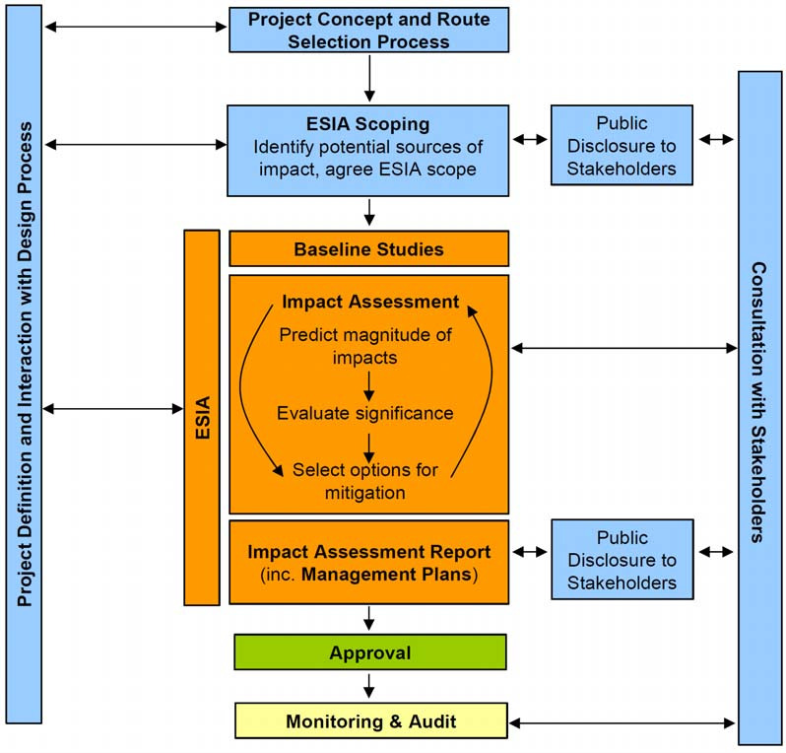
Figure 1-1 ESIA process schematic

Purpose of this Scoping Report
This Scoping Report is the first formal evaluation step in the ESIA process for the Trupale-Pojate (TP) gas pipeline. The primary output of the scoping process will be the final scope and contents for the full ESIA, taking into account the input from relevant stakeholders, and the specific requirements of the Serbian Authorities, World Bank and other stakeholders.
It defines the scope, boundaries, and methodological approach for the full ESIA. Specifically, this report:
- Defines the scope and boundaries of the ESIA, including the Area of Influence (AoI) for each impact type
- Identifies the key environmental and social issues requiring detailed assessment
- Outlines the methodological approach for baseline studies and impact assessment
- Identifies the specialist studies required to support the ESIA
- Documents initial stakeholder engagement undertaken during scoping
- Provides Terms of Reference (ToR) for the full ESIA
- Ensures alignment with both Serbian EIA legislation and the World Bank Environmental and Social Framework (ESF)

Structure of this Report
This Scoping Report is structured as follows:
- Executive Summary
- Section 1: Introduction
- Section 2: Project Description
- Section 3: Project Alternatives
- Section 4: Institutional and Legal Framework
- Section 5: ESIA Process
- Section 6: Stakeholder Engagement
- Section 7: Receiving Environment
- Section 8: Identification of Potential Risks and Impacts
- Section 9: Terms of Reference for the ESIA and Management Plans
- Appendices (A) Site Visit Report, (B) Corridor route sensitivity socio-economic Phase I & II, (C) Compliance matrix, (D) CERC, (E) Comments Form

Project Description

Project Location and Route
The proposed Phase 1 pipeline runs approximately 62 km from the Trupale compressor station / GRČ Niš area (43.369°N, 21.829°E) northward through the Južna Morava valley to Pojate / MS-2 / PPS-Pojate (43.747°N, 21.428°E). The route follows the existing Yugorozgas 1995–2003 pipeline corridor with deviations where required by settlement proximity, topography, or environmental sensitivity.
The pipeline traverses the municipalities of Niš, Aleksinac, Ćićevac, and the Pojate area. The route runs broadly south-to-north, trending northwest as it follows the Južna Morava valley (see Figure 2-1). The corridor is predominantly cultivated agricultural land (cereal crops). The route is preliminary, and subject to review and confirmation by the Spatial Planning Agency under the Spatial Plan for the Orljane–Niš–Batajnica–Horgoš–Hungarian Border Main Gas Pipeline, which covers the full programme corridor.
The full technical documentation for the entire 140 km Niš (Trupale)–Pojate–Veliko Orašje section will be prepared under Phase 1 funding, with subsections identified and marked in line with the MPA structure. Phase 2 (Pojate–Veliko Orašje, 80 km) is subject to a separate appraisal and budget allocation.
The start of the proposed pipeline around Trupale is characterised by mild hilly sections with peaks and troughs for around 5km before the alignment enters the expansive floodplain of the Juzna Morava (Morava River) for over 20km. The route then climbs sharply from around Praskovce into a series of sharp peaks and troughs typified by forest habitat, before gradually reducing in altitude to the end point in Pojate (see Figure 2-2).

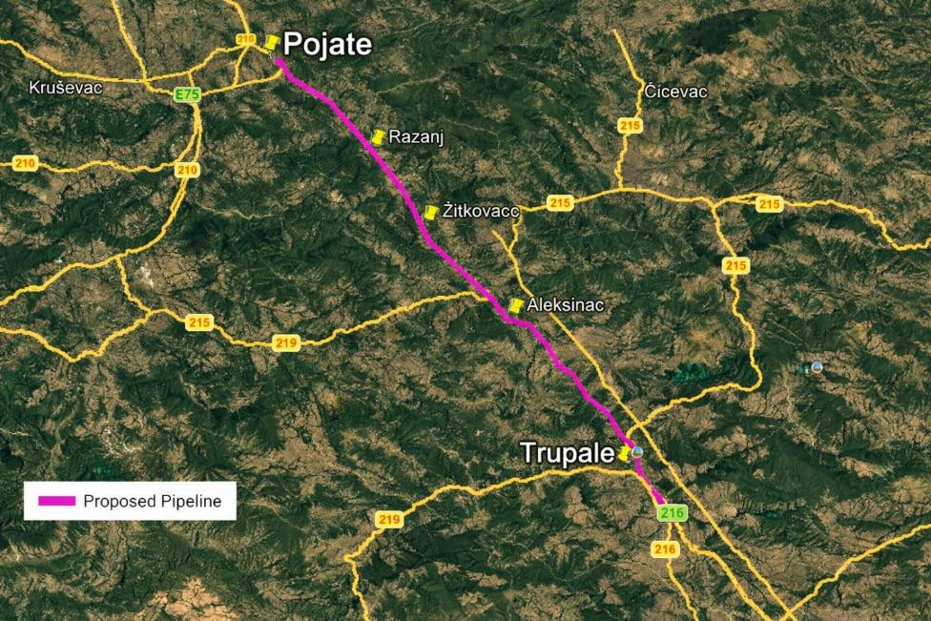
Figure 2-1 Project location

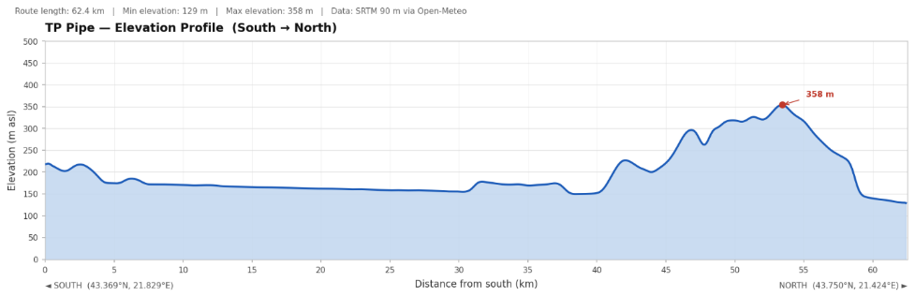
Figure 2-2 Route Topography S-N

Project Components

General
At the time of this Scoping Report the pipeline route is at a preliminary design stage. The diameter (DN) of the gas pipeline has yet to be determined but is expected to be a maximum of 900mm with varying pipe wall thickness driven by pressures from topography and safety protocols along the route, operating at 75 bar. As the pipe diameter is likely to be a maximum of 900mm, the construction right of way can be expected to be typically a maximum of 30m in width. This report will consequently refer to 900mm diameter, 75 bar and 30m construction RoW.
The primary approach to pipeline routing was driven by following the existing pipeline, with a number of route deviations to accommodate buildings, new developments and an area of steep terrain around Razanj.
The pipeline will be made of welded steel pipe sections which could typically be in the range of 6m to 18m in length. The steel pipe sections will be coated both inside and outside. The internal coating will be an epoxy resin which reduces friction and pigging, whilst the external coating will typically be 3-layer polyethylene to protect the pipeline from corrosion. Some of the pipeline sections, such as those in any wet ground, will be additionally weight coated with reinforced concrete to protect the pipe from external damages. The entire pipeline will be protected against corrosion by a cathodic protection system, comprising a low voltage electric current and anodes.
The pipeline will be buried underground for the entire length and for safety reasons and in order to minimise impacts to existing land uses (e.g. agricultural) the buried pipeline will have a soil cover of minimum 1m. Greater depth will be required when crossing existing infrastructure such as roads and irrigation canals and concrete slabs may be positioned above for extra protection.
The pipeline will typically be designed for a technical life time of 50 years. The design shall ensure that the gas transport system fulfils all safety requirements of the Serbian and base European Codes and Standards.
The project comprises the following main components:
- Main buried pipeline: 62 km high-pressure gas transmission pipeline, DN 900, 75 bar, installed within a 30m construction right-of-way (ROW)
- Block valve station (south of Razanj): automatic isolation valve for integrity management and emergency isolation. The valve station will include Pig launcher and receiver stations: for pipeline inspection and cleaning; SCADA & fibre-optic integration system, metering, regulation & safety systems
- Hydrogen-ready design
- River and watercourse crossings: HDD (horizontal directional drilling) envisaged for major crossings of the Južna Morava, with other watercourses being open-cut. It should be noted that the exact method of pipeline installation for each and every watercourse crossing will be determined during the detailed design stage, which will utilise information, inter alia, from geotechnical investigations that will be conducted as part of the detailed design stage.

Temporary Construction
The pipeline will be assembled in a conventional way by a construction spread that follows along the pipeline corridor. First, the top soil is stripped sidewards and stored separately in a windrow, followed by grading of subsoil as required and then later a trench is excavated.
Individual joints of pipe are then placed along the ROW (stringing) and then faced and welded to form a pipeline string which is subsequently lowered into the trench in various lengths as feasible. The sub soil is then placed back into the trench, followed by the topsoil and the landscape reinstated while the construction spread moves forward. Variations in timing will inevitable occur, with some sections of the ROW open for longer than others prior to reinstatement.
In flat soft terrain the average construction progress could be up to 600 m/day, in hilly or mountainous regions the average progress could be between 300 and 450 m/day whilst in difficult sections like steep slopes and rock the average progress could be as low as 50m/day; albeit these have been largely avoided.
For communication and data exchange during operation, a fibre optic cable will be laid alongside the pipeline within the pipeline trench. Specialised techniques will be used for crossing of roads and railways. The crossing of main roads/highways, railways and larger channels may require the use of trenchless methods (e.g. pipe jack or thrust bore, or horizontal drilling). Whether performing an open-cut or a trenchless installation, the pipeline shall be installed at least 2-3m below the existing infrastructure to be crossed, sometimes with additional concrete slab protection above the pipe.
The standard onshore pipeline construction, applicable along most parts, has the following main elements:
- Construction right-of-way (ROW): 30m strip for pipeline installation. The fertile topsoil (typically 0.3-0.5 m thick) will be stripped off over a width approximately 22-24 m. The top soil is temporarily stored on one side of the working strip in a windrow (see Figure 2-3).
- The non-fertile “sub-soil” obtained from the pipeline trench excavation will be typically stored on the opposite side of the working ROW, or on the same side with a gap to prevent mixing. Fertile topsoil must be re-deposited on top of the non fertile subsoil to assure adequate crop or natural vegetation growth.
- The width of the working ROW must provide room for pipeline fabrication (pipe stringing and welding, protective coating and quality testing of the fabricated pipeline section, lowering into the trench), and for simultaneous vehicle movements, both to happen in a safe manner.
- In areas where there are construction constraints (e.g. environmental or land use constraints) and in general where limited room is available, the working ROW may be reduced.
- Pipe storage and laydown yards
- Construction access roads (new and upgraded existing)
- Construction camp(s) for workforce or equipment laydown and storage
- Hydrotest water sources and discharge points
- Borrow pits (if required for access road construction)

Construction Methodology
- Main trench excavation using mechanical equipment; topsoil and subsoil separately stripped and stored
- Pipe stringing, bending, welding, and non-destructive testing (NDT) along the ROW
- HDD at major watercourse crossings (Južna Morava x2); Potentially open cut method Toponicka, Velepoljska and others, all to be designed/confirmed during detailed design)
- Open-cut crossing for minor watercourses, with appropriate diversion and erosion controls
- Backfilling, compaction, and full reinstatement of agricultural and non-agricultural land to pre-construction condition
- Hydrostatic testing before commissioning
- Reinstatement of access roads and laydown areas

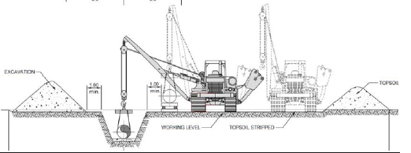
Figure 2-3 Typical ROW cross section

Figure 2-4 shows an indicative cross section profile of the two HDDs for the Morava river. The design is only at concept stage currently and will be developed following detailed engineering design informed by geotechnical investigations of ground conditions, to ensure this technique is feasible. If the alluvial material is deemed not suitable to support the cutting head tunnel, another option is micro-tunnelling, whereby vertical shafts are constructed either side of the river and a tunnel boring machine used to install the pipe. From an environmental perspective HDD is favourable as the river channel and its surrounding riparian habitats remain unaffected.
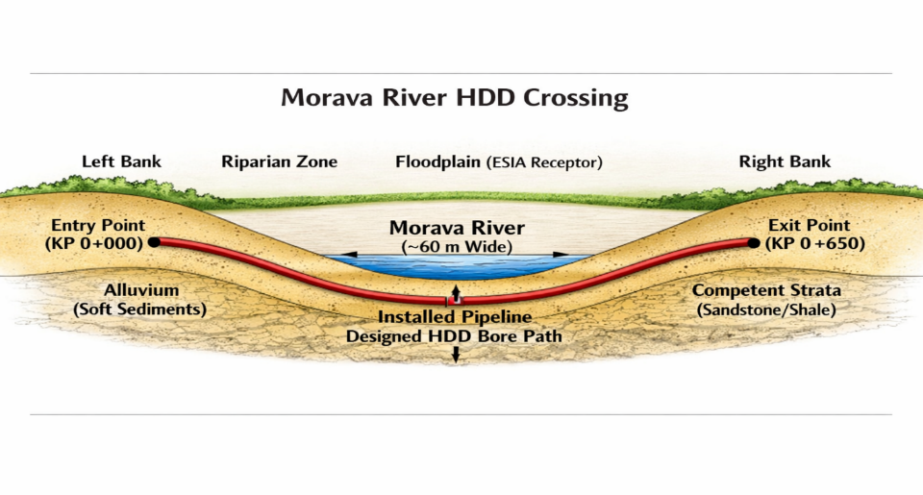
Figure 2-4 Indicative section of HDD

Pre-Commissioning
Once the pipeline has been installed and backfilled a number of activities will be required to ensure that the pipeline meets the operational requirements. The primary objective of these activities is to verify that the line has been laid without significant defects and that it is in a suitable condition to be filled and pressurised with the gas.
Prior to commissioning, the pipeline will be subject to a series of inline inspection and cleaning operations using pipeline pigs - cylindrical or spherical devices propelled through the pipeline bore by the pressure of a fluid or gas. Pig launcher and receiver facilities (pig traps) will be installed at each end of the pipeline and at intermediate block valve stations to facilitate pig deployment and retrieval.
The first operation is typically a gauging pig run, in which a pig fitted with a gauging plate, a metal disc machined to a defined percentage of the nominal internal diameter (typically 95%), is driven through the pipeline to confirm that no geometric deformation, dents, buckles, or ovality exist along the entire length. Any deformation sufficient to restrict the gauging plate will arrest or damage the pig, identifying the location of a defect requiring excavation and repair before the pipeline can be accepted.
Following successful gauging, cleaning pig runs are conducted to remove mill scale, debris, welding slag, and construction residues from the pipe interior. Cleaning pigs equipped with wire brushes or foam elements are passed through the line in multiple runs until the pig arrives at the receiver in an acceptably clean condition. This is essential to protect downstream equipment, particularly compressor internals and metering instrumentation, and to prevent contamination of the gas stream.
After hydrostatic testing and dewatering, a calliper pig (also known as a geometry pig) may be deployed as a final pre-commissioning check, using mechanical arms or electronic sensors to record the internal profile of the pipeline and generate a continuous record of bore dimensions, confirming fitness for service and establishing a baseline for future integrity management.
The water required for hydrotesting shall be fresh and clean water which will be drawn from (and discharged to) water sources along the route (most probably rivers). A detailed concept and assessment for the proposed hydrotesting activities and water resources to be used will be defined in detail in the ESIA, based on detailed studies. The maximum length of a test section is typically limited to 10 km horizontal. The length of vertical sections will depend on the final pipe design. Special sections such as main river crossings are often tested separately.

Associated Facilities
The pipeline will include some limited above ground infrastructure (AGI), such as a check valve south of Razanj. The AGIs occupy typically small footprints in a fenced compound, all of which is part of the TP project.
Under the World Bank ESF (ESS1), "Associated Facilities" means facilities or activities that are not funded as part of the project and that, in the judgment of the Bank, are: (i) directly and significantly related to the project; (ii) carried out, or planned to be carried out, contemporaneously with the project; and (iii) necessary for the project to be viable and would not have been constructed, expanded or conducted if the project did not exist.
Given that the TP project is a component in a larger pipeline infrastructure ‘set of projects’, the two compressor stations (near Nis and Batajnica) and perhaps others are proposed as planned for the new pipeline infrastructure corridor. These compressor stations (20–25 MW each) provide the pipeline its full delivery capacity. They are not financed under Phase 1 but only become viable and necessary once the Phase 1 pipeline exists. Similarly subsequent additional pipeline infrastructure that forms the remainder of the completed integrated system is planned.
However, none of the subsequent infrastructure is planned to be built contemporaneously with the Phase 1 TP pipeline and therefore they fail to meet the three-part criteria under ESS1. It is consequently concluded that there are no Associated Facilities for Phase 1.

Employment
Detailed workforce numbers are to be confirmed as the design progresses. A construction workforce of over a hundred workers is anticipated, drawing on both local Serbian labour and potentially international specialist contractors for HDD and possibly automatic pipeline welding. It is possible that all or the majority of Serbian workers may be accommodated locally within the housing system, but may be accommodated in a camp; to be determined during ESIA. As part of the ESIA, a Labour Management Procedure (LMP) is required under ESS2.

Construction Schedule
The construction schedule has not yet been designed but could typically extend up to a 2 year period. The schedule will take into consideration any seasonal constraints, such as floodplain working, factoring in the flood defence bund that is constructed parallel to the river along most of its length; albeit flooding remains a possibility and is known in the localities during Spring season.

Project Alternatives

Project Rationale
The need for the Trupale-Pojate pipeline is driven by a bottleneck in Serbia’s gas transmission network. The Energy Sector Development Strategy (ESDS) identifies four infrastructure bottlenecks constraining the inland movement of gas; the Trupale-Pojate pipeline directly addresses bottleneck 1: the central corridor capacity constraint that prevents the utilisation of gas flows arriving via the IBS from Bulgaria.
Without this pipeline, Serbia cannot efficiently move gas from the IBS interconnector to central and western Serbia, regardless of the volume or source of the gas contracted. The EU ban on Russian-origin gas imports, effective from 2027, makes inland capacity development a matter of strategic urgency: Serbia must be able to move Azerbaijani and other alternative gas supplies inland before Russian gas ceases to flow.
Three planned international interconnectors (North Macedonia–Serbia, Romania–Serbia, Croatia–Serbia) will, when operational, require this inland transmission capacity. The Trupale–Pojate pipeline is therefore not discretionary infrastructure but a prerequisite for Serbia’s energy security transition.

Route Selection

Selection of Corridor
The Trupale-Pojate-Veliko Orašje corridor was identified as the priority alignment because it follows the existing Yugorosgaz 1995-2003 pipeline corridor, making use of an established easement and avoiding the need to create an entirely new infrastructure corridor through virgin land. Following an existing corridor substantially reduces land acquisition complexity, biodiversity fragmentation, and cultural heritage risk compared with a greenfield route.
The Spatial Plan for the Orljane-Niš-Batajnica-Horgoš-Hungarian Border Main Gas Pipeline, currently being prepared by the Spatial Planning Agency with an expected approval timeline of up to one year, will formally establish and confirm the corridor. The ESIA is to be prepared in parallel to ensure that the routing is acceptable from a World Bank E&S perspective before construction commences.
As referenced above the Preliminary TP routing follows the existing pipeline alignment as closely as possible and only deviates at a limited number of locations where (obvious) constraints have presented themselves in this preliminary design stage, such as new housing developments and clear avoidance of potentially adverse ecological and landscape impacts. Given the preliminary (only) nature of the design to date, no multi-criteria analysis has been applied, and this will be undertaken during the detailed routing and in conjunction with the ESIA.

Route Deviations
The current route, developed by Srbijagas is preliminary and will be adjusted where required based on the findings of the ESIA and more detailed engineering design, that will consider construction feasibility. Specific deviations from the existing corridor have been identified at several locations where the pipeline passes close to buildings, households, or other sensitive receptors. The ESIA constraints mapping will confirm whether further deviations are required and will document the justification for each deviation or the acceptance of proximity.
A number of points of interest were considered during the Scoping stage and were appraised during the site visit of late June, early July. The general conclusion from this work was that Srbijagas have undertaken very positive routing to either avoid or minimise potential issues to habitats, buildings and infrastructure. This approach is in keeping with the mitigation hierarchy of Avoid, Minimise, Restore, Compensate.

No-Project Alternative
The no-project alternative would mean Serbia does not develop inland gas transmission capacity along the central corridor. The consequences include continued inability to move gas from the IBS (Bulgaria–Serbia interconnector) to central and western Serbia at the required volumes; continued high dependence on Russian-origin gas, particularly in light of the EU 2027 embargo; failure to utilise the energy security benefits of the IBS interconnector and SOCAR’s planned Combined Cycle Gas Turbine (CCGT) investment; and inability to receive gas from planned interconnectors with North Macedonia, Romania, and Croatia when they become operational
The no-project alternative is not a viable option given Serbia’s energy security obligations and its EU accession commitments. It is assessed as the least preferred alternative.

Institutional and Legal Framework

Serbian Policy, Institutional, and Legal Framework
Serbia’s environmental governance system is well-established and broadly aligned with EU directives. The following legislation is directly relevant to the ESIA.

Table 4-1 Relevant legislation
Legislation | Reference | Relevance to this Project
Law on Environmental Impact Assessment | OG 94/2024 | Mandatory EIA for gas pipelines exceeding the applicable regulatory threshold, including relevant gas pipeline projects; national screening, scoping, EIA study and consultation requirements. The broader ESIA is required under the World Bank ESF.
Law on Environmental Protection | OG 135/04, 36/09, 72/09, 43/11, 14/16, 76/18 and 95/18, 94/2024 | Overarching framework; sustainable development, precaution, public participation
The Law on Strategic Environmental Assessment | OG 94/2024 | The procedure and content of strategic environmental assessment for plans and programmes. Relevant to the Spatial Plan and its SEA, including assessment of environmental effects of the planned gas infrastructure corridor, consideration of alternatives, consultations and integration of SEA findings into the planning process.
Law on Nature Protection | OG 36/2009, 88/2010, 91/2010, 14/2016, 95/2018 and 71/2021 | Protected areas, ecological networks, species; pipeline crosses biodiversity-sensitive areas
Law on Waters | OG 30/2010, 93/2012, 101/2016, 95/2018 and 95/2018 – other law | Watercourse crossings, flood protection, hydrotest water management; Morava basin
Law on Waste Management | OG 36/09, 88/10, 14/16 and 95/18-other law and 35/23-68 | Waste management principles, classification, storage, transport, treatment and disposal of waste, including hazardous waste.
Law on Energy | OG 145/14, 95/18, 40/21, 35/2023 – other law, 62/2023, 94/2024 and 109/2025 – other law | Energy-sector framework, energy policy, gas-sector activities, operator obligations, permitting interface, pipeline safety and ownership/unbundling arrangements; applies to Spatial Plan development and pipeline permitting
Gas Law | Official Gazette of the Republic of Serbia No. 109/2025 | Regulates conditions for reliable, safe and quality supply of natural gas, gas-sector activities, market organisation, rights and obligations of market participants, protection of customers, design, construction, maintenance and use of gas pipelines and gas installations, pressure equipment and supervision. Relevant to gas infrastructure construction, operation, maintenance, safety, institutional responsibilities and sector regulation.
Law on Planning and Construction | OG 72/09, 81/09 - amended, 64/10 - CC decision, 24/11, 121/12, 42/13 - CC decision, 50/13 - CC decision, 98/13 - CC decision, 132/14, 145/14, 83/18, 31/19 and, 37/19 - other Law, 9/20, 52/21, 62/23 and 91/25 | EIA-related approvals are relevant to permitting, while the broader ESIA is required under the World Bank ESF.; Spatial Plan Decision OG 4/2024.
Law on Cultural Heritage | OG 129/21 | General framework for protection, preservation and management of cultural heritage. Relevant to cultural heritage baseline, consultations with cultural heritage institutions and local communities, and assessment of impacts on cultural heritage and locally significant cultural/community sites.; Serbia has high archaeological site density.
Law on Cultural Property | OG 71/94, 52/11 – other law, 99/11 – other law, 6/20 – other law, 35/21 – other law, 129/21 – other law and 76/23 – other law | Protection of cultural property, archaeological sites, cultural monuments, protected surroundings, chance finds and conditions issued by competent heritage protection institutions. Relevant to heritage walkover, archaeological risk assessment, chance-find procedures and mitigation of impacts on cemeteries, churches and other cultural/community sites.
Law on Occupational Health and Safety | OG 35/23 | Occupational health and safety framework, employer and contractor obligations, risk assessment, prevention measures, training, worker information and consultation, accident prevention and reporting. Relevant to construction-site safety, contractor OHS management, hazardous works, worker accommodation/interface issues, and coordination with the LMP and ESMP.
Law on Expropriation | OG 53/1995, OF FRY 16/2001 – FCC, OG 20/2009, 55/2013 – CC and 106/2016 – authentic interpretation | Land acquisition and compensation; three mechanisms apply: full expropriation, incomplete expropriation (ROW), and servitude/easement registration
Law on Free Access to Information of Public Importance | OG 120/2004, 54/2007, 104/2009, 36/2010 and 105/2021 | Regulates the right of access to information of public importance held by public authorities. Relevant to transparency, disclosure of Project information, access to environmental and social information, stakeholder engagement and ESS10.
Law on Public Information and Media | OG 92/23 | Regulates public information and media. Relevant to public announcements, communication with stakeholders, disclosure of Project information and dissemination of consultation notices.
Law on Social Protection | OG 24/2011 and 117/2022 – CC | Regulates social protection rights, services and institutions. Relevant where Project impacts may affect vulnerable households, livelihoods, access to social services or persons requiring targeted assistance during stakeholder engagement, land acquisition or livelihood restoration.
Law on Protection of Rights and Freedoms of National Minorities | OG FRY 11/2002 and 57/2002; OG S&M 1/2003 – Constitutional Charter; and OG 72/2009 – other law, 97/2013 – CC and 47/2018 | Protection of minority rights, cultural identity, participation and non-discrimination. Relevant if the pipeline corridor passes through or affects areas inhabited by ethnic minority communities, including for culturally appropriate stakeholder engagement and access to information.
Rulebook on Gas Pipeline Conditions (>16 bar) | OG 37/2013, 87/2015, 49/2025 | Technical conditions for construction and operation of the pipeline; applies to design and permitting
Decision on the Preparation of the Strategic Environmental Assessment for the Spatial Plan for the Special Purpose Area of the Bidirectional Main Gas Pipeline Niš–Batajnica–Horgoš–Hungarian Border, with elements of detailed regulation | OG 4/2024 | Initiates preparation of the Spatial Plan for the broader gas pipeline corridor; relevant to route consideration, spatial planning basis and subsequent permitting steps

Competent Authorities
There are a number of competent authorities which should be considered for consultation during the ESIA:
- Ministry of Environmental Protection (MoEP): competent authority for national EIA procedure, environmental permitting and environmental conditions
- Serbian Environmental Protection Agency (SEPA): environmental monitoring data, baseline data provision
- Institute for Nature Conservation of Serbia: biodiversity data, conditions for works near protected areas, Emerald Network geodatabase
- Republic Institute for the Protection of Cultural Monuments: archaeological and cultural heritage conditions, chance finds procedures
- Republic Geodetic Authority (land and expropriation), PE Putevi Srbije (road crossings), Infrastruktura železnice Srbije (railway crossings if applicable), Srbijašume (forest land)
- Water Management Directorate: permits for watercourse crossings
- Spatial Planning Agency: confirmation of pipeline corridor under the Spatial Plan
- Ministry of Mining and Energy (MoME): project proponent, PIU host
- Local self-governments / municipalities (City of Niš, Aleksinac, Ražanj, Ćićevac): public consultations, local permitting and coordination, local land-use information, first-instance expropriation procedures through competent municipal/city departments, identification of affected parcels and rights holders, and case-specific coordination on land acquisition issues with MoME/PIU and the designated expropriation beneficiary
- Republic Geodetic Authority (RGA): cadastral data, land ownership and parcel records, easement/servitude registration, spatial data relevant to land acquisition and expropriation
- Public Enterprise Roads of Serbia (PE Putevi Srbije): conditions, permits and coordination for national/state road crossings and works affecting public roads
- Serbian Railways Infrastructure (Infrastruktura železnice Srbije): conditions, permits and coordination for railway crossings, where applicable
- Srbijašume: forest land, forest management data, conditions for works affecting state-managed forests, tree removal/reinstatement and access to forest resources
- Ministry of Finance / Tax Administration: valuation inputs for statutory compensation and appeal-related issues in expropriation procedures, where relevant
- Ministry of Interior – Sector for Emergency Management: emergency preparedness and response, community safety, major accident risk coordination and local emergency response arrangements

International Conventions
There are a number of international conventions that require screening against in the ESIA.
- Espoo Convention: transboundary EIA obligations
- Aarhus Convention: access to information and public participation
- Bern Convention: conservation of European wildlife and natural habitats
- Ramsar Convention: wetlands of international importance
- Convention on Biological Diversity (CBD)
- UN Framework Convention on Climate Change (UNFCCC)
- World Bank Operational Policy 7.50 (OP 7.50): International Waterways – the Južna Morava / Velika Morava system requires screening for applicability

World Bank Environmental and Social Framework (ESF)
The project must comply with the World Bank ESF (2018). The following Environmental and Social Standards are applicable:

ESS | Key Requirements for this Project
ESS1 | Full ESIA; mitigation hierarchy; Area of Influence definition; cumulative impact assessment; ESMP; ESCP
ESS2 | Labour Management Procedures (LMP); OHS plan; Code of Conduct; workers’ grievance mechanism; ESS2 applies to all worker categories
ESS3 | Resource efficiency; pollution prevention; waste management; drilling fluid management; hydrotest water management; GHG assessment
ESS4 | Community health and safety plan; traffic management; emergency preparedness; trench safety; public exclusion zones
ESS5 | Land acquisition and livelihood restoration; economic displacement is the primary social risk; RPF at programme level; RAP for Phase 1; legacy due diligence on 1995–2003 corridor if feasible
ESS6 | Biodiversity assessment; critical habitat screening; no-net-loss approach; seasonal survey windows; Biodiversity Management Plan
ESS7 | Not applicable in Serbia
ESS8 | Cultural Heritage Management Plan or Chance Finds Procedure; pre-construction walkover; access management during works
ESS9 | Not applicable (no financial intermediary)
ESS10 | Stakeholder Engagement Plan; timely and accessible information disclosure; meaningful consultation; SEA/SH-sensitive GRM; early outreach to farmers and land users; multilingual and locally appropriate disclosure channels.

Spatial Plan Interface
The Spatial Plan for the Special Purpose Area of the Bidirectional Main Gas Pipeline Niš–Batajnica–Horgoš–Hungarian Border, with elements of detailed regulation, is being developed pursuant to the Decision on the Preparation of the Spatial Plan published in the OG 4/2024. A Strategic Environmental Assessment (SEA) is being prepared alongside the Spatial Plan, in accordance with the Law on Strategic Environmental Assessment (OG 94/2024) and the separate SEA decision published in the OG. 69/2023.This Spatial Plan is of importance to the ESIA process because:
- It formally establishes the pipeline corridor and enables direct issuance of location conditions and construction permits without additional urban planning documents
- It serves as the legal basis for determining public interest, forming public purpose building plots, and establishing rights of easement and servitude for the pipeline
- Its planning boundary encompasses the cities of Belgrade, Niš and Novi Sad, and the municipalities of Ada, Aleksinac, Batočina, Bečej, Varvarin, Velika Plana, Žabalj, Inđija, Jagodina, Kanjija, Lapovo, Paraćin, Ražanj, Senta, Smederevska Palanka, Svilajnac, and Stara Pazova
- Spatial Plan approval is expected to take up to one year from the decision to proceed; the ESIA must therefore be prepared in parallel so that E&S requirements can inform the Spatial Plan rather than react to it

The Spatial Plan will also cover the planned fibre optic cable to be laid alongside the pipeline and its connection to the existing optical network. Two compressor stations of approximately 20–25 MW capacity each are planned near Niš (KS-Niš) and Batajnica, which will give the DN 900 pipeline a delivery capacity of around 10 bcm/year in both directions. These facilities are not financed under Phase 1 and, for the purposes of ESS1, are not currently treated as Associated Facilities for Phase 1 unless subsequently confirmed to meet the applicable ESF criteria.
Key legislation governing the Spatial Plan preparation includes the Law on Planning and Construction, the Law on Energy, the Gas Law, the Law on Environmental Protection, the Law on Strategic Environmental Assessment, the Rulebook on Conditions for Unobstructed and Safe Transport of Natural Gas through Gas Pipelines with Pressure Greater than 16 bar, and the Rulebook on Content, Manner and Procedure of Drafting Spatial and Urban Planning Documents, as further referenced in Table 4-1. Gap Analysis: Serbian Law vs World Bank ESF

Gap Analysis: Serbian Law vs World Bank ESF
Where Serbian law is not as prescriptive of ESF requirements, the ESIA will apply the higher standard, in line with World Bank policy. The gap analysis below is informed by documentation from World Bank and Serbian legislation. Key gaps are:

Table 4-2 Legislative Gap Analysis
Topic | Serbian Law Position | ESF Requirement / Gap to Bridge
Social assessment | Not mandated under EIA law; no formal social assessment requirement. | Full social assessment required under ESS1; demographics, livelihoods, vulnerable groups, and cultural assets must be assessed in the ESIA. Full social assessment required under ESS1; demographics, livelihoods, vulnerable groups, cultural assets, community health and safety, and local labour sourcing opportunities must be assessed in the ESIA
Resource Efficiency and Pollution Prevention | Serbian legislation does not require project‑wide assessment of resource efficiency or quantification of GHG emissions across construction, operation, and decommissioning.  National and local perspectives with regards to emissions.  National law is not integrated, project-wide.  No water efficiency requirements. | ESS3; Develop a Resource Efficiency and GHG Management Plan; quantify energy, fuel, water use and GHG emissions; identify feasible efficiency measures; monitor and report resource use and emissions to World Bank.  Conduct cumulative impact assessment for all emissions.  Conduct a Construction waste management plan, covering all waste streams.  Develop a water management plan, to include abstraction and discharge of hydrotest water.
Land acquisition mechanisms | Three distinct mechanisms exist: full expropriation, incomplete expropriation (for easements/ROW), and servitude/easement registration. Each has different procedures, compensation rules, and cadastral requirements | ESS5 applies regardless of mechanism; all affected persons including informal users must be covered; compensation must equal replacement cost; livelihood restoration must be provided for significant economic impacts
Informal land users | Serbian law recognises only formal title holders and registered users; informal users, seasonal users, and persons without formal legal rights are not protected | ESS5 requires informal users to be identified, included in the census, and provided with assistance; eligibility cut-off date must be set and communicated
Replacement cost | Serbian valuation methodology (market value per cadastral category) may not equal replacement cost for agricultural land, particularly for smallholders | ESS5 requires full replacement cost without deduction for depreciation or transaction costs; the RPF must define a supplementary compensation mechanism to bridge any gap
Economic displacement | Not recognised under Serbian law; loss of agricultural income from easement restrictions is not compensated beyond the market value of the restriction | ESS5 requires livelihood restoration for economically displaced persons even where there is no physical relocation; growing season timing, crop loss, and income restoration must be addressed
Timing of compensation | Serbian law permits compensation to be determined after works commence in some cases | ESS5 requires compensation to be paid in full before impacts occur; the RAP must include a condition precedent to construction commencement
Biodiversity Conservation and Sustainable Management of Living Natural Resources | Critical Habitat: Serbian legislation protects designated areas but does not require identification of critical habitat or demonstration of no net loss / net gain.  Natural or modified habitats: National procedures focus on formally protected areas.  Species conservation: National legislation protects listed species but does not require project‑specific conservation measures or maintenance of ecological connectivity. | ESS6: Conduct critical habitat screening; apply avoidance/minimisation measures; prepare a subsequent Biodiversity Management Plan (BMP) with measurable no‑net‑loss/net‑gain targets.  Map and value all habitats along the corridor; apply the mitigation hierarchy; include restoration measures (natural bio-restoration, reinstatement of drainage patterns).  Conduct targeted species surveys; design wildlife crossings if relevant and connectivity measures; implement timing restrictions to avoid breeding/nesting periods.
Legacy due diligence | No requirement to review historical land acquisition practices for existing corridor | The 1995–2003 pipeline corridor was acquired under prior procedures; any unresolved compensation, servitude registration gaps, or informal arrangements should be identified and resolved before Phase 1 works commence
Stakeholder engagement | Disclosure and public announcement required; no requirement for two-way meaningful consultation or systematic feedback mechanisms | ESS10 requires meaningful, two-way engagement in accessible formats; SEP must include rural/agricultural community outreach, multiple channels, SEA/SH-sensitive GRM, and documented feedback loops
Grievance mechanism | No formal GRM required under Serbian EIA or expropriation law | Both a community-facing and a worker-facing GRM are required; GRM must be operational before construction; SEA/SH-sensitive features including confidential reporting channels are required
SEA/SH risk | Serbian legislation prohibits sexual harassment, discrimination, and sexual violence through labour, anti-discrimination, and criminal laws. However, it does not require project-specific SEA/SH risk assessments, mitigation plans, Codes of Conduct, survivor-centered grievance mechanisms, or SEA/SH monitoring and reporting for infrastructure projects, as required under the World Bank Environmental and Social Framework (ESF) | ESF requires SEA/SH risk assessment, Code of Conduct for all workers, and GRM features enabling confidential reporting by women and girls
Cultural heritage | Chance finds procedure and pre-construction archaeological survey may be required by the Institute; proactive assessment not systematically required | ESS8 requires proactive CH assessment including walkover survey with the competent Institute and community consultation on sites of cultural or spiritual importance to local communities, CHMP or CFP, and community liaison for access restrictions during works
Community health and safety and emergency preparedness | Serbian legislation establishes a general framework for emergency and crisis management through emergency/disaster risk management legislation and defines the roles of national and local civil protection authorities. For gas infrastructure, technical regulations set safety requirements for high-pressure gas pipelines and operators are required to maintain emergency response procedures. However, the national EIA framework does not require a project-specific Emergency Preparedness and Response Plan as part of the EIA process, nor does it systematically require assessment of construction-phase community safety risks, public disclosure and consultation on emergency arrangements, or formal coordination with local emergency responders during construction. | ESS4 requires assessment and management of community health and safety risks throughout construction and operation. The ESIA/ESMP shall assess construction-phase and operational risks, including traffic and access risks, open trenches near settlements, pipeline testing failures, HDD frac-out events, accidental spills near watercourses, pipeline safety, third-party damage and accidental releases. Project instruments shall define proportionate emergency preparedness and response measures, community awareness and communication arrangements, coordination with local emergency responders, and disclosure of relevant safety information to affected communities.

The ESIA Process

Screening Assessment
Under the Serbian Law on Environmental Impact Assessment (OG 135/2004, 36/2009) and the Rulebook on Projects for which EIA is Mandatory, a full ESIA is required for high-pressure gas pipelines exceeding 15 km in length. The proposed 62 km Trupale-Pojate pipeline clearly meets this threshold. Under the World Bank ESF, the project is classified as Substantial Risk (Phase 1) and High Risk (programme level), requiring a full ESIA in accordance with ESS1. The outcome of screening is therefore unambiguous: a full ESIA is mandatory under both national and international requirements.

Scoping
This Scoping Report constitutes the scoping methodology and output. The scoping process has been informed by: review of available project documentation including the ESRS (May 2026); the Project Preparation Workshop presentation (May 2026); pipeline alignment data; desktop review of Serbian environmental legislation; collation of biodiversity data, and cultural heritage databases; consultations with relevant organisations and specialists and site visits in end June to early July 2026 by the consultants; and discussions with the World Bank task team, Srbijagas, Gas Infrastructura and MoME.

Baseline Data Collection
Comprehensive baseline data collection will be undertaken following approval of this Scoping Report and the associated ToRs. Seasonal constraints are critical: biodiversity surveys (particularly breeding bird surveys, flora, bat activity, and herpetofauna) must be completed within specific seasonal windows. The ESIA schedule must be designed around these windows.

Stakeholder Engagement
Stakeholder engagement is addressed separately in Section 6 and will continue throughout the ESIA process. A Stakeholder Engagement Plan (SEP) is required at programme level by appraisal and has been prepared alongside this Scoping Report. The SEP will be updated alongside the ESIA to inform engagement for the construction and operations phase. This will also reflect the actual engagement process for the ESIA process.

Interaction with Design and Decision Making
The ESIA process is iterative in its nature, such that potential adverse impacts can be fed into the design and the design takes them into account wherever feasible. The outcome of a good ESIA should be a project design that is the least damaging, optimises the process of Resettlement planning and that adheres to the mitigation hierarchy of avoid, minimise, restore and offset.

Impact Assessment and Mitigation
The ESIA will apply a transparent significance methodology based on magnitude of impact and sensitivity of the receptor. The mitigation hierarchy (avoid – minimise – restore – offset) will be applied throughout. Cumulative impacts, including interactions with the existing pipeline corridor, other planned infrastructure, and future MPA phases, will be assessed.

Stakeholder Engagement

Objectives
Stakeholder engagement during scoping and in the ESIA aims to: inform relevant parties about the project and the ESIA process; gather local and technical knowledge to inform the scoping of issues; identify concerns and expectations; and integrate stakeholder input into the ESIA design.

Key Stakeholders
- Ministry of Mining and Energy (MoME): Saša Koković (Acting Assistant Minister for Oil and Gas), Jovana Joksimović, Aleksandar Puljević
- Srbijagas: pipeline route data provider; spatial planning process lead
- Transportgas Srbija: Transmission System Operator (TSO), ISO recertified March 2026
- Gas Infrastruktura: new Transmission Network Owner (TNO), established December 2025
- AERS: national independent energy regulator
- Ministry of Environmental Protection (MoEP) and SEPA: lead environmental authority
- Republic Agency for Spatial Planning and Urbanism: lead body for Spatial Plan preparation
- Republic Geodetic Authority (RGA): cadastral data, servitude/easement registration, land records
- Institute for Nature Conservation of Serbia: biodiversity and Emerald Network data
- Republic Institute for the Protection of Cultural Monuments: cultural heritage
- Affected municipalities: Niš, Aleksinac, Ćićevac, and Pojate area — public consultations, local permitting, land records
- Landowners and agricultural land users along the 62 km corridor — formal title holders, co-owners, lessees, and registered users
- Informal land users: persons using land without formal legal rights, including seasonal users, agricultural producers without registered leases, and customary users
- Vulnerable groups: elderly landowners with limited income diversification; female-headed households; smallholders highly dependent on affected parcels; persons with limited access to information or administrative processes
- Civil society organisations, local media, farmers’ associations, and community groups along the corridor. In relation to the EPR plan for Emergency Management (Sektor za vanredne situacije) within the Ministry of Internal Affairs (MUP) is the lead national body. It is the primary actor for any project-level EPRP and should be formally consulted on the emergency response framework applicable to the pipeline corridor. Disaster Management Departments at municipal level — covering Nis, Aleksinac, Razanj, and Cicevac are tasked with preventive protection, risk management, fire, rescue, and civil protection at the local level. These are the bodies that would respond first in the event of a construction or operational incident along the corridor and must be included in community communication and emergency coordination arrangements.

Approach to Stakeholder Engagement for Scoping
The following initial engagement has been conducted:
- Engagement to date has focused on an initial round of stakeholder identification and a first site visit, which flagged proximity of the alignment to households, a cemetery, and other sensitive receptors at several locations.
- Meeting shave been held with Municipalities in Ćićevac, Ražanj Aleksinac and the City of Niš. Meetings were attended by the Municipal Presidents as well as staff representing the core departments relevant to the scoping exercise.
- Engagement to date has been limited to initial scoping-stage outreach; broader consultation with affected households, local municipalities, and vulnerable groups is planned as part of the ESIA process.
- Working Group: World Bank and MoME/Srbijagas have discussed establishing a Working Group to engage directly in the Spatial Planning process and ensure routing is E&S-acceptable.

Grievance Redress Mechanism
A Grievance Redress Mechanism (GRM) must be established and operational before construction. Under ESS10, Serbian law does not require a formal GRM, so the ESIA must design and implement one that goes beyond national requirements. The GRM must include:
- Community-facing channels (written, in-person, phone/SMS) in Serbian, accessible to rural and agricultural communities without internet access
- A worker-facing channel as part of the LMP, separate from community channels
- Sexual exploitation and abuse (SEA)/Sexual harassment (SH)-sensitive features including confidential reporting channels for women and girls, with referral pathways to support services
- Clear eligibility: anyone affected by the project, including informal users, may submit a grievance regardless of formal title
- Documented response timelines: acknowledgement within 5 working days; resolution or escalation within 30 days
- A register of all grievances received, actions taken, and outcomes, to be reported to the World Bank quarterly
- An appeals mechanism for grievances not resolved to the satisfaction of the complainant
The GRM design will be developed as part of the programme-level SEP and must be disclosed in Serbian before any community engagement commences.
A project-level Grievance Redress Mechanism (GRM) will be established in accordance with ESS10 to provide affected communities, landowners, and other stakeholders with an accessible, transparent, and responsive channel for raising concerns, complaints, or grievances related to any aspect of the project. During the period prior to formal establishment of the Project Implementation Unit (PIU), the E&S Working Group — supported by the environmental and social specialists engaged under the project preparation consultancy — will open a dedicated project grievance channel, publicised at the point of disclosure of the Scoping Report, SEP, RPF, and ESCP. This interim channel will provide a designated contact point, telephone/SMS number, email address, and the facility for written submissions, enabling grievances to be received, registered, acknowledged within five working days, and tracked from the date of first public disclosure. Once the PIU is formally established and operational, it will assume full ownership of the GRM, formalise the intake and resolution procedures set out in the SEP, and ensure the mechanism meets all ESS10 requirements — including community-facing and worker-facing channels, SEA/SH-sensitive confidential reporting, documented response timelines, a grievance register reported to the World Bank quarterly, and an appeals process for unresolved complaints. Contact details for the interim grievance channel will be included in all disclosed project documents and posted at municipal offices in Niš, Aleksinac, Ražanj, and Ćićevac.
In addition to the project-specific GRM, existing independent channels may be organized and utilized, with targeted improvements made for this project. This approach ensures that the mechanism is practical, recognizable, and immediately accessible to communities.
Institutions to be involved:
- Ministry of Mining and Energy – Sector for Oil and Gas
- Ombudsman (Protector of Citizens) – independent institution for receiving and processing citizen complaints.
- Commissioner for Information of Public Importance and Personal Data Protection – for cases involving misuse or violation of privacy.
- Commissioner for Protection of Equality – for complaints related to discrimination, harassment, and SEA/SH.
- Local self-governments – through the establishment of contact centers in municipalities and cities along the project route.
- Centers for Social Work and Health Institutions – as part of referral pathways for SEA/SH cases.
Contact centers by project locations:
- Niš – City Administration of Niš, contact center within the Department for Social Affairs.
(Phone numbers: +381 18 504 544 and +381 18 504 411 and email: brzi.odgovori@gu.ni.rs)
- Aleksinac – Municipal Administration of Aleksinac, citizen service office.
(Phone numbers: +381 18 804 711 / +381 18 809 000)
- Ražanj – Municipal Administration of Ražanj, contact center in the municipal building
(Phone number: 037/3841-174 and email: infopult@razanj.org)
- Ćićevac – Municipal Administration of Ćićevac, office for local development and citizen initiatives.
(Phone numbers: +381 37 811-260 /+381 37 811-178 and email: kabinet@cicevac.ls.gov.rs)
- Novi Sad – City Administration of Novi Sad, contact center within the Citizen Office.
(Phone number: 0800-021-021 for free and email: gradns@novisad.rs)
- Belgrade
City Administration of Belgrade, central contact center within the Secretariat for Citizen Services.
(Phone number: 0800 11 00 11 and email: servisnicentar@beograd.gov.rs)
or
Ministry of Mining and Energy Nemanjina 22–26, 11000 Belgrade, Republic of Serbia
(Phone number: +381 11 3112 080 and email: naftaigas@mre.gov.rs)

Each contact center will provide:
- Telephone line and SMS number for grievance submission,
- Registry office for written complaints,
- Trained staff for confidential handling and referral,
- Mechanisms for escalation to independent institutions (Ombudsman, Commissioner for Equality, Centers for Social Work).
This combined approach—linking new project-specific channels with existing institutional mechanisms—will strengthen community trust and ensure timely responses to grievances and harassment complaints.

Next Steps
- Prepare programme-level Stakeholder Engagement Plan (SEP) for disclosure by appraisal (prepared as part of this scoping stage)
- Undertake structured community consultations in affected municipalities before and during ESIA baseline work
- Establish Working Group prior to establishment of the PIU for provision of environmental and social technical guidance and Spatial Planning oversight
- Disclose this Scoping Report in Serbian and English; closing out the Scoping process, including consultations and feedback, which will then feed into the subsequent ESIA
- Conduct structured interviews with farmers, landowners, and other directly affected parties along the 62 km corridor

The Receiving Environment

Physical Environment

Introduction
The pipeline corridor runs through the Južna Morava (Morava River) valley, a major river valley running broadly north–south through central Serbia. The topography is generally flat to gently rolling in the valley floor, with higher ground to the east and west. Elevations range from approximately 200 m at Trupale (Niš area) to approximately 190 m at Pojate, with higher elevations in between. There are steep sections of terrain around Praskovce which are generally forested.
Soils are predominantly alluvial and fluvial deposits on the valley floor, transitioning to colluvial and residual soils on valley sides. Erosion susceptibility may be elevated on valley margins, particularly where the route deviates from the flat floor. The 2014 floods (51 casualties nationally) demonstrated the flood risk profile of the Morava basin, which is directly relevant to crossing design and seasonal construction planning. A flood defence bund has been constructed many years ago and affords protection from the Morava when it spreads outside its river banks. Detailed flood risk data will be collected during the ESIA to inform any seasonal constraints for working.

Climatic conditions
The climate in the project area is continental to temperate-continental, and the amount of precipitation is usually up to 500–600 mm/ year, while the air humidity is moderate. It is characterized by relatively colder winters, warmer autumns than spring and moderately warm summers. More specifically, low annual precipitation dominates, while summer precipitation is characterized by strong evaporation due to high temperatures, with frequent occurrence of summer storms and showers. Winds are a very important factor causing temperature differences, bringing precipitation or drought. Wind speed is usually low. Most of Serbia has Cfb climate16 (Köppen climate classification). https://climateknowledgeportal.worldbank.org/country/serbia
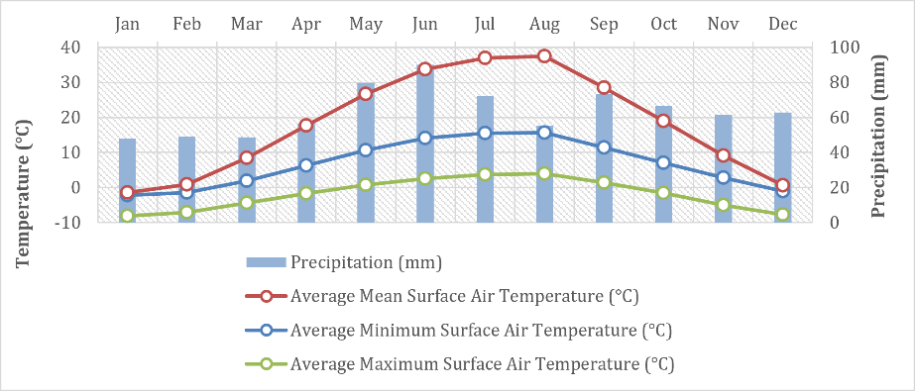
Figure 7-1 Average minimum surface air temperature and precipitation

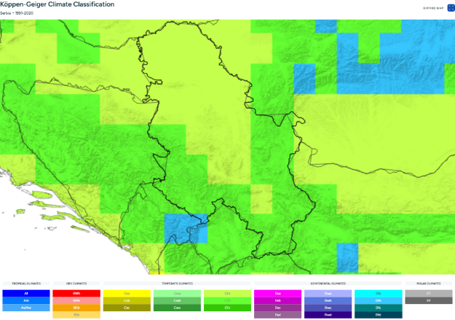
Figure 7-2 Koppen-Geiger climate classification Serbia 1991-2020

Air quality
Monitoring of air quality indicators in Serbia is carried out by the Environmental Protection Agency. The obligations and tasks of the Environmental Protection Agency in air quality management are more closely defined by the Law on Air Protection (Official Gazette of RS No. 36/09, 10/13 and 26/21).
Air quality in Serbia is generally influenced by emissions from the energy sector, industry, residential heating and road traffic, with elevated concentrations of particulate matter (PM₁₀ and PM₂.₅) occasionally recorded in urban areas, particularly during the heating season. Rural areas along the proposed pipeline corridor generally experience better air quality due to the absence of significant industrial emission sources.

Climate change
Serbia is positioned in 155th (of 192) place in the World Risk Index Report 2022 (Institute for the Environment and Human security of the United Nations University) (111th place of 181 countries in the 2021 report) with the World Risk Index of 1.84 (very low). Exposure is also very low and vulnerability is medium. Susceptibility is high, which is a change from the 2021 report, when it was assessed as medium. ThinkHazard assesses that in Serbia the risk of river floods, urban floods and wildfires is high, while earthquakes, landslides, water scarcity and extreme heat carry a medium risk.
The data presented in the document ‘Observed climate changes in Serbia and projections of the future climate based on different scenarios of future emissions (UNDP, 2018)’ represent the most likely value from the set (ensemble) of solutions obtained using daily values of temperatures and precipitation from nine regional climate models that can be downloaded from the EURO-CORDEX database. The reference period with respect to which the change in future climatic conditions is analysed is 1986–2005 and the analysed future periods are: 2016–2035 (near future), 2046–2065 (mid-century) and 2081–2100 (end of century). The analyses were performed according to two selected greenhouse gas emission scenarios: RCP4.5 (stabilization scenario, which anticipates the stabilisation of emissions from 2040) and RCP8.5 (constant growth scenario), which are assumed to cover the likely range of possible future outcomes.
Over the future periods, an increase in temperature is expected in both scenarios compared to the 1986–2005 reference period. A more intense increase in temperature is anticipated according to RCP8.5, which is expected due to the more intense emissions of GHG and their impact on the energy balance in the climate system. In this scenario, the mean annual temperature, on average for the territory of Serbia, will increase by 1ºC in the near future compared to the reference period, in the period attributed to the mid-21st century, it will rise to 2ºC, and, by the end of the century, the average annual temperature will be higher by as much as 4.3ºC compared to the reference period. The stabilisation scenario, RCP4.5, shows a slightly less increase in mean annual temperature by about 0.5ºC compared to RCP8.5 during the first two analysed periods. In this scenario, by the end of the 21st century, the increase in the average annual temperature in the territory of Serbia will reach a much lower value than the value obtained under the RCP8.5 scenario, which is 2ºC higher than the value of the reference period. A spatial analysis of changes in temperatures over future periods indicates an increase in warming from north to south. The selected results obtained from the analysis of future temperature changes are shown in Figure 7-3.
Figure 7-3 Climate change predictions
Anomaly of the mean annual temperature (°c) for the 2046-2065 period (left panel) and for the 2081-2100 period (central panel) relative to the values for the 1986-2005 reference period; anomaly of the mean maximum temperature (°c) obtained for the June-August 2081-2100 period compared to the mean maximum temperature values of this period for 1986- 2005 (right panel); the results obtained according to the rcp4.5 scenario are shown in the top panels and the results obtained according to the rcp8.5 are shown in the bottom panels. Source: climate changes observed in Serbia and future climate projections based on different scenarios of future emissions
The number of frost and ice days will progressively decrease in the future due to the temperature increase. In the near future, there will be almost 10 less frosty days on average annually in the territory of Serbia compared to the values of the 1986–2005 reference period.
The number of hot and tropical days will continue to increase in the future climate conditions. In the climate of the near future, relative to the reference period, changes indicate an extension of summer season conditions by almost half a month, and in the second half of the 21st century, an extension of almost a month may occur, after which the change will stabilize according to the RCP4.5 scenario, while according to RCP8.5, by the end of the century, summer conditions will be on average nearly two months longer than during 1986–2005 period. By the end of the 21st century, the expected increase in the average annual number of tropical days will be in the range between 20, according to RCP4.5, up to almost 50 days in the RCP8.5 scenario.
Extreme heat waves in the future climate will occur on average at least 2–3 times a year, while during the 1986–2005 reference period these were very rare events. According to the RCP8.5 scenario, by the end of the 21st century, their average occurrence in the territory of Serbia will be as high as 7 occurrences during the year, and in some areas even more than 10.
The future changes in mean annual accumulated precipitation, averaged for the territory of Serbia, will not have a pronounced trend in future periods, as is the case with temperature. However, in the second half of the 21st century, according to the RCP8.5 scenario, the average annual precipitation will start to decrease and in the period at the end of the 21st century, central and especially southern Serbia will experience the largest precipitation decrease, even exceeding 10% compared to the 1986–2005 reference period. The spatial distribution of change in precipitation shows a declining trend towards the south. Precipitation decreases during the June–August period has already been observed and it will continue during future periods according to both scenarios. In the period at the end of the 21st century, according to RCP8.5, the average precipitation decrease in the territory of Serbia will be 20.5%, with a much larger decrease in the southern regions, of as much as 40%. The selected results obtained from the analysis of future precipitation changes are shown in Figure 7-4.
As shown in Figure 7-4 the anomaly of the mean annual precipitation sum (%) for the 2046-2065 period (left panel) and for the 2081–2100 period (central panel) relative to the values for the 1986–2005 reference period; anomaly of mean precipitation sum (%) for the June–August season for the 2081–2100 period compared to the mean seasonal value for the 1986–2005 period (right panel); the results obtained according to the rcp4.5 scenario are shown in the top panels, while the results obtained according to the rcp8.5 are shown in the bottom panels
In the 21st century, according to RCP4.5, as much as 40% more precipitation, will occur during the days when precipitation is extremely high compared to the precipitation events of the 1986–2005 reference period. According to RCP8.5, this precipitation intensity increase will reach up to 60%.
Figure 7-4 Annual precipitation predictions

Geography, Geology, soils and Seismicity
The South Morava river, along with their tributaries, have formed zones of alluvial and terrace deposits, classifying most of the Project AoI as flatland terrain. Hilly-rolling terrains are present along the peripheral parts of the river valley, where the terrain begins to "rise." This type of relief is found within unconsolidated to weakly consolidated Miocene-aged sediments.
The highest points are within mountainous areas, including the peaks of Manjin kam (1186 m) and Koviljak (1138 m) on the Devica mountain; Jezerski stolovc (1129 m) and Leskovik (1174 m) on the Ozren mountain, and the highest peaks of the Veliki Jastrebac mountain, namely: Turka Karaula (1140 m) and Anatema (1075 m). The rest of the area (Pomoravlje) is predominantly flat or hilly with an occasional low mountain.
The largest geological formation comprises the wide alluvial plain of the South Morava River, which consists of Quaternary age deposits in the form of river terraces, as well as river facies (beds, floods and floodplains).
The geological structure of the pipeline route has been determined according to the Basic Geology Map – Paraćin and Aleksinac sheet . On this sheet, through the middle of which the South Morava River flows in a northwest direction, there are the mountains Devica, Ozren, Leskovik, Mali Jastrebac and parts of Veliki,Jastrebac and Poslon mountains. There are sections on the northern, western and southern parts of the sheet, Sokobanja, Krusevac and Toplica basins.
There are metamorphosed highly crystalline rocks to the garnet-amphibolite facies (staurolite-almandine subfacies), in places and eclogitic facies, often with pronounced potassic metasomatosis. Within these rocks, which belong to the core of the Serbian Macedonian massif, are andesine gneisses, amphibolites and amphibole gneisses, eclogites, marbles and migmatites (Mi) see Figure
Within the Neogene sediments, deposits of the Lower Miocene (M1) and Middle Miocene series (M2) are represented. The freshwater Lower Miocene series is made up of conglomerates, siltstones and sandstones alternating with clays and sandy marls. Middle Miocene sediments are represented by marls, limestones and marly clays, sands and sandstone. The higher parts of the series sometimes contain conglomerates, gravels and volcanic tuffs. The upper Miocene (M3) sediments are represented by clay, gravel, and sand. This part of the railway also includes miocene-pliocene (M,Pl) deposits represented by sands, silts and clays.
Within the Quaternary deposits, lake sediments, river terraces and deluvial-proluvial curtains are of Pleistocene age, while proluvial cones, alluvial deposits, floodplain facies and „mrtavaja“ facies are of Holocene age. Alluvial sediments consist of heterogeneous gravelly material up to 10 m thick, representing the main sources of drinking water in the research area18. Lake sediments are made up of fine-grained to coarse-grained gravels. In the highest parts of the lake deposits, white clayey carbonate bigroid sediments mixed with gravels were registered. The lower river terrace, consists of dark yellow siltstones of the floodplain facies lying on bed facies sediments (sands and gravels). Deluvial-proluvial curtains are built of sands and gravels, while proluvial cones consist of poorly sorted and heterogeneous material accumulated by occasional floods. The structure of the „mrtavaja“ facies includes sandy and silty soils in the remains of the river bed of the earlier stages of the Great Morava, while the floodplain facies is represented by siltstones, sands and clayey. In the structure of deluvial deposits, colluvial gravelly-sandy sediments, sandy loams, subsoils and loessoidal subsoils take part.
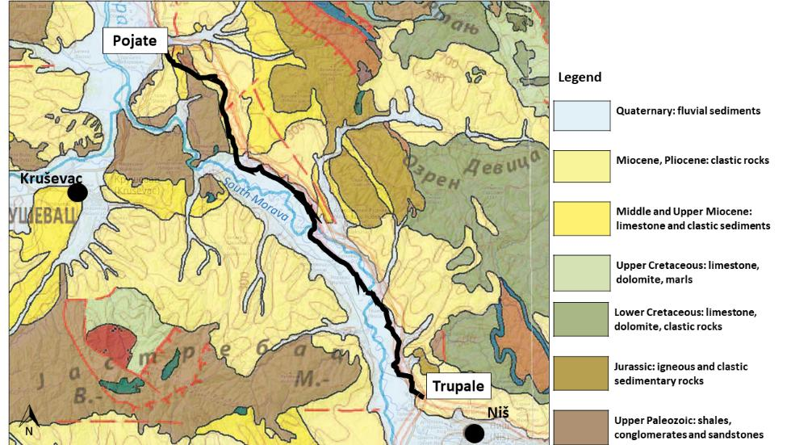
Figure 7-5 Simplified geological map

The project area is dominated by azonal soils whose development has been shaped by river flooding, groundwater levels, and the variety of materials deposited over time. These soils are generally moist, receiving water from rainfall, seasonal floods, and groundwater. Floodwaters carry and deposit fine sediments that enrich the soil, while groundwater circulation adds oxygen, contributing to overall soil fertility.
The predominant soil type in the area is fluvisol (alluvial soil), found across the Great and South Morava valleys. These soils are agriculturally valuable and are largely classified as Class II agricultural land, indicating high productive capacity. The main soil types present include alluvial soil, alluvial meadow soil (smonica), gajnjača, and deluvial soil. Barren or unproductive soils are largely absent from the area.
Within the project corridor three main land types are encountered:
- Loess and lake terraces (below 500 m a.s.l.) make up approximately 5% of the route. Fertility varies depending on humus content, depth, and substrate composition; soils on tertiary sediments are well-suited to fruit growing and viticulture, while those on eruptive rocks are better suited to forestry.
- Alluvial meadow soils, formed in the Great Morava valley, are highly variable in texture, ranging from gravels and sands to fine clays. When well-developed, they are among the most productive agricultural soils. The project area is predominantly agricultural, with arable land, orchards, and vineyards, and riparian vegetation influenced by farming activity.
- Gajnjača and smonica are fertile, clay-rich soils. Smonica is dark, humus-rich, and among the most fertile soil types in Serbia. Gajnjača is reddish to dark in color and slightly less fertile, but still of good agricultural quality. Both are widespread in the South Morava basin.
Soil degradation in the area is primarily driven by water erosion, particularly along riverbanks where high flows cause periodic bank collapse and channel shifting. Protective and landscaping measures have been partially implemented to address this. South Morava carries a high sediment load due to erosion in its upper catchment, leading to deposition in the riverbed. Additional pressures on soil quality include flooding (which can alter mechanical composition), inadequate waste disposal, and pollution from industrial activities.
Seismicity
From a seismological point of view, the Trupale-Pojate gas pipeline is located in a seismic area. This part of the Balkan Peninsula is part of a seismically active area in the Mediterranean-Trans-Asian seismic belt.
To determine the seismicity of the terrain, maps of the Republic Seismological Institute of Serbia were used, based on probability, represented by the maximum horizontal ground acceleration of type A (Vs,30>800 m/s), which corresponds to the return period of the seismic effect of 475 years. The probability of exceedance is 10% for a period of 50 years, and the maximum horizontal acceleration for the given area from Pojate to Trupale (Niš) is 0.15. The observed area is according to the seismological map created in 2018 or a return period of 475 years in zone VIII of macroseismic intensity.
Serbia does not belong to the area of high seismic activity, such as the primary zones of collision of tectonic plates (where 90% of all earthquakes on planet Earth occur), but earthquakes with magnitudes reaching 5.9 on the Richter scale have occurred. Due to the location which is on the very edge of the tectonic plate, earthquakes in Serbia, according to seismologists, are unlikely to be stronger than 6.2 to 6.3 on the Richter scale.
Seismic activity was recorded on the territory of Serbia with over 400 moderate and strong earthquakes. According to the available sources of information, about 180 earthquakes occurred with the epicenter in Serbia and the surrounding area, which, in addition to material damage, also resulted in loss of life (see Figure 7-6).

The last earthquake above 5 degrees on the Richter scale occurred in Kraljevo in 2010, which was one of the most destructive earthquakes in Serbia in the last few decades. Its strength was 5.4. on the Richter scale.

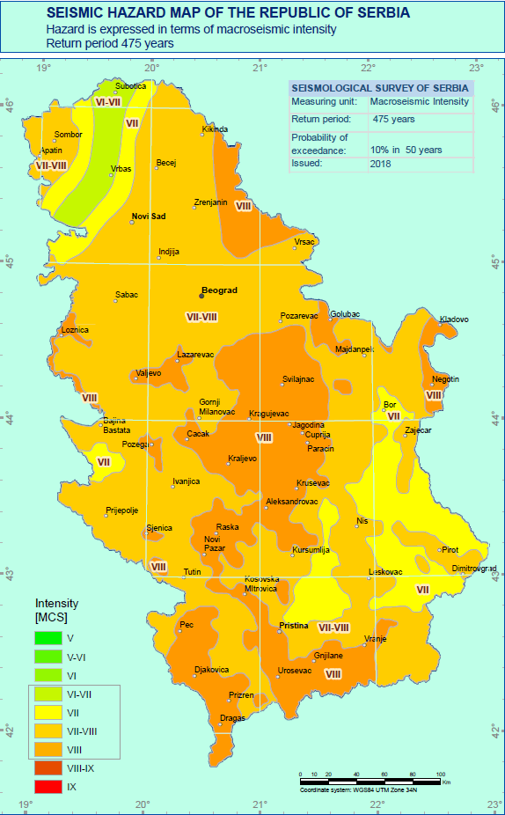 | 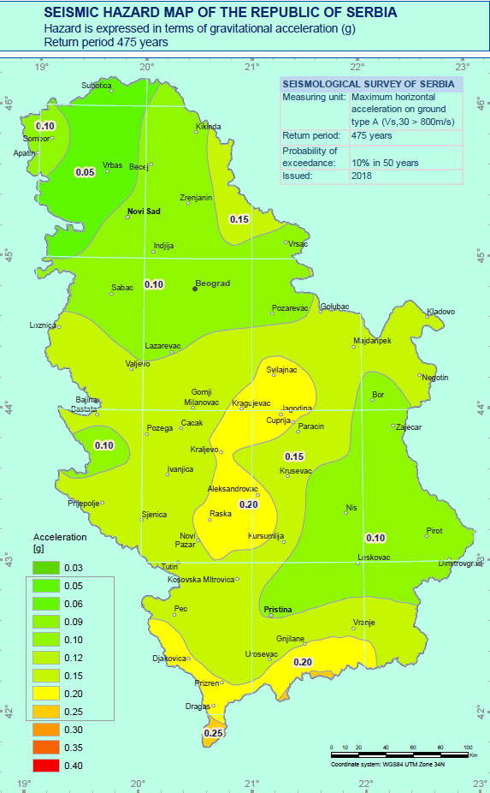
Figure 1. Seismic hazard map of the Republic of Serbia in the project area of the Trupale–Pojate gas pipeline, hazard expressed in degrees of microseismic intensity | Figure 2. Seismic hazard map of the Republic of Serbia in the project area of the Trupale–Pojate gas pipeline , hazard expressed in units of gravity acceleration [G]
Figure 7-6 Seismic map of Serbia

Surface Water
In the South Morava basin (Figure 7-6) 35 hydrological stations have been installed where measurements of the most important hydrological parameters are made. The first measurements began in the 1920s – at stations on the main stream of the South Morava. For the analysis of the average annual and seasonal flow values and their trends, data from 16 active hydrological profiles were used, in the territory covered by the project area, for which there are empirical data for the period of 50 years (1968-2017).
The South Morava receives a total of 157 tributaries – streams, rivulets and rivers – 75 left and 82 right. Most of them dry up in summer. Significant streams are Veternica, Jablanica, Pusta reka and Toplica on the left, and Vranjsko-banjska reka, Vrla, Kozaracka reka, Vlasina, Nišava, Toponicka reka and Sokobanjska Moravica on the right.
Near the village of Trubarevca (East of the TP route), the Moravica enters the Bovanska Gorge. It is 10 km long, up to 220 m deep and has a smaller extension near the village of Bovna. At its lower end, an earthen dam was built and an artificial lake with a volume of almost 100 million m³ of water, which extends upstream for about ten kilometers. Downstream of the Moravica dam, it enters the Niš-Aleksinac basin, flows through Aleksinac and flows into the South Morava 1 km southwest of that city. It gives the South Morava an average of about 5 m³ of water per second.
The Toponicka River flows into the South Morava near the village of Mezgraje at an altitude of 170 m above sea level. It is formed by two streams. The right one springs from under the southern slopes of Devica, and the left one east of Golemi Vrh. They meet at an altitude of 631.5 m and for the first 9 km, to the village of Zabukova, the river is called Suva. In its upper reaches, the Toponicka River flows through a valley up to 300 m deep. Between the villages of Popšica and Kravlje, it widens into a small basin, in which the alluvial plain reaches a width of 350-500 m, and downstream from Kravlje a gorge begins. In places it has the appearance of a canyon, as steep limestone slopes descend directly into the river bed. In the middle part of the gorge, at the place where the Toponicka River makes a sharp turn, in the extension of Topilo, there is a spa of the same name. Thermomineral springs erupt in a series of 10 m in length directly along the river course, almost at the level of the riverbed, at 0.5-1 m of relative height, and have a total yield of 10 l/s. From the village of Miljkovac, the valley of the Toponicka River gradually widens and near Gornja Toponicka it enters the South Pomoravlje. The Toponicka River has a catchment area of 200 km². Due to the significant spread of carbonate rocks (109 km²) and the bareness of the catchment, the discharge of precipitation waters is abrupt, so the Toponicka River has the characteristics of a typical torrential flow. However, in the summer half of the year it is deficient in water. On average, its flow at the mouth is about 1.5 m³/s.

Historical flood context.
The South Morava River basin has a well-documented history of flooding and represents one of the most flood-prone river systems in Serbia. Historical hydrological records indicate that major flood events occurred in 1963, 1976, 2005, 2009 and 2014, affecting the river corridor between Niš and Stalać. The 1963 event is considered one of the most severe on record, with exceptionally high river discharges recorded throughout the basin.
Flooding in this section of the South Morava is typically associated with prolonged rainfall, rapid snowmelt and the simultaneous occurrence of high flows in major tributaries, including the Nišava, Toplica, Toponička River and several smaller torrential streams. These events have historically resulted in inundation of agricultural land, disruption of transport infrastructure and localized damage to settlements.
Although the Toponička River has not experienced catastrophic flooding comparable to the main South Morava River, it is recognized as a typical torrential watercourse. Owing to the steep topography of its catchment, extensive carbonate formations and rapid runoff response, the river is susceptible to flash floods during intense rainfall events. Historical hydrological observations confirm the occurrence of significant high-flow events, while flood hazard assessments identify several locations along the river and associated transport infrastructure as having high flood susceptibility.
Consequently, historical records and basin characteristics demonstrate that flood hazard should be considered a relevant natural risk for projects located within or in the vicinity of the South Morava and Toponička River catchments. The potential impacts of future flood events should therefore be taken into account during project planning and design, particularly in view of the increasing frequency and intensity of extreme precipitation associated with climate change.
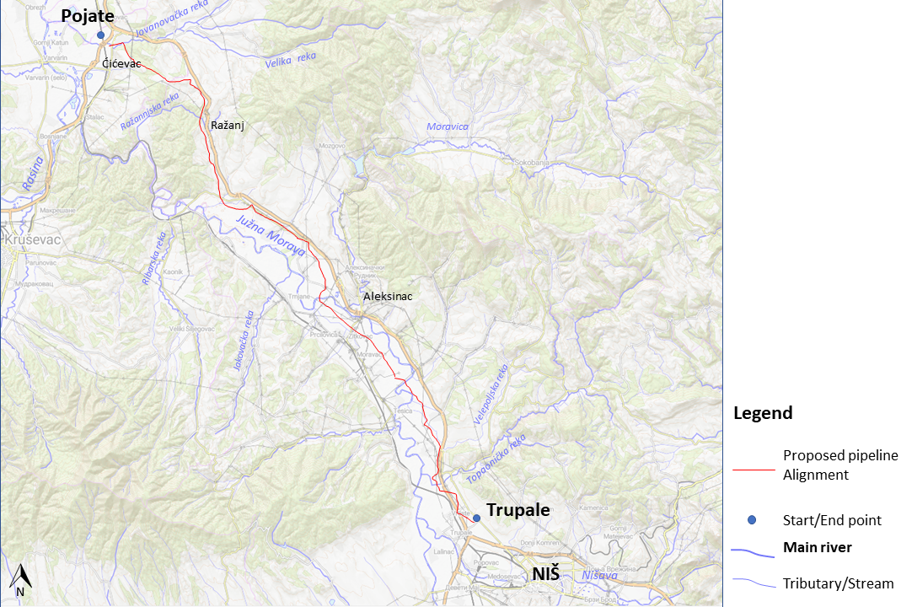
Figure 7-7 Simplified hydrology map

Groundwater
According to the isolated lithostratigraphic composition, the project area consists of a Paleozoic rock complex that makes up the peripheral parts of Great and South Morava, within which neogene and quaternary sediments were deposited. Each of these separate environments is characterized by a certain hydrogeological specificity, which primarily refers to the possibility of accumulating groundwaters within these environments. Based on the hydrogeological properties of the lithological environments as well as on the structural types of porosity, the following structural type of porosity can be distinguished in this area: intergranular type (with high and low potential), fissure-karst, and areas poor in outcrops - conditionally arid terrains.
In the territory of central Serbia, the largest part of groundwater reserves is located in the areas of alluvial sources, primarily in the Great Morava valley. The filtration characteristics of the sandy-gravel layer along the entire length of the alluvium are favourable, and the springs for water supply are mainly formed in the area of lower Pomoravlje. The use of groundwaters is organized mainly through dug wells for the needs of individual households, while larger quantities for organizational water supply are obtained from sandy sediments of the Neogene.
The city of Paraćin (ca. 12 km north of Pojate) has been supplied with water for over 40 years from the karst spring "Sveta Petka" located in the village of Izvor , about 16 km east of Paraćin. From the physico-chemical and bacteriological aspect, the quality of this water corresponds to the quality of drinking water required by law.
Significant water-bearing capacity of Neogene sediments was determined in the village of Kaonik, which is located 15 km east of Kruševac. A self-flow of 20 l/s was obtained from the well 70 m deep. Apart from this well, there are several artesian wells with good characteristics in the immediate vicinity of the village.
Groundwater source “Moravište” with previous capacity of 15 l/s due to unsatisfying quality and chemical status has been closed and the Ćićevac settlement has been transferred to the regional water supply system “Ćelije”.
In the South Morava basin, there are several springs of smaller capacity, and Mediana with a capacity of 440 to 550 l/s being one of the most important springs. It is about 16 km from Trupalе. The source of "Medijana" is abundant in sandy clay, gravel and sand, while the main conductors of groundwater are alluvial gravels of small thickness. The specificity of this source is the floor, which is made of Neogene sediments and according to experts' estimates, precisely because of this composition, they are practically impermeable to water.
According to the hydrogeological characteristics of the area in question, the degree of vulnerability to groundwater also varies. The least vulnerable areas are represented by pre-Paleozoic and Paleozoic formations, except for those areas where the hydrogeological complex was formed. Partially vulnerable areas represent less permeable neogene and quaternary deposits, while extremely vulnerable areas represent alluvial and terrace deposits. Areas located in the source area, as well as areas in the zone of influence of surface watercourses, are particularly important within the vulnerable areas.
The hydrogeological characteristics of the alluvial aquifer were considered on the basis of observation wells, within the framework of the continuous monitoring system by the Republic Hydrometeorological Institute of Serbia in the period 2017–2021 year. Below are presented groundwater levels on the following profiles: Obrež-Ratare, Varvarin-Ćićevac, and Striža nova within the „Velika Morava neogen-sever” groundwater body, as well as Žitkovac-RO Moravica, Bobovište and Mramor profiles within the “Južna Morava neogen-sever” groundwater body.

Sanitary protection zones
Sanitary protection zones for water supply sources are defined in the Rulebook on the Method of Determining and Maintaining Sanitary Protection Zones of Water Supply Sources (Official Gazette of the Republic of Serbia, No. 92/2008). These zones are established to protect water sources used, or potentially used, for public drinking water supply.
The Rulebook defines three protection zones: Zone I (immediate protection), Zone II (inner protection), and Zone III (outer protection). Zone I covers the area immediately surrounding the water intake structure and must be fenced at a distance of 3-10 m from the facility. For groundwater sources in porous intergranular aquifers, Zone II includes the area from which groundwater reaches the intake within 50 days under unconfined conditions, while under confined conditions it must extend at least 50 m from the intake. Zone III includes the area from which groundwater reaches the intake within 200 days under unconfined conditions, while under confined conditions it must extend at least 500 m from the intake.
On the Pojate – Trupale section, water supply sources are considerably distant from the pipeline corridor.There is a possibility that there are un-licensed local wells used for water supply in the vicinity of the route.
The project sub-section along the South Morava River extends over fertile alluvial soil, which is considered to be the highest quality and most fertile soil in the Nišava District. The alluvial deposits in the South Morava Valley and favorable irrigation conditions have led to a large part of the population along the pipeline route being engaged in agriculture. More than 60% of the territory of the Aleksinac municipality, with its villages, is used for agriculture, but formal irrigation systems have not been established. There are no formal irrigation systems along the pipeline route within the project impact area. Instead, farmers use alternative methods for irrigation, such as manually diverting water from surface watercourses, which is the simplest method, although it depends on the proximity of watercourses and the availability of water in rivers. this may be the reason for dry beds in several smaller streams, which were recorded during the tour of the field.
As part of the ESIA the identifying and mapping of any private or unregistered wells along the corridor will be undertaken during the hydrogeological assessment, particularly near HDD crossings and other sensitive groundwater receptors.
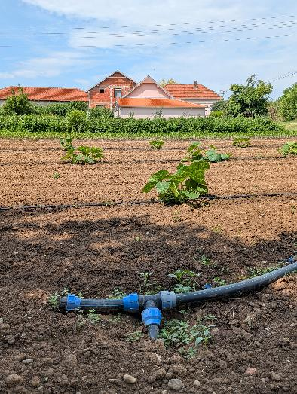
Figure 7-8 Example of irrigation from nearby river

Transport infrastructure
The pipeline corridor generally follows parallel to transport infrastructure, including the A1 major highway, numerous smaller roads and agricultural road networks and the rail line connecting Trupale and Pojate, which passes within around 500 m of the pipeline near Trupale.
The planned High Speed Rail (HSR) Belgrade to Niš directly crosses the existing gas pipeline infrastructure at the following locations: 155+788, 155+791 –155+985, 158+955, 162+505, 164+510, 165+789, 166+143 - 166+615, 167+180, 167+215 - 167+313, 167+350 –167+950, 168+148, 169+100 - 169+265, 169+450. The proposed HSR does not cross the alignment of the TP Pipeline.

Biological Environment
Serbia hosts disproportionately high biodiversity relative to its territory (1.9% of European land area), including 39% of European vascular plant species, 51% of freshwater fish species, 74% of bird species, and 67% of mammal species. 462 protected natural areas cover approximately 5.91% of Serbian territory (Ministry of Environmental Protection, 2015).

Protected Areas and Key Biodiversity Areas
The Republic of Serbia, through the Ministry of Environmental Protection and the Institutes for Nature Conservation of Serbia and Vojvodina, has been working on identification and designation of the Natura 2000 network for several years now.
One of the main and important requirements that accession countries have to prepare in the Natura 2000 network, is a list of sites designated by each Member State in the framework of two European Directives: the Birds and the Habitats. The European Union Delegation of Serbia is supporting the Ministry of Environmental Protection and Institutes on this task.
The implemented project “EU for Natura 2000 in Serbia”, through five big results, has provided to the Republic of Serbia the first list of potential sites Natura 2000 (SPAs and SCIs) with an information data system, database and GIS for Natura 2000 developed, besides a harmonization of Serbian legislation with EU Directives related to nature protection.
The Emerald Network is part of the Bern Convention (officially known as Convention on the Conservation of European Wildlife and Natural Habitats) with the adoption of Recommendation No. 16 (1989) of the Standing Committee and implemented by the Council of Europe. It is an ecological network made up of Areas of Special Conservation Interest (ASCIs).
The following protected areas and sensitive zones have been identified in proximity to the corridor through desktop review:
- Dobrič-Nišava IBA (RS048 – globally recognised and RS063 alternate numbering in early inventories that is still used in national datasets): BirdLife International Important Bird Area, 35,389 ha, qualifying under criteria B1b and B2a. Approaches the southern end of the corridor near Trupale. All route deviations in this section require screening against IBA boundaries.
- Juhor Forest Massif: ecologically significant forested area flanking the western side of the Morava valley in the mid-corridor section (approximately km 25–60). Not formally designated but significant for woodland bird species and mammal connectivity. The pipeline is expected to pass its eastern edge. Requires confirmation through baseline survey.
- Osredak Special Nature Reserve (SNR): small wetland reserve (246 ha, established 2020) in the West Morava valley, approximately 25 km west of the route. No direct intersection expected but may be a receptor for water quality impacts from river crossings.
- Stalać Fortress: Cultural Monument of Great Importance at the Morava confluence, 8km from the northern end of the Phase 1 route. Relevant to cultural heritage assessment.

Key data gap: the Institute for Nature Conservation of Serbia’s Emerald Network geodatabase must be overlaid in detail against the pipeline route using GIS to confirm presence or absence of designated areas. This is a required action in the ESIA ToR.
The alignment was screened for potential protected sites or sites designated as part of Serbia’s accession to the EU – Natura 2000.
The existing gas pipeline, as well as the proposed parallel pipeline alignment, crosses the proposed Special Protection Area (pSPA) and Important Bird Area (IBA) Dobrić–Nišava (IBA RS063) near the confluence of the Toponička River with the Južna Morava River. This section is located in the north-eastern part of the designated site.
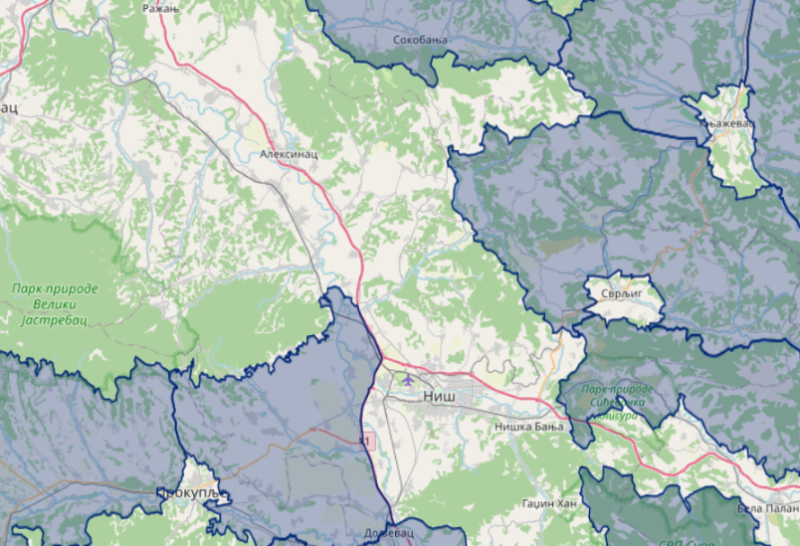
Figure 7-9 pSPA and IBA near the pipeline
Within a 10 km buffer around the Project, a further seven proposed Natura 2000 sites have been identified, including one additional pSPA (IBA) a few proposed Sites of Community Importance (pSCIs).
pSPA (IBA) Dobrić–Nišava: The proposed Special Protection Area (pSPA) and Important Bird Area (IBA) Dobrić–Nišava covers approximately 35,389 ha and was identified as an internationally important site for bird conservation. The designation is based on the presence of 50 Natura 2000 bird species and more than 110 additional recorded bird species.
The site is characterised by an agricultural landscape interspersed with rivers, streams, villages, gravel pits and small wetlands, providing suitable habitats for numerous breeding and migratory bird species. It supports internationally significant breeding populations of Grey Partridge (Perdix perdix) and Black-headed Bunting (Emberiza melanocephala), which are among the trigger species for its designation.
Given that both the existing and the proposed gas pipeline alignments cross this pSPA/IBA, a detailed ornithological assessment will be undertaken during the ESIA to determine potential impacts and define appropriate avoidance and mitigation measures.
Unlike most other proposed Natura 2000 sites identified within the wider Project Area, the proposed pSPA/IBA Dobrić–Nišava is directly crossed by both the existing gas pipeline and the proposed parallel pipeline alignment. Consequently, this site has been identified as a key biodiversity receptor and will be a primary focus of the biodiversity assessment (and World Bank ESS 6) during the ESIA.
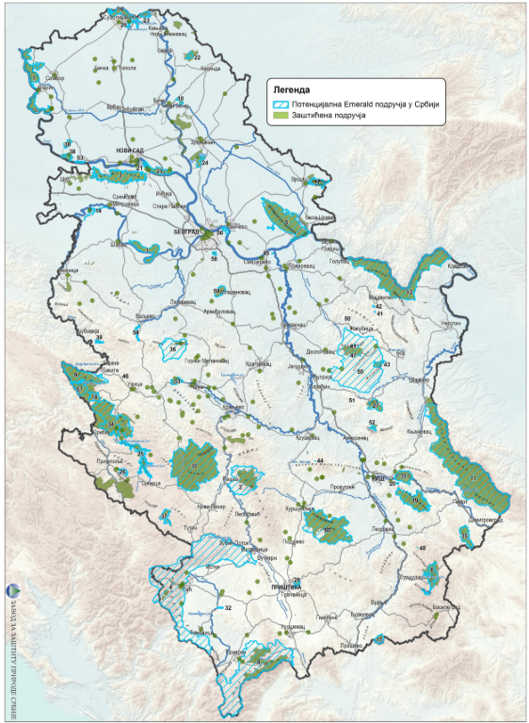
Figure 7-10 Potential Emerald Network
Figure 7-8 illustrates the known biodiversity areas within the wider study area. There are two main sites, namely Juhor Forest Massif (Western Flank) and Dobrič–Nišava Important Bird Area (IBA RS063).

Figure 7-11 Biodiversity Areas in the wider study area
Two Natural Monuments, Rajković's Oak and the Pedunculate Oak (Quercus robur) in Donja Trnava, both classified as within IUCN Category III protected areas and recognised as features of cultural as well as ecological significance, are located in the immediate vicinity of the proposed gas pipeline alignment. These protected trees represent outstanding mature specimens of exceptional age, size, and landscape value. During the ESIA preparation phase, a detailed assessment of potential project impacts on these natural monuments will be undertaken. Based on the findings of this assessment, the need for route refinement or other appropriate avoidance and mitigation measures will be evaluated to ensure that adverse impacts are avoided or minimized.
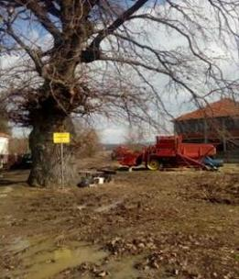  Figure 7-12 Protected monument Rajkovicev and Hrast Luznjak u donioj Trnavi | 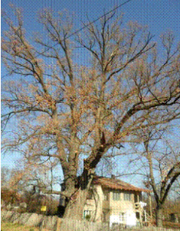

Habitat types along the route
The habitat types are heavily influenced by the landscape and land use along the route. Irrigated agriculture (cereals) and orchard fruits are cultivated throughout pretty much the entire alignment, taking advantage of the rich, fertile soils of the Morava floodplain. Within these expansive areas there are a large number of small forest groves in non-farmed areas and along smaller water courses and irrigation canals, many of which dry up in Summer.
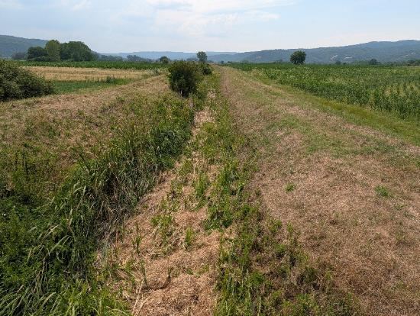
Figure 7-13 Typical channel and crops either side
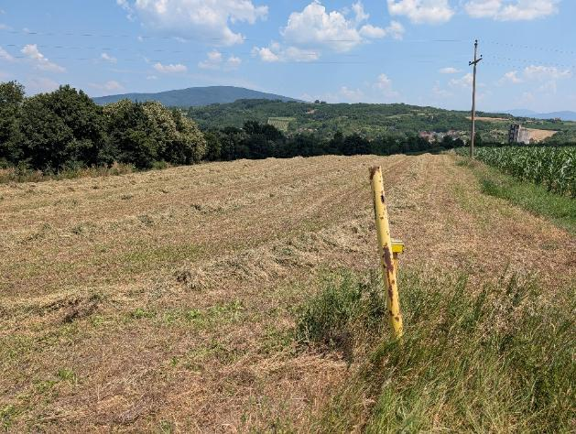
Figure 7-14 Typical cultivated land with Yugorozgas pipeline marker
Larger sections of riparian marshy vegetation, scrub and trees area associated with the margins of the Morava river and there are ox-bow lake sections where the river has changed its course within the floodplain. The area where the pipeline crosses the Morava river is predominantly cultivated with only small areas of trees or scrub forest.
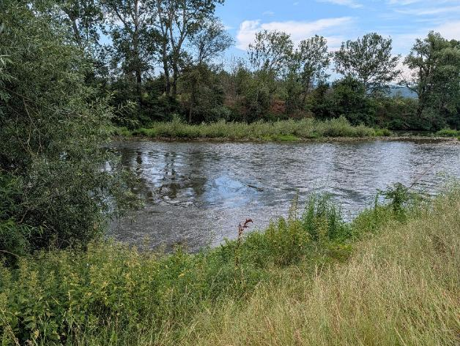
Figure 7-15 View across Morava River
The main change from agriculture lies to the west of Razanj, where the alignment traverses, for over 15km distance, a steep section of terrain that is predominantly forested. The Yugorozgas pipeline has been routed uphill and through the steeper forest areas, whereas the TP alignment has been selected by Srbijagas/Gas Infrastructura to take a lower level alignment towards the main highway, thus avoiding the majority of valuable forest habitat.
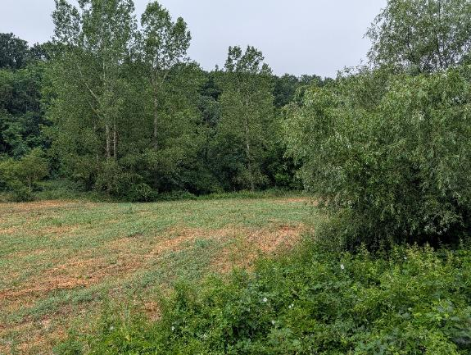
Figure 7-16 View towards forested hills near Razanj

Environmental and Social Standard 6 (ESS6):

Introduction
Environmental and Social Standard 6 (ESS6): Biodiversity Conservation and Sustainable Management of Living Natural Resources requires the Project to protect and conserve biodiversity, maintain ecosystem services, and promote the sustainable management of living natural resources. The TP gas transmission pipeline traverses a landscape comprising agricultural land, riparian corridors, forested slopes, and designated biodiversity areas. The ESIA will assess potential impacts on habitats, species, and ecosystem services (see below) and will apply the mitigation hierarchy to avoid, minimize, restore, and where necessary offset residual impacts.
The requirements of ESS6 are presented within the ESIA ToR in Section 9 and is briefly summarised below.
The Project will comply with ESS6 by:
- Avoiding major biodiversity impacts through route selection and HDD/trenchless crossing
- Conduct Critical Habitat Screening to flag whether the proposed pipeline corridor may intersect any likely/potential Critical Habitat under ESS6, and to prioritise avoidance, rerouting, or more detailed field assessment.
- Conducting robust seasonal baseline surveys, including an ecosystem services dependency assessment.
- Applying the mitigation hierarchy.
- Preparing a Biodiversity Management Plan.
- Implementing restoration and, if necessary, offsets.
- Ensuring no net loss and where required, net gain of biodiversity values.

Socio-Economic Characteristics
The corridor traverses a predominantly agricultural landscape. The ROW is described in the World Bank ESRS as extensively cultivated with cereal crops. The social assessment for the ESIA shall also capture any use of rivers near planned crossings in terms of fishing for cultural, recreational, and subsistence purposes, as well as other ecosystem-dependent livelihoods. The following socio-economic characteristics are relevant:
- Land use: predominantly cereal agriculture (wheat, maize); some market gardens and orchards may be present
- Land tenure: predominantly private ownership; cadastral data needs to be confirmed along the full corridor
- Municipalities: Niš (major urban centre, approx. 250,000 population); Aleksinac (approx. 55,000); Ćićevac (approx. 20,000); Pojate area (smaller rural settlements)
- Ćićevac is a town and municipality located in the Rasina District of central Serbia. According to the 2022 census, the population of the town is 3,902, while the population of the municipality is 7,860. The municipality lies in the confluence area of the Južna and Zapadna Morava rivers and gravitates towards Kruševac as its regional centre. Its economy is predominantly agricultural, based on arable and cereal cultivation on small and medium family holdings in the Morava valley. Under Serbia’s official classification of local self-government units by level of development, Ćićevac falls in the third group (a development level in the range of 60–80% of the national average) and, like much of the region, is affected by depopulation and an ageing rural population.
- Ražanj is a village and municipality located in the Nišava District of southern Serbia. The municipality consists of 23 settlements, having a total population of 7,010 inhabitants, with 1,138 inhabitants living in Ražanj itself (2022 census). The municipality covers an area of 289 square kilometers, and it is located 50 kilometers (31 mi) northwest of Niš. It is the smallest and most rural of the affected units, with a very low population density of roughly 24 inhabitants per square kilometre across its dispersed settlements, and its local economy is dominated by small-scale agriculture. Ražanj is classified in the fourth — extremely underdeveloped — group of Serbia’s official development classification (below 60% of the national average), and pronounced depopulation, an ageing population and limited local services mean that affected households are more likely to include elderly and low-income persons who depend on Aleksinac, Niš or Kruševac for higher-order services.
- Aleksinac is a town and municipality located in the Nišava District of southern Serbia. According to the 2022 census, the municipality has a population of 43,258 inhabitants. Covering approximately 707 square kilometres, it is the largest and most urbanised of the three municipalities, with a historic coal-mining tradition in the Aleksinac basin alongside a substantial rural and agricultural population. Notwithstanding its size, it is classified in the fourth — extremely underdeveloped — group of Serbia’s official development classification (below 60% of the national average), reflecting long-term industrial decline and comparatively high unemployment. Both farming households and the town economy are therefore relevant to livelihood and vulnerability considerations under this framework.
- The City of Niš is the third-largest city in Serbia and the administrative centre of the Nišava District. According to the 2022 census, the city proper had a population of approximately 182,800 and the wider administrative area approximately 260,200 inhabitants. Niš is the administrative, economic, commercial, financial, educational and healthcare hub of south-eastern Serbia, with a comparatively diversified economy spanning electronics, mechanical engineering, textiles, tobacco and food processing, together with a free economic zone and an international airport.
- Physical displacement: not anticipated; economic displacement from temporary restriction of agricultural land use during construction and permanent easement restrictions during operation is the primary social risk
- Vulnerable groups: to be identified during socio-economic baseline study; may include elderly landowners with limited income diversification, informal land users without formal title, and female-headed households
- Legacy: the 1995–2003 pipeline was constructed through the same corridor; any unresolved compensation or land issues from that construction require due diligence

Land Use and Ownership
The pipeline corridor traverses a predominantly agricultural landscape in the Južna Morava valley, with the right-of-way extensively cultivated with cereal crops across the municipalities of Niš, Aleksinac, Ćićevac, and the Pojate area. Land use and ownership risks arise across three distinct temporal phases of the project: pre-construction land acquisition, construction-phase restrictions on access and use, and permanent operational easements.
Under Serbian law, land acquisition for linear infrastructure proceeds through three distinct mechanisms: full expropriation (transfer of ownership); incomplete expropriation (establishment of a right of use over a defined corridor without transfer of title); and servitude or easement registration. Each mechanism carries different procedures, compensation rules, and cadastral requirements.
The construction right-of-way (ROW) for a high-pressure pipeline of this type is typically 30 m during construction. During operations there are three zones defined by the regulations:
- The Protective Zone: This is the widest zone and extends 200 meters to the left and right of the pipeline centreline, regardless of pressure and diameter. The wall thickness of the pipe is determined based on factors derived from the number of structures within this zone.
- These next two zones depend on both diameter and pressure:
  - The Restricted Building Zone: This defines the area where future construction will be prohibited. For this diameter and a pressure up to 55 bar, it is 30 meters on each side of the pipeline centreline. If the pressure is 75 bar, the width of the zone is 75 meters on both sides of the pipeline centreline.
  - The Exploitation Zone / Maintenance Strip: This is the area where planting trees and performing any works other than agricultural activities is prohibited: For this diameter and a pressure up to 55 bar, it is 7.5 meters on both sides of the pipeline centreline. If the pressure is 75 bar, the width of that zone is 15 meters on both sides of the pipeline centreline. A new regulation is currently being drafted, which will reduce these two zones for pressures over 55 bar. Specifically, the distinction between pipelines over and up to 55 bar will be eliminated, meaning that once adopted, the smaller zones will apply to both cases.
Serbian expropriation and land law does not provide compensation for the loss of income-generating use of land subject to an operational easement beyond the capitalised market value of the restriction; this creates a significant gap with the requirements of ESS5, which requires full livelihood restoration regardless of the legal mechanism applied.
Physical displacement of households is not anticipated for Phase 1: the route has been developed to follow the existing 1995–2003 pipeline corridor, and deviations have been introduced specifically to avoid settlements that have grown up close to the old alignment. However, the scale of economic displacement — meaning impacts on livelihoods and income from disruption to agricultural land use — is not yet known and will be determined through the land acquisition census and socio-economic survey required under the RAP process. Based on the nature of the corridor (predominantly cereal cultivation over approximately 62 km), temporary economic displacement from construction and permanent income impacts from operational easement restrictions are the primary social risks for Phase 1. Seasonal timing of construction is relevant: the main cereal growing season in this part of Serbia runs broadly from April to September, meaning that construction activities during this window will intersect with active cropping and could result in crop losses requiring compensation.
Land ownership in the corridor is characterised by a mix of formally registered private parcels, state-owned land, and informally occupied or used land. It is anticipated that some land users — particularly smallholders farming parcels that may not match the cadastral record precisely — will not hold formal title or documentation to establish their rights. Under ESS5, informal users and those without formal title are entitled to the same consideration as formally titled owners for income and livelihood impacts arising from temporary construction restrictions and must be included in the RAP census and compensation framework. This requirement is not recognised under Serbian expropriation law and the gap must be explicitly addressed in the Resettlement Policy Framework (RPF) and subsequently in the Phase 1 RAP.
Updated cadastral data for the full 62 km corridor is not yet available and constitutes a key data gap required to be filled in the ESIA process. The RAP process will require a full census of affected land parcels and users, asset valuation aligned with ESS5 replacement cost principles, and a livelihood restoration strategy addressing both temporary and permanent income impacts.

Health
The health baseline of the corridor communities has not yet been formally assessed along the municipalities traversed. Available national data for the Nišava and Rasina districts suggests patterns broadly consistent with the wider southern and central Serbian context: above-average rates of population ageing and outmigration of working-age adults, limited secondary healthcare capacity outside Niš, and relatively high rates of cardiovascular disease and respiratory conditions. These factors are relevant to the baseline against which construction-phase health impacts will be assessed.
Construction of the pipeline will introduce a range of potential health impacts on communities along the route. Dust and particulate emissions from earthworks, trenching, pipe stringing, and vehicle movements on unpaved access roads will affect communities closest to the working strip, particularly where the route passes within 30 m or less of residential buildings, as has been flagged at several locations during the site visit. Exhaust emissions from a large fleet of heavy construction vehicles and machinery will add to localised air quality loading. The magnitude of these impacts will depend on meteorological conditions, the proximity of sensitive receptors, the duration of construction activities at any given location, and the effectiveness of dust suppression and traffic management measures.
Noise and vibration from construction plant, including excavators, side-boom tractors, welding equipment, and compressors used during hydrotesting, will affect communities within the zone of influence of the working strip. The corridor passes through a number of settlements where the pipeline runs close to residential buildings, and baseline noise surveys at sensitive receptors, combined with impact modelling, will be required to assess whether construction activities would breach applicable Serbian noise standards and World Bank EHS Guidelines limits. If (perhaps unlikely) rock excavation or blasting is required in the steeper terrain sections around Razanj, noise and ground vibration impacts could extend considerably further, potentially up to several hundred metres.
Construction traffic on rural roads connecting the ROW to the national road network will increase HGV movements significantly in communities along haulage routes, with associated risks of road accidents, road surface deterioration, and community severance. The pipeline alignment crosses roads and a major highway, creating temporary access restrictions during crossing operations for the smaller roads, as all major roads and tarmac roads should be crossed trenchless. Traffic management risks are particularly relevant in the vicinity of schools, health centres, and at the cemetery identified during the site visit as lying close to the alignment.

Cultural Heritage
Serbia has high archaeological site density, particularly along river terraces and at elevated points with strategic visibility. From desktop studies the main archaeological feature within the wider study context of the pipeline is the Stalać Fortress, which sits roughly 8 km west of the TP pipeline corridor. As such it is located outside the cultural heritage Area of Influence (AoI), however cultural heritage aspects should be further researched in the ESIA and include consultation with the Institute for Cultural Monuments. Communities along the corridor shall be consulted on sites of cultural, spiritual, or social importance to them, including heritage trees, the cemetery, the church, and any access restrictions that may arise during construction works.

Baseline Data Gaps
The following data gaps have been identified, each should be addressed in the ESIA:
- Cadastral data: updated cadastral information along the full 62 km corridor is needed for the land acquisition census
- Cultural heritage registry: walkover survey with the Institute for the Protection of Cultural Monuments has not yet been conducted community consultation to identify sites of local cultural or spiritual importance should also be carried out as part of the walkover process
- Seasonal biodiversity data: no field surveys have been conducted; surveys must be scheduled to meet seasonal windows and will also yield data for the ecosystem services study component.
- Hydrology and flood risk: detailed hydrological data for watercourse crossings, including flood frequency analysis and HDD feasibility assessments
- OP 7.50 (International Waterways) screening: the Morava River system, which is a tributary of the Danube River, and thus an international waterway, requires consideration to determine whether OP 7.50 applies. At this Scoping stage it is considered that the Policy may not apply given the circumstances of the construction and operation of the pipeline and the considerable distance to the border.
- Socio-economic baseline: no formal socio-economic and health survey of the corridor communities has been undertaken.

Identification of Potential Risks and Impacts

Introduction
The potential risks of this preliminary route were identified by analysis of satellite and topographic mapping and a number of features were selected prior to the visit of 30/6/2026 to 2/7/2026. During the site visit it was not feasible to walk/drive along the entire route to evaluate all of the possible features, but priority was given to the two major crossings of the Morava river; crossing of smaller rivers/irrigation channels; proximity to households, buildings, a cemetery and built infrastructure including major highways and tele-communication towers.
The tables below present a list of the main potential environmental, socioeconomics and cultural heritage impacts for the pipeline and presents the following information:
- Impact Area: list of impact areas intended as the environmental, socioeconomic and cultural heritage component potentially affected by the project’s activities;
- Potential Impacts of Significance: list of types of impact or sources of impacts that could occur from the project on the basis of information currently available (project design and baseline). The magnitude and significance of the impacts will need to be ascertained during the detailed impact assessment;
- Area of Influence: the geographical area which could be potentially affected by the impact. The definition of the area of influence is to be intended as indicative. The extent of the area of influence will need to be ascertained during the detailed impact assessment;
- Mitigation Options: list of types of mitigation and control measures that may be considered where significant impacts are identified during the assessment.
With regards to the Area of Influence the following criteria has been adopted:
- Local – impacts that affect local environmental, socioeconomic or cultural heritage resources or are restricted to a single habitat/biotope, a single (local) administrative area or a single community. Although considered local, the geographical extent of each impact within this category can be variable, depending on the impact type and location. Local impacts may be restricted to the Right of Way (RoW, 30 m wide), and areas directly affected by the AGIsand any temporary works (e.g. access roads, laydown camps and pipe yards), however there will be local impacts that extend beyond but are still within the local context (e.g. within hundreds of meters or further from the RoW). Orders of magnitude of distances for each local impact are presented in the following tables. Given the occurrence of mining activities in Aleksinac, information on mining activities will be obtained; albeit it is unlikely given the presence of the existing pipeline and its associated safety zones that prevent certain developments.
- Regional/Provincial – impacts that affect regional environmental, socioeconomic or cultural heritage resources or are felt at a regional scale as determined by habitat type, administrative boundaries or community. Tentatively the geographical extent of regional impacts will be up to tens of kilometres.
- National – impacts that affect national environmental, socioeconomic or cultural heritage resources or affect an area that is nationally protected/important. Tentatively the geographical extent of national impacts will be up to hundreds of kilometres.

Environmental and Social Resources and Receptors
From visual inspection during the site visit, the Environmental and Social Consultants, focussed on several pre-identified features; these sites and the analysis during the site visit are presented in Annex A.
From an environmental perspective the main sensitive receptors include:
- Morava River crossings. These will most likely be traversed by HDD, with the drive and receptor pits located typically over 300m either side of the river channel and all construction plant and equipment such as bentonite/drilling fluid mud lagoons, generators, pumps and control equipment sited well outside of the river defence bund and therefore largely protected from any direct river flooding. Therefore significant adverse environmental effects are not anticipated. However, there are inherent risks associated with HDD, which include drilling fluid break out, which could potentially adversely affect surface or ground waters. Other techniques such as Direct Pipe have much lower inherent risks due to the microtunnel approach.
- Crossing of a number of smaller rivers and modified river channels/irrigation watercourses. Due to the variable water flows and often modified flow regimes and water abstraction these areas support vegetation (Phragmites, Typha, Iris etc) that is resistant to disturbance and can therefore be expected to return following reinstatement, with little or no adverse impact on ecology. Species of amphibia and many bird were observed during the visit and these require evaluation in the ESIA.
- Forest habitat mainly associated with the steep forested area west of Razanj and small pockets in between cultivated land and alongside water courses. The valuable forest habitat on the steeper hillsides is to be protected by selection of a route through the flatter ground to the east alongside the A1 highway. It should be feasible to undertake construction using a reduced width ROW to reduce tree loss, with pre-fabricated sections tracked in for ditching into the trench.
From a social perspective the main sensitive receptors include:
- Agricultural land users and smallholders farming the corridor's cereal cropland, particularly those without formal title, whose incomes depend on land currently subject to temporary construction restrictions and permanent operational easements.
- Households and residents of settlements where the alignment passes close to buildings (in places less than 30 m), including the cemetery identified during the first site visit, who may experience construction-phase noise, dust, vibration and traffic impacts.
- Vulnerable groups within corridor communities, including elderly landowners with limited income diversification, informal land users without formal title, and female-headed households, who may be disproportionately affected by economic displacement, and those whose livelihoods depend on access to local ecosystem services (e.g. firewood, grazing, fishing, medicinal plants..
- Communities and individuals potentially affected by legacy compensation or land issues from the 1995–2003 pipeline construction along the same corridor.

Environmental and Social Risks and Impacts, Scoping In/Out
A scoping report defines the focus of the subsequent Environmental and Social Impact Assessment (ESIA). Its core function is to ensure that the assessment concentrates on the issues that matter most; those with a realistic potential to experience significant change as a result of the project, while avoiding unnecessary analysis of topics that are irrelevant or of negligible consequence.
The methodology has been presented in this report, collecting information on the full range of potential environmental and social issues, before determining the possible interactions with the project, taking into consideration:
- The nature of the project activities
- The sensitivity of the receiving environment
- The scale, duration, and reversibility of potential impacts
- Legal and regulatory requirements
- Stakeholder concerns
- International standards (e.g., World Bank ESF, IFC Performance Standards).

Construction phase

Table 8-1 Potential Environmental Impacts and Mitigation
Impact Area | Potential Impact/Source | Area of Influence | Potential preventative measures/mitigation
Resources and waste | - Use of large quantities of construction material  - Disposal of construction waste  - Transportation of construction material and waste through villages  - Consumption of fuel by vehicles and machinery  - Sewage (black and grey water) management and disposal  - Use of water for construction activities, camps, yards  - Use of water for pre-commissioning (hydrotesting) | - Local to Regional, depending on impact and specific location of waste disposal sites and origin of construction material and fuel | - Materials to be sourced and disposed of with sustainable procurement principles and from as close as possible to the project so as to minimise impacts of production and transport.  - Identify beneficial uses or opportunities for recycling any construction spoil and other wastes wherever possible.  - Waste management plan and system to be implemented  - Environmental and social management plan  - Evaluation/assessment of water sources and discharge for hydrotesting so as to minimise impacts to other water users and aquatic habitats
Geology, Soils and Contaminated land | - Excavation works during construction including off-site quarrying where needed (block valve)  - Clearance of working strip, logistic sites (yards, camp sites) and any access roads will affect top soil with the risk of resource loss  - Physical damage through soil compaction especially in alluvial agricultural areas and accidental contamination should also be considered (see also resources and waste).  - Contaminated sediments from past activities  - Potential flood season March-May main season but second flooding can occur outside of this window. | - Local, within working strip (30 m) and the footprint of associated facilities (valve station)  - Impacts from contaminated sediments will be Local or Regional depending on the location of the waste disposal sites  - Floodplain habitats, river ecosystem, could spread pollution from any plant and equipment left in the floodplain | - Construction site management plan  - Preservation of topsoil  - Reinstatement of topsoil following completion of construction activities  - Oil & Chemicals Spill Contingency Prevention & Planning  - Detailed route investigations to avoid any contaminated areas  - Safest construction window on the floodplain: July–October (after spring floods subside, before autumn rains). Flood risk assessment and consideration of flood bund alongside Morava.  - Plan work carefully to avoid flood season and have a system to monitor river levels and take action to clear the working area accordingly.
 | - Impacts to aquatic habitats, water quality & river morphology from river crossings of the ROW and any new access roads | - Impacts to river morphology will be local and typically within the working strip (30 m). Impacts to water quality will depend on the river/channel to be crossed but could extend hundreds of meters downstream of the crossing | - Minimise number of river crossings and select crossing locations in order to minimise impacts to riparian vegetation and to the river channel and habitat  - Select working window to minimise impacts on aquatic species and/or when channels are dry  - Monitoring of water quality – Environmental Monitoring Plan  - Reinstate channel, banks and riparian vegetation to preconstruction status  - Audit management and reinstatement  - Alternative construction techniques to open cut trenching and backfilling (e.g. Horizontal Directional Drilling, trenchless techniques)
 | - Sediment plumes from working strip, yards, camps and access roads due to rainwater runoff | - Local, specific distances depend on local conditions. Could be up to a kilometre downstream of the discharge location | - Erosion control on ROW.
Air Quality and Climatic factors | - Dust generated from earth movements, excavation, vehicle movement, stockpiles and unpaved surfaces along the working strip, access roads, yards and camps; emissions to the atmosphere from machinery and vehicles such as generators, excavators, bulldozers, side booms, trucks, cars and compressors for hydrotesting. | - Local, typically within 100 m of the working strip and any facilities, and in some conditions up to hundreds of metres. Greenhouse gas effects are global. | - Apply good construction site management practices such as covering loose materials, vehicle speed limits, watering dusty surfaces in dry weather and sheeting trucks; implement an environmental and social management plan; maintain equipment and vehicles; route construction traffic away from sensitive areas; train operators and drivers; avoid routing traffic through densely populated areas or historic centres; implement a traffic management plan; use low-sulphur fuels where available; model pollutant dispersion from main emission sources; monitor main emission sources under the environmental monitoring plan.
Noise and Vibration | - Noise and vibration from machinery, construction vehicles, blasting of rock if required, and compressors for hydrotesting, affecting residents, sensitive receptors such as schools and hospitals, potentially vulnerable persons (including the elderly) workers, fauna, and cultural or historic buildings. | - Local, depending on source and conditions. Machinery and vehicles typically affect areas from the working strip up to hundreds of metres away. Blasting effects may extend up to 10 km. | - Use good construction site management; limit working hours near sensitive receptors; apply mitigation to noisy equipment such as acoustic shielding; locate noisy equipment away from noise-sensitive receptors; impose vehicle speed limits; provide adequate personal protective equipment for workers; model main noise emission sources; monitor main emission sources under the environmental monitoring plan; implement an environmental and social management plan.
Biodiversity and Natural Habitats | - Habitat loss, both temporary and long-term or permanent; impacts on fauna and flora species of conservation interest from project activities such as noise, aqueous discharges, sediment plumes, water abstraction for hydrotesting, and increased human pressure on previously inaccessible areas, especially in nesting areas, old-growth forests, wetlands, rivers, riparian vegetation, and areas rich in endemic and protected species. | - Local, primarily within the working strip (40 m) and associated facilities, though impacts may extend to hundreds of metres in unfavourable conditions and up to around one kilometre for water quality and aquatic habitat effects. | - Select routes and associated infrastructure locations carefully; consider alternative construction techniques such as horizontal directional drilling; minimise footprint wherever possible; restore pre-construction conditions as far as possible, including revegetation under a vegetation and landscape restoration plan; manage dust, air emissions, aqueous discharges and waste to minimise impacts on ecosystems; restrict construction during certain periods or seasons in sensitive areas; monitor impacts on flora and fauna at sensitive locations under the environmental monitoring plan; implement an environmental and social management plan; develop a Biodiversity Management Plan for the life of the project, including action plans for important species and habitats; relocate endemic or rare plant species to suitable nearby habitats where necessary.
Landscape and Visual Impacts | - Temporary and permanent landscape and visual impacts from land take and above-ground structures. Temporary impacts arise from the working strip, camps and yards until reinstatement after construction. Potentially significant impacts may occur on mountain ridges, elevated terrain, and old-growth or mature forests. | - Local, and in certain circumstances regional, with visibility effects extending up to 10 km depending on local conditions. | - Minimise footprint wherever possible; restore pre-construction conditions as far as possible, including revegetation under the vegetation and landscape restoration plan; apply visual mitigation measures where necessary, including for valve station; locate new roads, temporary accesses and camps away from sensitive landscape locations.

Table 8-2 Potential Socioeconomic Impacts and Mitigation
Impact Area | Potential Impact/Source | Area of Influence | Potential preventative measures/mitigation
CONSTRUCTION
Labour and Working Conditions | Risk of failure to meet minimum wage, fair remuneration, and contractual requirements for all worker categories (direct, contracted, and supply-chain workers).  Risk of informal or verbal-only employment arrangements leaving workers unable to assert rights or access the workers’ grievance mechanism.  Risk of inequitable treatment between local Serbian workers and international specialist contractors in pay, accommodation, and grievance access.  Risk of child or forced labour in subcontracting and supply chain arrangements where oversight may be more limited.  Risk of non-compliance with freedom of association and collective bargaining rights, particularly among migrant workers. | Local – primarily affecting the construction workforce along the 62 km corridor and associated facilities (camps, yards, laydown areas).  Supply-chain risks may extend regionally or nationally depending on sourcing of materials and subcontractors. | Prepare and disclose a Labour Management Procedure (LMP) covering all worker categories before construction commences; address terms and conditions, OHS requirements, and a dedicated workers’ grievance mechanism separate from community channels.  Develop and enforce a Code of Conduct applicable to all workers with defined consequences for violations, including specific provisions on SEA/SH.  Include child and forced labour risk screening in supply chain due diligence.  Address the gap between Serbian labour law and ESF requirements (ESS2) in the LMP, including provisions for workers without formal contracts.  Monitor LMP implementation through contractor ESMP provisions and Owner’s Engineer oversight.
Worker Health and Safety | Risk of injuries from deep trench excavation including collapse in alluvial soils of the Južna Morava valley floor where groundwater may be close to the surface.  Risk of gas release, fire, or explosion from accidental damage to the live existing pipeline during construction activities including excavation and HDD.  Specialist OHS risks from HDD at major watercourse crossings (Južna Morava x2): drill-string failures, drilling fluid pressure hazards, frac-out.  Hot work risks (welding, cutting) and ionising radiation risks from radiographic NDT.  Road traffic and heavy plant collision risks for workers on the ROW and at access road interfaces.  Heat stress risk during summer construction (temperatures regularly exceeding 35°C in July–August) and cold exposure in winter. | Local – primarily affecting the construction workforce within the ROW (30–50 m) and associated facilities.  Live pipeline risks extend along the existing corridor; gas release scenarios could affect an area extending up to several hundred metres depending on conditions. | Prepare an OHS Risk Assessment and contractor HSE Management System before construction, including Job Hazard Analyses (JHAs) for all high-risk activities.  Implement permit-to-work systems for all activities near the live pipeline, with gas detection, safe working distances, and clear demarcation of the existing pipeline alignment.  Require specialist OHS protocols for HDD operations in addition to standard pipeline construction procedures.  Enforce hot work permit systems and radiological safety management with defined exclusion zones.  Implement a Traffic Management Plan (TMP) and workforce road safety training.  Provide appropriate worker welfare facilities including heat stress management and cold weather provisions per World Bank EHS Guidelines and ESS2.  Monitor OHS performance throughout construction and report under the ESCP schedule.
Community Health and Safety – Construction | Physical hazard from open pipeline trench (up to 4 m wide, several metres deep) to community members, children, elderly, and livestock if not adequately fenced throughout the active working strip.  Noise and vibration from heavy construction plant affecting communities at close-proximity receptor locations: several locations identified within 30 m of the alignment during the site visit.  Dust and particulate emissions from earthworks, topsoil stripping, and vehicle movements affecting communities adjacent to the ROW and along haulage routes.  Access severance: the active ROW creates a linear barrier disrupting community access to agricultural land, grazing areas, water points, and community facilities, including a cemetery identified close to the alignment.  Community road safety risk from increased HGV movements on rural roads, particularly near schools and community infrastructure.  Increased demand on local healthcare, policing, and social services in rural municipalities with limited capacity.  Community disruption from worker camps located near settlements. | Local – communities within the zone of influence of the ROW (typically up to several hundred metres for dust and noise) and along haulage routes.  Health service pressure risks may extend to the regional level in areas near worker camps.  Access severance and trench hazards are highly localised to specific crossing points. | Prepare a Community Health and Safety Plan (CHSP) including public exclusion zones, fencing and signage for open trenches, and emergency response procedures.  Conduct baseline noise surveys at flagged close-proximity receptor locations; undertake impact modelling and apply working hour restrictions near sensitive receptors.  Implement dust suppression measures (watering, speed limits, covering of loose materials, sheeting of trucks) on the ROW and haulage routes.  Provide temporary crossing points or managed access to maintain community access to agricultural land and facilities throughout construction.  Prepare and implement a Traffic Management Plan (TMP); consult municipalities and provide traffic awareness information in affected communities.  Provide on-site medical facilities for the workforce to reduce demand on local health services; avoid locating worker camps close to settled communities.  Deploy Community Liaison Officers (CLOs) throughout construction for community interface.
Sexual Exploitation and Abuse / Sexual Harassment (SEA/SH) | Risk of SEA/SH from construction workforce labour influx into predominantly rural corridor communities, driven by income and mobility differentials between incoming workers and host communities.  Risk elevated if workers are accommodated in camps in or near communities, increasing the frequency of worker–community interactions.  Heightened vulnerability of women and girls in small, isolated settlements (particularly between Aleksinac and Ćićevac) with limited access to support services and confidential reporting channels.  Risk of power imbalances between project staff or contractors and community members, particularly in relation to employment and procurement opportunities.  Preliminary significance: Unknown – subject to SEA/SH risk assessment in the ESIA. | Local communities– due to community worker interactions or changes to social determinants and primarily affecting women and girls in communities along the corridor and near any worker camps.  Extent of risk will be confirmed by the SEA/SH risk assessment and labour influx assessment. | Conduct a SEA/SH risk assessment as part of the labour influx assessment in the ESIA.  Prepare and enforce a Code of Conduct applicable to all workers explicitly addressing SEA/SH with defined disciplinary consequences.  Generate a SEA/SH Action Plan.  Design the community GRM with SEA/SH-sensitive features: confidential reporting channels accessible to women and girls without requiring interaction with male project or contractor staff; referral pathways to local survivor support services.  Ensure the workers’ GRM is a separate channel from community channels.  Address the gap between Serbian law and ESF obligations (ESS2, ESS4) on SEA/SH in the LMP, Code of Conduct, and GRM design.  Include SEA/SH awareness training in the worker induction programme.
Socio-Economic Impacts – employment and local economic development | Economic benefits to households and the local economy may arise from direct and indirect job creation during construction. The project may also benefit local communities and the economy through local procurement of construction materials and other services. | Local and regional, especially communes and districts benefiting from employment and procurement opportunities. Effects on infrastructure, customs, norms and safety are expected mainly in the vicinity of the pipeline working strip (30 m), associated facilities such as roads, yards and camps, and areas around compressor stations and block valve stations. Traffic impacts may affect communities living along transport routes, including mountain roads. | Develop an Employment and Procurement Strategy to maximise opportunities for local people and businesses. Maximise local employment during construction, ensure a fair and transparent recruitment process, and strengthen local skills through training. Procure goods locally where possible through subcontracting to local firms and purchasing from local retailers, subject to availability, quality and cost.
Social Service Overload | The presence of workers on site during construction may place pressure on social infrastructure such as water, electricity, roads and health centres, although in the medium to long term it may also contribute positively to infrastructure development. Workers' presence and spending may also affect local customs and norms. |  | Provide adequate social infrastructure for the workforce and facilitate local community access to new infrastructure, especially access roads. Implement the Community Engagement Plan as part of stakeholder engagement. Use Community Liaison Officers to monitor the effectiveness of community relations procedures. Develop and enforce a Workers' Code of Conduct with disciplinary measures. Prepare a community Safety Management Plan covering traffic-related risks, and provide traffic awareness training in schools and communities.
Noise and Disturbance | Construction noise and vibration from heavy plant affecting communities at close-proximity receptor locations, particularly the multiple locations identified within 30 m of residential buildings during the site visit.  Risk of exceedance of Serbian noise standards and World Bank EHS Guidelines limits (55 dB(A) daytime in residential areas) at nearest receptors.  Potential rock hammering noise and ground vibration in hilly terrain around Razanj if rock excavation is required; vibration effects may extend up to several hundred metres. Blasting is considered unlikely but would create risk of cosmetic or structural damage to buildings within the blasting vibration zone of influence. | Local – typically within several hundred metres of the working strip for construction machinery noise.  Blasting vibration effects may extend up to several kilometres depending on geology and topography. | Conduct baseline noise surveys at sensitive receptor locations; undertake construction noise impact modelling before works commence.  Restrict construction working hours near sensitive receptors; apply acoustic shielding to noisy equipment and locate plant away from sensitive receptors where practicable.  If rock hammering or blasting is required: conduct pre-construction building condition surveys within the predicted vibration zone; implement vibration monitoring; establish a complaints and remediation mechanism.  Consider micro-route deviations at the closest residential receptor approaches, subject to ESIA constraints mapping.
Legacy Issues from the 1995–2003 Pipeline | Risk of unresolved compensation claims from the 1995–2003 pipeline construction being reactivated by the new project where the same or adjacent parcels are affected.  Risk of incomplete easement registration from the previous construction creating legal ambiguity about the corridor and current landowner rights.  Risk of community trust deficit from negative prior project experiences reducing the effectiveness of stakeholder engagement. | Local – along the existing 1995–2003 pipeline corridor, broadly coterminous with the Phase I alignment, in the municipalities of Niš, Aleksinac, Ćićevac, and the Pojate area. | Design engagement plans to cater for expectations/resentment potentially linked to legacy issues and explain approach to be followed for the purposes of resettlement and displacement associated with Phase I and the role that the GRM can play.
Cultural Heritage | Risk of encountering previously unrecorded buried archaeological remains during pipeline trenching: river terraces of the Južna Morava system have high archaeological site density from prehistoric to historic periods.  Specific risk at the Stalać Fortress (Cultural Monument of Great Importance) near the northern end of the Phase I alignment: accidental disturbance would be serious and irreversible.  Risk of damage to community-significant but unlisted heritage features (rural cemeteries, wayside religious monuments, vernacular agricultural structures).  Risk of construction delays if unrecorded remains are encountered without a pre-agreed Chance Finds Procedure. | Local – within the ROW and working strip (30 m) throughout the 62 km corridor.  The Stalać Fortress protection zone extent requires specific verification with the Republic Institute for the Protection of Cultural Monuments.  Archaeological sensitivity is elevated along river terraces throughout the corridor. | Conduct a pre-construction heritage walkover survey with Republic Institute for the Protection of Cultural Monuments specialists before any ground-disturbing activities.  Undertake documented stakeholder consultations with local communities, relevant cultural heritage institutions and local authorities, to inform a community-level significance assessment where such sites may be affected, and an assessment of potential temporary or permanent access restrictions.  Undertake further archaeological sensitivity mapping for the full 62 km corridor based on geomorphology, known site distributions, and proximity to watercourses.  Prepare and agree a Chance Finds Procedure (CFP) with the Institute before construction; train all site supervisors and workers in CFP requirements.  Prepare a Cultural Heritage Management Plan (CHMP) including specific provisions for the Stalać Fortress protection zone.  Include identification of community-significant but unlisted heritage in the ESIA stakeholder engagement process.  Comply with ESS8 and Serbian Law on Cultural Heritage throughout construction.
CONSTRUCTION AND OPERATIONS
Land Use Restrictions and Livelihood Impacts | Temporary crop loss and income disruption during construction: the 30–50 m ROW requires clearance of standing cereal crops; construction during the main growing season (April–September) will result in total loss of the season’s yield on affected parcels.  Indirect disruption to irrigation infrastructure, drainage features, and field access tracks serving parcels beyond the immediate ROW.  Permanent operational easement restrictions (10 m, 60 m, and 200 m corridors) constraining future land development options for affected landowners.  Gap between Serbian law (capitalised market value of restriction) and ESS5 (livelihood restoration to pre-project standard of living) for operational easement compensation.  Risk that informal land users without formal cadastral title are excluded from compensation under Serbian expropriation law.  Scale of economic displacement not yet determined – to be confirmed through the RAP census. Physical displacement of households is not anticipated. | Local – within the pipeline ROW (30–50 m construction) and operational easement corridors (15 m (7.5 m either side of the centreline) in which the growing of trees and any vegetation routing down to 0.5m) will be restricted, a corridor of maximum 75 m either side of the centreline in which the construction of houses will be restricted and a corridor of maximum 200 m either side of the centreline in which the establishment of cluster of houses and/or industrial infrastructure is limited..  Indirect agricultural access impacts may extend beyond the ROW to adjacent parcels.  Livelihood and revenue effects are local to the households and communities directly affected. | Prepare a programme-level Resettlement Policy Framework (RPF) and Phase I Resettlement Action Plan (RAP) aligned with ESS5.  Conduct a full census of affected land parcels and users, including informal users, before construction; assess household income dependency on affected parcels.  Apply ESS5 replacement cost standard to compensation; design a livelihood restoration strategy addressing both temporary crop losses and permanent easement income impacts.  Address the gap between Serbian statutory compensation and ESF requirements explicitly in the RPF/RAP.  Plan construction timing to minimise overlap with the growing season where feasible; ensure full compensation for crop losses where unavoidable.  Operationalise the community GRM before land access begins; deploy CLOs to identify and support informal land users.  Reinstate agricultural land to pre-construction condition including topsoil, drainage, and field access tracks.
Disproportionate Impacts on Vulnerable and Disadvantaged Groups | Risk of disproportionate adverse impacts on: (i) elderly landowners with limited income diversification; (ii) informal land users without formal title excluded from Serbian statutory compensation; (iii) female-headed households facing barriers to engagement and SEA/SH exposure; (iv) smallholders with income concentrated on affected parcels; (v) Roma communities with lower rates of title formalisation and limited administrative access; (vi) persons with low literacy or limited mobility unable to engage with written or online consultation processes.  Risk that vulnerable groups are not identified in the RAP census and are therefore excluded from compensation and livelihood restoration.  Risk that consultation processes fail to reach or be understood by vulnerable groups. | Local – affecting vulnerable individuals and households within the corridor communities across all four municipalities.  Vulnerability assessment scope to be confirmed by the ESIA socio-economic baseline study. | Conduct a socio-economic baseline study and household survey to identify and characterise vulnerable groups before the RAP census.  Actively identify vulnerable persons (including informal users) through CLO outreach and include them in the RAP compensation and livelihood restoration framework.  Design engagement with accessible formats for each vulnerable group: in-person visits for elderly and mobility-impaired persons; visual/oral formats for persons with low literacy; confidential channels for women and girls.  Include specific provisions for Roma communities in the SEP and RAP, addressing title formalisation barriers.  Design livelihood restoration measures tailored to the vulnerabilities of affected households; monitor restoration outcomes for vulnerable groups separately.  Train CLOs to support vulnerable persons through the grievance process.
Stakeholder Engagement and Grievance Management | Risk that the gap between Serbian EIA law (disclosure and announcement only) and ESS10 (meaningful two-way consultation with documented feedback loops) results in inadequate community engagement.  Risk of insufficient outreach to rural communities without internet access, elderly landowners, and persons with low literacy.  Risk of GRM inaccessibility to vulnerable groups or absence of SEA/SH-sensitive features.  Risk of community conflict if stakeholders feel uninformed about land acquisition, construction impacts, or grievance resolution.  Risk that stakeholder concerns are not integrated into project design and ESIA findings. | Local to regional – affecting all communities and stakeholders along the 62 km corridor across the municipalities of Niš, Aleksinac, Ćićevac, and the Pojate area. | Prepare and disclose a programme-level Stakeholder Engagement Plan (SEP) before appraisal: stakeholder mapping, accessible formats (written, in-person, telephone/SMS in Serbian), schedule aligned with ESIA and construction timeline.  Design and operationalise the community GRM before any land access or construction: multiple channels; free of charge; timely response commitments; SEA/SH-sensitive confidential channels; separate workers’ channel; quarterly grievance register reported to World Bank; appeals mechanism.  Deploy Community Liaison Officers (CLOs) throughout construction as the primary community interface.  Conduct structured community consultations in all affected municipalities before and during ESIA baseline work.  Establish the Working Group to coordinate spatial planning with World Bank E&S requirements.  Implement a documented feedback loop confirming how stakeholder input has been incorporated into project design.
OPERATIONS
Community Health and Safety – Operation | Long-term community safety risk from a 75-bar high-pressure buried gas pipeline in proximity to residential areas, including risk of third-party interference.  Risk of community conflict from enforcement of operational easement restrictions (15 m tree planting, 150 m residential construction, 200 m cluster development – all centred on the centreline of the pipeline) where restrictions have not been adequately communicated or compensated. | Local – communities within the operational easement corridor and in the vicinity of above-ground infrastructure (block valve stations, pig launcher/receiver facilities). | Consider pipeline rerouting.  Prepare and implement a Pipeline Integrity Management Plan with third-party interference prevention, regular inspection, and emergency preparedness and response plan per ESS4 and World Bank EHS Guidelines.  Ensure operational easement restrictions are clearly communicated to all affected landowners through the RAP, with adequate compensation under ESS5 replacement cost standard before construction begins.  Maintain the community GRM throughout the operational phase to address pipeline safety concerns and easement enforcement disputes.

Operations
As referenced in the above table, potential impacts during operations are expected to be limited:
- Habitat reinstatement – one can expect habitats and species to recover in a reasonable time, following good pipeline practice of reinstatement to pre-construction conditions, especially in any elevated, steep sections, where erosion control measures will be required to prevent subsequent erosion.
- Socioeconomic – predominantly associated with land use restrictions, deep plough, trees, new building limitations etc.

Scoping determination
This evaluation determines whether an issue warrants detailed study in the subsequent ESIA and the outcome of the analysis is presented in Table 8-3.

Table 8-3 Results of Scoping Analysis
Environmental / Social Topic | Scoped In? | Rationale
Population & Human Health | In | Construction traffic, noise, air quality, and land disturbance may affect nearby communities.
Livelihoods and income | In | Temporary loss of income from crop lands and operational land use restrictions.
Ecosystem Services | In | Pipeline construction and operation may affect community access to ecosystem services including firewood, grazing areas, water sources, fishing, and medicinal plants. Ecosystem services dependency assessment required under ESS1, ESS5, and ESS6.
Biodiversity & Habitats | In | Pipeline corridor crosses habitats; potential impacts on protected species and designated sites.
Soils, Geology & Hydrogeology | In | Trenching, HDD, and ground disturbance may affect soil quality and groundwater pathways.
Water Environment (Surface & Groundwater) | In | Watercourse crossings and pollution risks including extensive work within the major Morava floodplain require assessment.
Air Quality & Climate | In | Dust during construction; GHG emissions from construction activities.
Noise & Vibration | In | Construction plant, trenching, trenchless crossing techniques and HDD operations may cause disturbance.
Landscape & Visual | In | Temporary construction compounds and working areas may affect views.
Traffic & Transport | In | HGV movements and road safety impacts during construction.
Cultural Heritage & Archaeology | In | Potential for buried archaeology along the corridor.
Waste & Materials | In | Excavated spoil and construction waste require management.
Major Accidents & Disasters | In | Pipeline integrity and emergency scenarios must be considered.
Seismic activity | In | Seismic risk will be investigated further during detailed design and design measures will be designed, such as ‘slip trenches’ which allow pipeline movement to avoid rupture and accommodate seismic activity.
Transboundary Effects | Out | No plausible cross-border environmental effects identified; considering the major river crossings via HDD.
Operational Noise | Out | Buried pipeline and limited AGI produces negligible operational noise.
Operational Air Quality | Out | No emissions during normal operation of a buried pipeline system.
Shadow Flicker / Aviation / Telecommunications | Out | Not relevant to linear buried infrastructure.

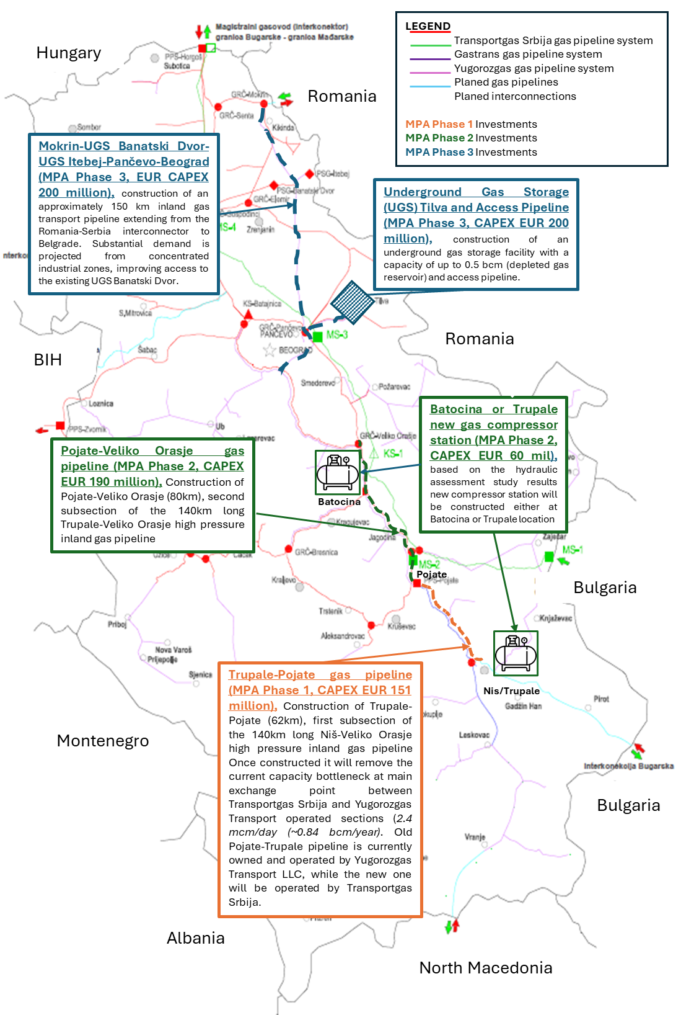
Figure 8-1 Investments supported under the MPA program

Impact Register
The following table presents the preliminary impact register for Phase 1 of the pipeline. This register is indicative and will be developed into a full impact matrix in the ESIA. Significance ratings are preliminary and subject to revision following baseline data collection. Detailed Valued Environmental and Social Components (VEC) identification and the cumulative impact assessment cannot be undertaken at Scoping stage and will be undertaken during the ESIA, supported by field surveys and specialist studies, in accordance with World Bank ESS requirements and Serbian legislation.

Table 8-4 Impact Register
Impact Topic | Phase | Receptor | Preliminary Significance | Key Data Need / Study Required
Soil disturbance and erosion | Construction | Soils, watercourses | Medium | Soil survey; erosion susceptibility mapping; reinstatement plan
Watercourse impacts | Construction | Južna Morava, Toponicka, Velepoljska | Medium–High | HDD feasibility study for large watercourses; drilling fluid management plan; frac-out response plan (drilling fluid management and spill contingency)
Flood risk | Construction & Operation | Communities, infrastructure | Medium | Hydrology study; flood frequency analysis; seasonal construction planning
Air quality (dust) | Construction | Nearby settlements | Low–Medium | Baseline air quality; receptor distances; mitigation commitments
Noise and vibration | Construction | Households within 30 m | Medium | Baseline noise survey; impact modelling at flagged receptors
Biodiversity – habitat loss | Construction | Forest, riparian habitats, IBA | Medium–High | Habitat survey; protected area GIS overlay; seasonal constraints; BMP
Biodiversity – fragmentation | Construction & Operation | Wildlife corridors | Medium | Landscape ecology assessment; reinstatement criteria
Land acquisition – temporary | Construction | Agricultural land users | Medium–High | Census; asset inventory; compensation; growing season planning
Land acquisition – permanent | Operation | Landowners (easement) | Medium | RPF; RAP; livelihood restoration; grievance mechanism
Legacy land issues | Pre-construction | 1995–2003 corridor users | Unknown | Due diligence on prior construction; compensation records review if available
Community health and safety | Construction | Roadside communities, public | Medium–High | CHSP; TMP; trench safety; emergency response; public exclusion zones
SEA/SH risk | Construction | nearby communities, workers | Unknown | SEA/SH risk assessment and service provider mapping to inform SEA/SH Action plan to include Code of Conduct; SEA/SH-sensitive GRM,, mapping, training awareness raising, monitoring and capacity building
Worker health and safety | Construction | Construction workforce | Medium | OHS risk assessment; LMP; permit-to-work; gas detection near live assets
Cultural heritage | Construction | Archaeological sites | Medium–High | Identify archaeological sensitivity zones using national databases, Heritage Authority consultation, and field reconnaissance; Heritage walkover with Institute; chance finds procedure; CHMP
Traffic | Construction | Local roads, communities | Low–Medium | Traffic Impact Assessment; TMP; consultation with municipalities
Waste and hazardous materials | Construction | Soils, watercourses | Low–Medium | Waste Management Plan; spill prevention; drilling fluid management
Pipeline integrity and safety | Operation | Communities along route | Low (residual) | Emergency preparedness; inspection and maintenance plan; third-party interference controls
Cumulative impacts | Construction & Operation | All receptors | Medium | Cumulative impact screening including Phase 2/3 and SOCAR CCGT

Overview of main findings
The preliminary assessment presented in the tables above has been based on the project information currently available: the baseline information collected to date; the site visit of late June-early July 2026; consultations with municipalities; and the consultants’ experience gained in similar projects constructed in similar environmental and socioeconomic contexts.
The likelihood, magnitude and significance of the impacts will be further assessed in the detailed ESIA. However the preliminary assessment highlights that construction impacts of a pipeline and associated facilities are typically temporary in nature and localised. These include temporary noise and air emissions from construction machinery, impacts on land use, loss/disturbance of natural habitats (flora and fauna), landscape and temporary impacts to water quality and aquatic habitats during river crossings and predominantly temporary effects on land use and income generation. The magnitude and significance of construction impacts will depend on the local conditions. Typically, construction impacts can be managed and mitigated efficiently.
The pipeline will be buried and the land will be reinstated to its pre-construction status. The main limitations on land use above the pipeline will be a narrow corridor of maximum 15 m (7.5 m either side of the centreline) in which the growing of trees and any vegetation routing down to 0.5m) will be restricted, a corridor of maximum 75 m either side in which the construction of houses will be restricted and a corridor of maximum 200 m either side in which the establishment of cluster of houses and/or industrial infrastructure is limited.
The preferred route was selected to accommodate these criteria and allows sufficient space also for future developments of neighbouring communities.
The operation of the valve station will generate minimal air emissions and noise and will have a limited impact on the landscape. The magnitude and significance of these impacts are expected to be minimal, as pigging operations and the like are only occasional activities. Best practice and mitigation measures will be adopted to minimise operational impacts. Landscape impacts will be managed through the restoration of the original landscape along the pipeline route and through vegetation screening of the permanent structures where required.

World Bank EHS Guidelines
Assessment of environmental and social risks and the development of mitigation measures will be informed by the World Bank Environmental, Health, and Safety (EHS) Guidelines for Onshore Oil and Gas Development. These provide specific guidance on minimising risk for linear pipeline construction, including: limiting the amount of open pipeline trench at any one time; minimising impact through routing alongside existing linear infrastructure; minimising the width of the construction right-of-way; careful assessment and design of river crossings; and a range of operational integrity and emergency preparedness requirements.

Terms of Reference for the ESIA and Management Plans

ESIA Objectives
The ESIA shall:
- Ensure full compliance with Serbian EIA legislation (Law on Environmental Impact Assessment, OG 135/2004, 36/2009)
- Meet the requirements of the World Bank ESF (2018) and Environmental and Social Standards ESS1 through ESS10
- Identify, predict, and evaluate environmental, social, health, safety, and cultural heritage impacts during construction, operation, and decommissioning
- Apply the mitigation hierarchy (avoid – minimise – restore – offset)
- Provide a comprehensive Environmental and Social Management Plan (ESMP) and all required thematic sub-plans
- Support the construction permitting process and inform route and design optimisation
- Provide all required E&S management plans including SEP, LMP, RPF/RAP, BMP, Community Health and Safet Plan and Emergency Response and Preparedness, CHMP,

ESIA Process and Tasks

Task 1: Inception Phase
- Review all available project documentation, feasibility studies, and preliminary routing
- Confirm the project definition boundary including ROW width, temporary work areas, access roads, laydown yards, hydrotest water sources, and associated facilities
- Prepare an Inception Report with methodology, survey plans, and stakeholder engagement strategy
- Verify and update the pipeline route against the latest Srbijagas data and Spatial Planning Agency information

Task 2: Baseline Data Collection
- Conduct desktop studies, field surveys, and stakeholder consultations
- Ensure seasonally appropriate biodiversity surveys (minimum spring + summer windows): breeding birds (April–July), flora (May–August), bats (May–September), amphibians and reptiles (April–September)
- Map land ownership, tenure, and informal land use using cadastral data and field verification
- Identify archaeological sensitivity zones using national databases, Institute consultation, and field reconnaissance
- Obtain hydrogeological and hydrological data for watercourse crossings including flood frequency analysis and HDD feasibility parameters (ground investigation etc)
- Conduct socio-economic household survey, including a health component, along the corridor, including identification of vulnerable groups

Task 3: Impact Assessment
- Apply transparent significance methodology (magnitude × sensitivity) to all identified impacts
- Assess impacts for construction, operation, and decommissioning phases
- Evaluate cumulative impacts with any existing infrastructure (roads, rail, transmission lines, existing pipeline) and future MPA phases
- Assess the no-project alternative and route deviation alternatives
- Assess HDD vs open-cut crossing alternatives at each watercourse
- Conduct OP 7.50 screening for the Južna Morava system

Task 4: Mitigation and Management
- Develop mitigation measures aligned with the mitigation hierarchy
- Prepare the full suite of management plans
- Provide a residual impact assessment after mitigation
- Define monitoring indicators, institutional responsibilities, and budget

Task 5: ESIA Disclosure and Consultation
- Prepare materials for public disclosure in Serbian and English
- Conduct public consultations in all affected municipalities
- Document all feedback and integrate into the final ESIA

Specialist Studies
The following specialist studies are required. Each study must include its own methodology statement, baseline chapter, impact analysis, mitigation measures, and monitoring plan.

Specialist Study | Key Requirements
Biodiversity and Ecology Assessment | Habitat mapping (EUNIS/Serbian classification); flora and fauna surveys (birds, bats, herpetofauna, mammals, invertebrates); KBA/Emerald Network overlay; seasonal survey windows; BMP and biodiversity offset framework if required
Cultural Heritage Assessment | National heritage register review; field walkover with Republic Institute; archaeological sensitivity mapping; Stalać Fortress assessment; Chance Finds Procedure; CHMP
Land Acquisition and Livelihood Restoration (RAP) | Census of affected landowners and users; informal users identification; asset valuation methodology aligned with ESS5; compensation framework; livelihood restoration measures; vulnerable groups assessment; legacy due diligence
Socio-economic Baseline and Vulnerability Analysis | Demographics, livelihoods, land use; water resources; ecosystem services; vulnerable groups identification; SEA/SH risk context; community health baseline
Hydrology and Watercourse Crossings | HDD feasibility screening at all major crossings; geotechnical data requirements; drilling fluid management; frac-out prevention and response; flood risk analysis; OP 7.50 screening
Air Quality, Noise, and Vibration | Baseline monitoring at nearest receptors to flagged locations; construction impact modelling; mitigation hierarchy; monitoring programme
Traffic Impact Assessment and TMP | Construction traffic routing and volumes; blackspot identification; Traffic Management Plan; consultation with municipalities
Community Health and Safety Plan (CHSP) | Risk controls for working near live assets; public exclusion zones; emergency preparedness and response; incident notification protocol; community engagement
OHS Risk Assessment and Contractor LMP | Job hazard analyses; work near existing pipelines; hot work/permit-to-work; confined space; gas detection; cathodic protection interference; contractor requirements
Waste and Hazardous Materials Management Plan | Waste stream inventory; drilling muds; contaminated spoil; fuels and chemicals storage; spill prevention and response; disposal facility identification
Cumulative Impact Screening | Interaction with existing pipeline corridor; Phase 2/3 planned works; SOCAR CCGT; other regional infrastructure; valued receptor focus

Environmental and Social Standard 6 (ESS6): Biodiversity Conservation and Sustainable Management of Living Natural Resources

Introduction
Environmental and Social Standard 6 (ESS6) requires the Project to protect and conserve biodiversity, maintain ecosystem services, and promote the sustainable management of living natural resources. The TP gas transmission pipeline traverses a landscape comprising agricultural land, riparian corridors, forested slopes, and designated biodiversity areas. The ESIA will assess potential impacts on habitats, species, and ecosystem services, and will apply the mitigation hierarchy to avoid, minimize, restore, and where necessary offset residual impacts.

Legal and Institutional Context
The ESIA will review relevant Serbian biodiversity legislation, including the Law on Nature Protection, the Law on Environmental Protection, and regulations governing protected areas, species protection, and ecological networks. International obligations including the Bern Convention, EU Habitats and Birds Directives (as applicable through Serbia’s EU accession process), and Emerald Network commitments will be assessed. The ESIA will ensure full alignment with ESS6 requirements where national legislation provides lower levels of protection.

Baseline Biodiversity Conditions
The ESIA will establish a comprehensive biodiversity baseline, including:

Habitat Types
- Agricultural mosaic (dominant along the corridor)
- Riparian and floodplain habitats along the Južna Morava and tributaries
- Forested slopes near Razanj and the Juhor Forest Massif
- Shrubland, grassland, and ruderal habitats
- Wetlands and small watercourses

Protected and Sensitive Areas
- Dobrič–Nišava Important Bird Area (IBA RS063) near the southern end
- Emerald Network candidate sites requiring GIS confirmation
- Locally protected areas (to be verified with the Institute for Nature Conservation of Serbia)

Species of Conservation Concern
Seasonal surveys will identify:
- Birds (breeding, migratory, overwintering)
- Bats (roosting, foraging, commuting corridors)
- Amphibians and reptiles
- Mammals (including small carnivores)
- Flora of conservation interest
- Aquatic species in the Južna Morava and tributaries

ESS6 Requirements and Project Approach

Application of the Mitigation Hierarchy
The Project will apply the mitigation hierarchy as follows:
- Avoidance:
  - HDD at major rivers to avoid disturbance of riparian and aquatic habitats.
  - Route deviations to avoid forested slopes and sensitive biodiversity areas.
- Minimization:
  - Seasonal restrictions on vegetation clearance and construction near breeding habitats.
  - Erosion and sediment control to protect water quality.
  - Noise and lighting controls near sensitive receptors.
- Restoration:
  - Reinstatement of agricultural land and riparian vegetation.
  - Restoration of temporary access roads and laydown areas.
- Offsets:
  - If critical habitat is confirmed and residual impacts remain, biodiversity offsets will be developed in accordance with ESS6.

Critical Habitat Assessment
The ESIA will conduct a Critical Habitat Screening and, if triggered, a Critical Habitat Assessment, considering:
- Presence of globally or nationally endangered species
- Importance of the area for migratory species
- Ecological integrity of forested slopes and riparian corridors
- Proximity to Emerald Network sites and IBAs
If critical habitat is identified, the Project must demonstrate:
- No net loss of biodiversity
- Net gain for critical habitat values
- Long-term conservation measures
- Implementation of a Biodiversity Action Plan (BAP)

Aquatic Biodiversity and Watercourse Crossings
The pipeline crosses the Južna Morava twice and several tributaries. HDD will be used for major crossings to avoid:
- Disturbance of riverbeds
- Sediment release
- Habitat fragmentation
- Impacts on fish spawning and migration
The ESIA will assess:
- Aquatic species and habitats
- Water quality
- Flow regime sensitivity
- HDD frac-out risk and mitigation
- Hydrotest water abstraction and discharge impacts

Invasive Species Management
Construction activities may introduce or spread invasive plant species, such as Fallopia japonica, which was observed near the route. The ESIA will include:
- Baseline mapping of invasive species
- Measures to prevent spread (equipment cleaning, topsoil management)
- Monitoring and control procedures

Ecosystem Services Assessment
The ESIA will identify ecosystem services relevant to local communities, including:
- Agricultural productivity
- Soil fertility
- Water regulation and floodplain function
- Pollination
- Cultural and recreational values
Impacts on ecosystem services will be assessed and mitigated.

Biodiversity Management Plan (BMP)
A BMP will be prepared as part of the ESIA, including:
- Habitat-specific mitigation measures
- Species protection measures
- Construction-phase controls
- Monitoring and reporting requirements
- Restoration and offset plans (if required)
- Roles, responsibilities, and budget

Monitoring and Reporting
The ESIA will define monitoring requirements for:
- Vegetation reinstatement
- Riparian habitat recovery
- HDD performance and frac-out prevention
- Species presence and disturbance
- Effectiveness of mitigation measures
Monitoring results will be reported to the PIU and the World Bank.

Summary
The Project will comply with ESS6 by:
- Avoiding major biodiversity impacts through route selection and HDD
- Conducting robust seasonal baseline surveys
- Applying the mitigation hierarchy
- Preparing a Biodiversity Management Plan
- Implementing restoration and, if necessary, offsets
- Ensuring no net loss and where required, net gain of biodiversity values

Management Plans
The ESIA shall include or define the structure for the following plans that maybe further expanded or produced by the Construction Contractor, as required:
- Environmental and Social Management Plan (ESMP) – with monitoring matrix, roles, and reporting requirements
- Emergency Preparedness and Response Plan (including community communication protocols)
- Community Health and Safety Plan
- Construction ESMP (CESMP) framework for contractors
- Biodiversity Management Plan (BMP)
- Reinstatement and Restoration Plan
- Erosion and Sediment Control Plan
- Waste and Hazardous Materials Management Plan (WMP)
- Traffic and Access Management Plan (TMP)
- Community Health and Safety Plan (CHSP)
- Labour Management Procedures (LMP)
- Stakeholder Engagement Plan (SEP) – programme level
- Resettlement Policy Framework (RPF) – programme level
- Resettlement Action Plan (RAP) – Phase 1 specific
- Cultural Heritage Management Plan (CHMP) or Chance Finds Procedure (CFP)
- Emergency Response Plan
- Hydrotest Water Management Plan
- Drilling Fluid / Frac-out Response Plan

ESIA Schedule
The ESIA schedule must accommodate the following constraints:

Activity / Constraint | Timing
Breeding bird surveys | April–July
Flora surveys | May–August
Bat activity surveys | May–September
Amphibian/reptile surveys | April–September
Flood risk season (construction constraint) | March–May (avoid open trench at major crossings)
Agricultural growing season (land constraint) | April–September (crop compensation planning) if feasible
Spatial Plan approval (estimated) | Up to 1 year from June 2026
Overall ESIA duration (estimate) | 8–12 months from inception, depending on seasonal survey windows

ESIA Deliverables
The ESIA Consultant shall deliver the following:
- Deliverable 1: Inception Report – work plan, survey plan, stakeholder engagement plan, route verification
- Deliverable 2: Specialist Baseline Reports (all studies listed above)
- Deliverable 3: Draft ESIA Package for disclosure – ESIA, ESMP, SEP, LMP, RPF/RAP, BMP, CHMP, CHSP, Emergency Response Plan, Non-Technical Summary (Serbian and English)
- Deliverable 4: Public Consultation Report – record of all consultations and responses during ESIA
- Deliverable 5: Final ESIA Package – incorporating all comments from MoME, MoEP, and the World Bank
- Deliverable 6: GIS Package – shapefiles of route, sensitive receptors, land parcels, constraints maps, crossing schedule

Conclusion
This Scoping Report establishes the framework for a robust, ESF-compliant ESIA for the Serbia Gas Sector Development Program MPA – Phase 1 Trupale-Pojate gas pipeline. The key conclusions of the scoping process are:
- A full ESIA is mandatory under both Serbian EIA Law and the World Bank ESF. The project is classified as Substantial Risk (Phase 1) and High Risk (programme level).
- The primary environmental sensitivities along the corridor are: watercourse crossings (particularly the Južna Morava system), biodiversity (Juhor Forest, Dobrič-Nišava IBA, riparian habitats), and cultural heritage (high archaeological density, Stalać Fortress landscape).
- The primary social risk is economic displacement from agricultural land use restrictions, not physical displacement. Serbian law does not recognise economic displacement; the ESIA must apply ESF ESS5 standards.
- Seasonal survey constraints are critical to the ESIA schedule. Biodiversity surveys must be planned immediately to avoid missing the 2027 survey window as 2026 is not achievable.
- Several significant gaps exist between Serbian EIA law and World Bank ESF requirements in the areas of social assessment, economic displacement, stakeholder engagement depth, and SEA/SH risk management. The ESIA will apply the higher standard throughout.
- Legacy due diligence on the 1995–2003 pipeline construction is required.
- A Working Group should be established promptly to ensure that E&S considerations are integrated into the Spatial Planning process in parallel with ESIA preparation.
- Programme-level instruments (SEP, RPF, CERC Guidelines) are required by appraisal in September 2026.

The Terms of Reference set out in Section 9 provide the basis for procurement of the ESIA consultant and will guide the preparation of a comprehensive, defensible ESIA for submission to both the Ministry of Environmental Protection and the World Bank.

APPENDICES

- Site Visit Report

No. | location | Photo | Potential Issue | Mitigation
1. | Trupale settlement, starting point  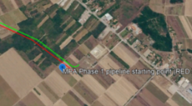 | 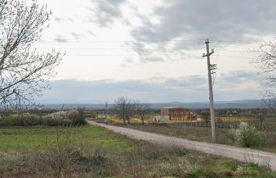 | The starting point of the pipeline at this stage. There is already a gas compound of ‘Srbijagas’. | Standard construction methods will be applied, the space is very large and sufficient for the needs of this kind of infrastructure construction.
2 | Topaonička river crosing  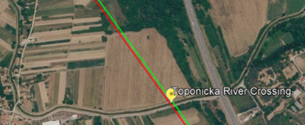 | 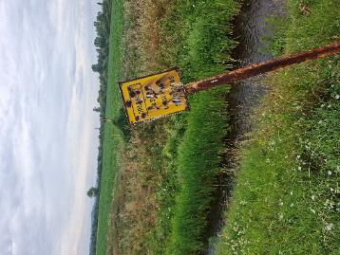 | Potential damage to ecosystem and water quality  The Topaonička river is channelized in this part. The estimated width of the watercourse and embankment part is about 8 meters. The Topaonička River is a typical karst and fast flowing watercourse. In the summer months, the flow drops drastically, so in some places in the upper reaches the water "barely trickles" or is even lost in the limestone. The Topaonička River is not completely canalized. | The proposed pipeline crossing of the watercourse may be undertaken using either the flume crossing or the open-cut crossing method, as the watercourse is relatively small and characterized by low and seasonal flow conditions. Both methods are considered technically feasible at this stage; however, the final crossing technique will be determined during the detailed design phase based on site-specific topographical, hydrological, geotechnical and environmental investigations, with the objective of minimizing environmental impacts while ensuring safe and efficient construction. The habitat types and plant species are characteristic of disturbed wetland and can be expected to recover quickly following disturbance.
3 | Deviation  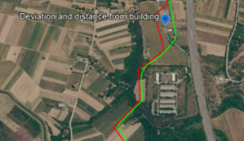 | 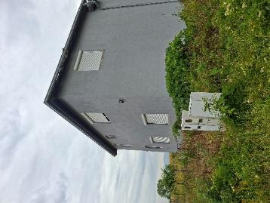 | Proximity to house. | There is sufficient space to construct TP pipeline, with enhanced safety design aspects such as heavier wall line pipe and increased burial depth of the pipe. During construction mitigation can include fabricating a length of pipe and tracking it into the trench to reduce disturbance to residents of the house if required.
4 | Velepoljska river, near village Draževac  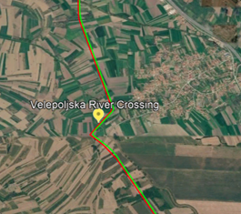 | 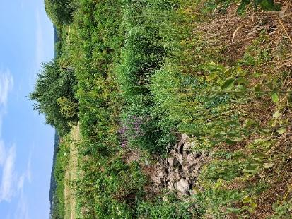 | Potential damage to ecosystem and water quality  During the field visit the river was dried up, with no water in this watercourse.  The Velepoljska river is a fast flowing watercourse that forms on the slopes of the Ozren and Devica mountains, and its valley is located on the southern edge of the Aleksinac basin, in the immediate vicinity of the village of Draževac (municipality of Aleksinac) and the settlement of Gornja Trnava | Open Cut Crossing would probably be employed due to the variable flows and generally disturbed habitat and plant species, which will recover rapidly following reinstatement.  The final crossing methodology will be confirmed during the detailed design stage based on site-specific engineering, hydrological and environmental investigations.
5 | 1st intersection with the Južna Morava River  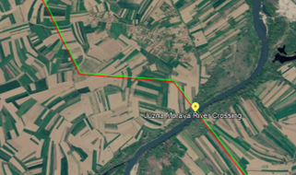 | 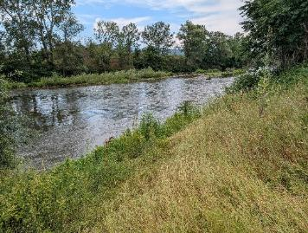 | Morava River crossing. Potential damage to ecosystem and water quality. | This large river will be crossed by trenchless techniques, whereby the pipe will be installed several metres below the river bed. There are feasibly two main techniques, Horizontal Directional Drilling (HDD) and Micro Tunnel. Geotechnical and other considerations will determine the technique, which is likely to be HDD; comprising a pipe sting length of typically around 600m. There should be no impact on the ecosystem or water quality using HDD. There is a major flood defence bund to prevent flooding of land and property and the construction equipment should be located outside of this bunded area and be protected from flooding.
6 | 2nd intersection with the Južna Morava River  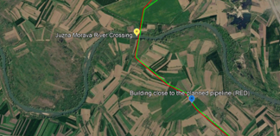 | 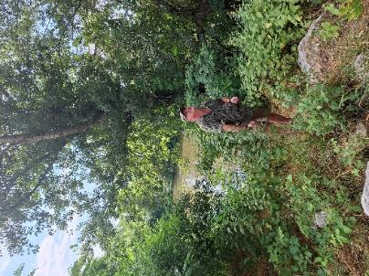 | Second Morava River crossing. Potential damage to ecosystem and water quality | This large river will be crossed by trenchless techniques, whereby the pipe will be installed several metres below the river bed. There are feasibly two main techniques, Horizontal Directional Drilling (HDD) and Micro Tunnel. Geotechnical and other considerations will determine the technique, which is likely to be HDD; comprising a pipe sting length of typically around 600m. There should be no impact on the ecosystem or water quality using HDD. There is a major flood defence bund to prevent flooding of land and property and the construction equipment should be located outside of this bunded area and be protected from flooding.
7 | Cemetery  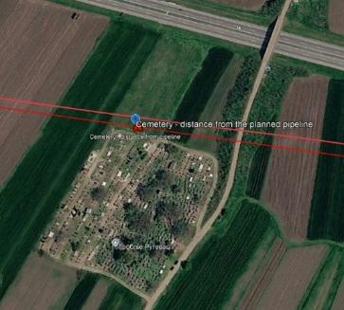 | 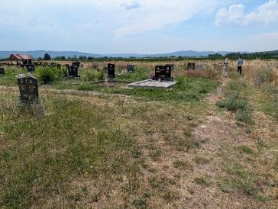 | Potential conflict with boundary of cemetery, which has been expanded in recent years. | TP routing is outside of the cemetery boundary and there should be no conflict of land use.
8 | Deviation  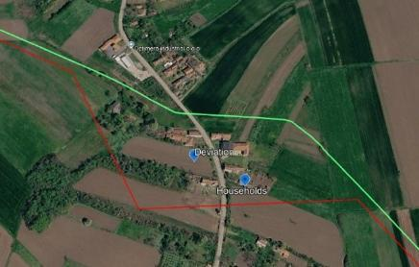 | 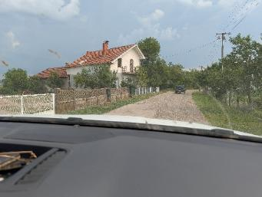 | Routing issue with properties. | The deviation southwards from the existing route was made to avoid nearby houses that have developed in recent years. The proposed route thus provides sufficient space for safe construction of the new gas pipeline.
9 | Canalized watercourse through the village of Jasenje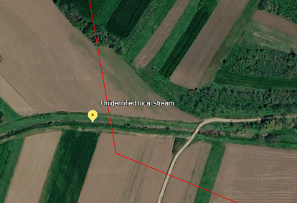 | 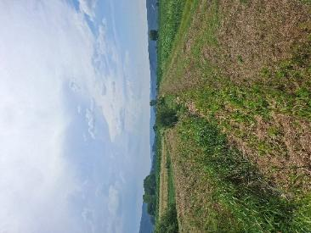 | Potential damage to ecosystem and water quality | The proposed pipeline crossing maybe constructed using the open-cut crossing method, as the watercourse is small, intermittent and the construction works are expected to be of short duration. The final crossing methodology will be confirmed during the detailed design stage based on site-specific engineering, hydrological and environmental investigations.
10 | “Telecom Tower” (near village Poslon)  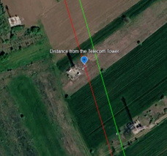 |  | The proposed pipeline alignment passes in close proximity to an existing mobile telecommunications tower. As Serbian legislation does not prescribe specific minimum separation distances between high-pressure gas pipelines and telecommunications towers, the final design will be based on Good International Industry Practice (GIIP), relevant engineering standards and consultation with the infrastructure owner. | During the detailed design stage, a site-specific assessment will be undertaken to verify the required separation distance, ensure the structural stability of the tower, maintain safe access for operation and maintenance of both facilities, and prevent potential conflicts between the two infrastructures.
11 | The largest deviation of the new proposed gas pipeline route compared to the existing gas pipeline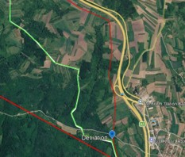 |  | Valuable forest habitat | The Yugorozgas line was constructed through valuable forest habitat. The Trupale-Pojate (TP pipeline) routing has carefully avoided the valuable habitat with steep slopes, that would have had a potentially significant adverse ecological impact. Instead the new routing has selected predominantly agricultural land with small relatively amounts of forest, which should result in significantly reduced adverse impacts. An example of positive environmentally sensitive routing.
12 | The Cottage, auxiliary building in the vineyard 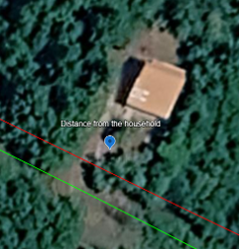 | 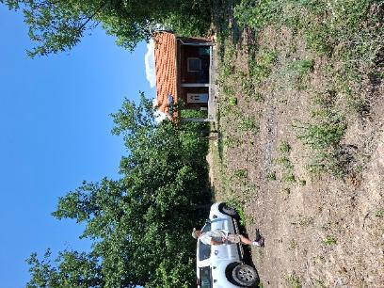 | The cottage is located 15 meters from the planned route of the gas pipeline. | This new house/cottage has been constructed since the initial routing was undertaken and it will be necessary to adjust the alignment in this local area to provide sufficient distance from the property. Considerations could include heavier wall pipe and a slightly deeper burial depth.  During construction mitigation can include fabricating a length of pipe and tracking it into the trench to reduce disturbance to residents of the house.
13 | Two isolated houses 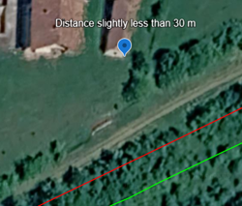 | 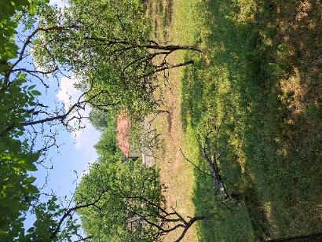 | Two isolated houses but far enough from the planned gas pipeline route. | There is sufficient space to construct TP pipeline, with possibility if required of enhanced safety design aspects such as heavier wall line pipe and increased burial depth of the pipe. During construction mitigation can include fabricating a length of pipe and tracking it into the trench to reduce disturbance to residents of new house.
14 | Jovanovačka river (local stream) crossing  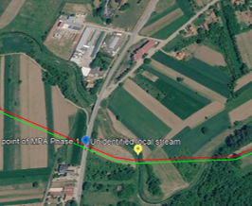 | 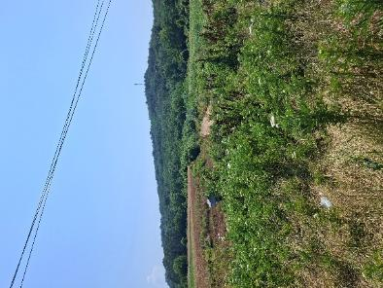 | Potential damage to ecosystem and water quality  The Jovanovačka River is a watercourse about 32 to 39 km long that rises and forms by merging near the village of Novi Bračin and flows into Velika Morava near Donji Katun. It is known that it often dries up during the summer, but also for flooding due to fast flowing water, which was solved by infrastructural rehabilitation of the riverbed in the municipality of Ćićevac. | The proposed pipeline crossing may be constructed using the open-cut crossing method, as the watercourse is small, intermittent and the construction works are expected to be of short duration. The final crossing methodology will be confirmed during the detailed design stage based on site-specific engineering, hydrological and environmental investigations.
15 | New large house  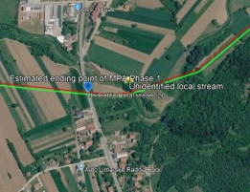 | 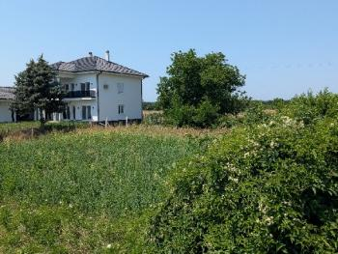 | New large house constructed close to TP proposed route. | There is sufficient space to construct TP pipeline, with enhanced safety design aspects such as heavier wall line pipe and increased burial depth of the pipe. During construction mitigation can include fabricating a length of pipe and tracking it into the trench to reduce disturbance to residents of new house.
16 | Road designation IIA class: 215, Pojate–Kruševac–Đunis–Deligrad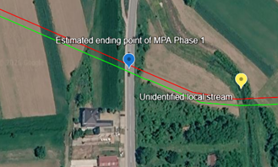 | 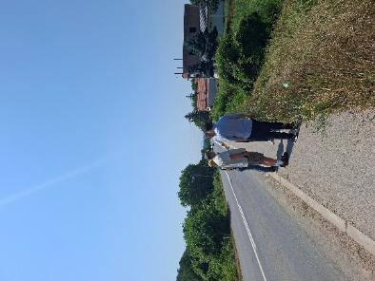 | The proposed pipeline will cross a State Road Class IIA. The crossing will be designed in accordance with the applicable legislation of the Republic of Serbia and the technical requirements of the relevant road authority. A trenchless construction method, such as Horizontal Directional Drilling (HDD), auger boring or pipe jack, is anticipated as the preferred option to minimize traffic disruption and avoid impacts on the road structure. | The final crossing methodology will be confirmed during the detailed design stage based on site-specific engineering investigations and the conditions issued by the competent authority. No disturbance or damage to the highway would be anticipated.

- Full corridor route sensitive socio-economic perspective for Phase I and II
Phases I and II - Preliminary Working Note for ESIA Scoping and World Bank Discussion
Status: preliminary route inventory reconstructed from the route-map screenshots reviewed jointly with the project team. The inventory must be verified against the latest georeferenced alignment and official cadastral boundaries before it is used as a definitive ESIA, SEP, RPF or RAP footprint.
1. Purpose and methodological note
This note provides a route-sensitive socio-economic perspective for the gas pipeline corridor covered by Phases I and II. It is designed to support ESIA scoping, stakeholder engagement, land acquisition planning, legacy due diligence and preparation of subsequent ESS5 instruments.
The central methodological correction is that the corridor cannot be represented by a single undifferentiated line. The route maps show an existing/legacy pipeline alignment in yellow and proposed deviations or a new alignment in red. Where the red alignment departs from the yellow alignment, both corridors must be recorded separately because they may cross different cadastral municipalities, parcels, owners and users. Where the routes rejoin, shared and repeated exposure must also be identified.
Accordingly, the inventory below distinguishes: (i) cadastral municipalities crossed by the current/new alignment; (ii) cadastral municipalities crossed by the legacy alignment; (iii) shared/overlap cadastral municipalities; and (iv) places where both alignments cross the same cadastral municipality but on spatially different corridors.
Important terminology: names such as Aleksinac Van Varoš, Gornje Vidovo I, Velika Plana II and Ćuprija (van grad) are treated here as cadastral municipalities/areas (KO), not automatically as statistical settlements. Census settlement data should be linked only through a verified crosswalk.
2. Overall socio-economic perspective
The proposed pipeline does not cross an abstract strip of agricultural land. It traverses a socially inhabited landscape of private and used agricultural parcels, inherited family property, ageing and depopulating villages, peri-urban areas and households with very different capacities to navigate land restrictions, compensation procedures and project information.
For many affected households, land may simultaneously function as a source of income, household food production, security in old age, an intergenerational asset, a future housing resource for children and a material connection between family members and their place of origin. A narrow easement or temporary construction strip can therefore create significant effects even where the formal area of land take is small.
The social assessment should examine current use and reasonably foreseeable future use, including agricultural investment, orchards, farm buildings, future family housing, inheritance plans, access, irrigation, drainage and parcel fragmentation. It should distinguish registered ownership from actual use and should identify tenants, informal users, family users, heirs, absentee owners, deceased registered owners and persons affected by unresolved succession.
The guiding principle should be that no household is left worse off because the project crosses, restricts or temporarily occupies its land, and that no affected person loses access to rights, compensation or livelihood restoration because of age, disability, weak administrative capacity, informal use, unresolved inheritance, absence from the municipality or limited access to project information.
3. Reconstructed cadastral-municipality sequence along the corridor
This section records the sequence agreed during the screenshot-by-screenshot review. “Confirmed” means confirmed for this working note from the jointly reviewed map sequence; final GIS verification remains required. KO Moravski Bujmir is specifically flagged because the route runs immediately along the boundary.
3.1 Common / current-route sequence from Trupale to the first major divergence
KO Trupale → KO Vrtište → KO Gornja Toponica → KO Donja Toponica → KO Donja Trnava → KO Draževac → KO Tešica → KO Lužane → KO Moravski Bujmir (boundary verification required) → KO Nozrina → KO Moravac → KO Žitkovac → KO Prćilovica → KO Donji Adrovac → KO Aleksinac Van Varoš → KO Bobovište → KO Ćićina → KO Rutevac → KO Vukašinovac → KO Deligrad → KO Jasenje → KO Praskovče → KO Poslon → KO Čubura → KO Ražanj → KO Mađere → KO Šetka → KO Ćićevac → KO Pojate
3.2 Legacy yellow alignment from Pojate through the Paraćin-Cuprija section
KO Pojate → KO Drenovac → KO Sikirica → KO Ratare → KO Lebina → KO Tekija → KO Glavica → KO Paraćin → KO Paraćin (van grad) → KO Ćuprija (van grad)
3.3 Current/new red alignment from Pojate through the Paraćin-Cuprija section
KO Pojate → KO Drenovac → KO Sikirica → KO Obrež → KO Gornje Vidovo I → KO Donje Vidovo → KO Striža → KO Čepure → KO Paraćin → KO Ćuprija (van grad) → KO Sinji Vir → KO Jovac → KO Ostrikovac → KO Majur → KO Mijatovac
3.4 Jagodina-area legacy alignment after the routes converge in KO Končarevo
KO Končarevo → KO Rakitovo → KO Jagodina (brief crossing) → KO Ribare → KO Kočino Selo
3.5 Jagodina-area current/new alignment after the routes converge in KO Končarevo
KO Končarevo → KO Jagodina → KO Ribare → KO Kočino Selo
3.6 Northern section - current/new alignment
KO Lanište → KO Bagrdan (Selo) → KO Vojska → KO Bagrdan (Selo) → KO Miloševo → KO Brzan → KO Lapovo → KO Markovac → KO Novo Selo I → KO Staro Selo → KO Velika Plana II → KO Veliko Orašje
3.7 Northern section - legacy alignment
KO Lanište → KO Bagrdan (Selo) → KO Vojska (brief crossing) → KO Bagrdan (Selo) → KO Miloševo → KO Brzan → KO Lapovo → KO Markovac → KO Novo Selo I → KO Staro Selo → KO Velika Plana II → KO Veliko Orašje
4. Municipal and route-sensitive socio-economic perspective
The municipal profiles below combine the route-sensitive KO inventory with the socio-economic indicators already extracted from official 2022 Census datasets. Municipal averages should be used as contextual indicators only; they do not replace settlement-level profiling or household-level fieldwork.
4.1 City of Niš
Route-relevant KOs: KO Trupale; KO Vrtište; KO Gornja Toponica; KO Donja Toponica; KO Donja Trnava
Selected socio-economic indicators:
• Population 2022: 249,501
• Population change 2011-2022: approx. -4.1%
• Population aged 65+: approx. 21.1%
• Average age: approx. 43.4 years
• Households: 100,274
• One-person households: 29,436
• Elderly-only households: 20,709
• Economically active: 113,895
• Unemployed: 18,858
• Pensioners: 57,725
City-level indicators are comparatively stronger than in most corridor municipalities, but they conceal major differences between the urban core and the northern rural settlements crossed by the route. Rural landownership, agricultural use and legacy-pipeline experience should therefore be assessed separately from the aggregate city profile.
4.2 Aleksinac
Route-relevant KOs: KO Draževac; KO Tešica; KO Lužane; KO Moravski Bujmir (verify boundary); KO Nozrina; KO Moravac; KO Žitkovac; KO Prćilovica; KO Donji Adrovac; KO Aleksinac Van Varoš; KO Bobovište; KO Ćićina; KO Rutevac; KO Vukašinovac; KO Deligrad; KO Jasenje
Selected socio-economic indicators:
• Population 2022: 43,098
• Population change 2011-2022: approx. -16.9%
• Households: 15,662
• One-person households: 4,164
• Elderly-only households: 3,631
• Economically active: 16,095
• Employed: 12,847
• Unemployed: 3,248
• Pensioners: 11,317
• Own-use production: 901
Aleksinac combines strong long-term depopulation, a substantial pensioner population and continuing household production. Land may remain economically and socially significant even where agricultural income is supplementary rather than primary. Route deviations also create a need to distinguish newly affected households from households with prior pipeline experience.
4.3 Ražanj
Route-relevant KOs: KO Praskovče; KO Poslon; KO Čubura; KO Ražanj; KO Mađere; KO Šetka
Selected socio-economic indicators:
• Population 2022: 7,010
• Population change 2011-2022: approx. -23.4%
• Population aged 65+: approx. 33.2%
• Average age: approx. 49.2 years
• Households: 2,593
• One-person households: 732
• Elderly-only households: 836
• Economically active: 2,253
• Unemployed: 430
• Pensioners: 2,384
• Own-use production: 305
Ražanj presents one of the strongest structural-vulnerability profiles in the corridor. Enhanced outreach, direct household contact, vulnerability screening and support for older owners/users are warranted. Digital disclosure and centralised meetings should not be relied upon as the primary means of engagement.
4.4 Ćićevac
Route-relevant KOs: KO Ćićevac; KO Pojate
Selected socio-economic indicators:
• Population 2022: 7,860
• Population change 2011-2022: approx. -17.1%
• Households: 2,816
• One-person households: 749
• Elderly-only households: 676
• Economically active: 3,139
• Unemployed: 659
• Pensioners: 2,124
• Own-use production: 112
Ćićevac combines demographic decline, ageing, pension dependence and a rural household economy. Pojate is particularly important as a project node and transition area; repeated engagement burdens and cumulative expectations should be considered.
4.5 Varvarin
Route-relevant KOs: KO Obrež
Selected socio-economic indicators:
• Population 2022: 14,217
• Population change 2011-2022: approx. -20.9%
• Population aged 65+: approx. 28.2%
• Households: 5,039
• One-person households: 1,292
• Elderly-only households: 1,307
• Economically active: 4,581
• Unemployed: 1,169
• Pensioners: 4,045
• Own-use production: 775
Varvarin shows severe demographic pressure and a notable own-use production signal. Household-level assessment should examine actual cultivation, informal use, crop dependence and whether older households rely on family land as a supplementary resource.
4.6 Paraćin
Route-relevant KOs: KO Drenovac; KO Sikirica; KO Ratare; KO Lebina; KO Tekija; KO Glavica; KO Gornje Vidovo I; KO Donje Vidovo; KO Striža; KO Čepure; KO Paraćin; KO Paraćin (van grad)
Selected socio-economic indicators:
• Population 2022: 45,543
• Population change 2011-2022: approx. -16.0%
• Households: 16,485
• One-person households: 4,436
• Elderly-only households: 3,764
• Economically active: 17,970
• Unemployed: 4,447
• Pensioners: 12,683
• Own-use production: 778
This is a critical divergence area where new and legacy routes cross different KOs and potentially different households. The ESIA should separately identify current-project PAPs, legacy-only households and KOs shared by both alignments but through different parcel corridors.
4.7 Ćuprija
Route-relevant KOs: KO Ćuprija (van grad); KO Sinji Vir; KO Jovac; KO Ostrikovac; KO Mijatovac
Selected socio-economic indicators:
• Population 2022: 25,325
• Population change 2011-2022: approx. -17.4%
• Population aged 65+: approx. 27.4%
• Households: 9,785
• One-person households: 2,901
• Elderly-only households: 2,522
• Economically active: 9,511
• Unemployed: 2,092
• Pensioners: 7,470
High ageing and demographic decline make accessible, repeated and direct engagement especially important. The distinction between formal owners and actual agricultural users should be verified in the field.
4.8 Jagodina
Route-relevant KOs: KO Majur; KO Končarevo; KO Rakitovo; KO Jagodina; KO Ribare; KO Kočino Selo; KO Lanište; KO Bagrdan (Selo); KO Miloševo
Selected socio-economic indicators:
• Population 2022: 64,644
• Population change 2011-2022: approx. -10.0%
• Households: 24,809
• One-person households: 7,336
• Elderly-only households: 5,786
• Economically active: 26,651
• Unemployed: 5,860
• Pensioners: 16,350
Jagodina is socio-economically heterogeneous: the corridor intersects agricultural, village and peri-urban contexts. KO Jagodina is crossed by both alignments, with the legacy alignment entering only briefly, while the current route crosses it more substantially. Future land-use expectations may be as important as current agricultural use.
4.9 Svilajnac
Route-relevant KOs: KO Vojska
Selected socio-economic indicators:
• Population 2022: 20,141
• Population change 2011-2022: approx. -14.5%
• Population aged 65+: approx. 28.7%
• Households: 7,715
• One-person households: 2,433
• Elderly-only households: 2,238
• Economically active: 6,971
• Unemployed: 1,133
• Pensioners: 6,137
• Own-use production: 715
Svilajnac combines pronounced ageing with continued land-based supplementary livelihoods. KO Vojska is crossed by both alignments, but the new alignment is more substantial while the legacy route only briefly crosses the KO; this distinction is important for PAP identification and legacy due diligence.
4.10 Batočina
Route-relevant KOs: KO Brzan
Selected socio-economic indicators:
• Population 2022: 10,162
Population change 2011-2022: approx. -13.6%
Population aged 65+: approx. 25.0%
Average age: 45.3 years
Households: 3,540
One-person households: 938
Elderly-only households: 835
Economically active: 4,076
Employed: 3,213
Unemployed: 863
Pensioners: 2,783
Own-use production: 160
Batočina shows substantial demographic decline, above-national ageing and a large pensioner population. Its 2011-2022 population decrease of approximately 13.6%, together with around one quarter of the population aged 65+ and 835 elderly-only households, indicates reduced household resilience and a need for direct, accessible engagement. KO Brzan is crossed by both alignments and contains a visible deviation; parcel-level identification is therefore required even where both routes remain within the same cadastral municipality, because the affected owners and users may differ.
4.11 Lapovo
Route-relevant KOs: KO Lapovo
Selected socio-economic indicators:
• Population 2022: 6,582
Population change 2011-2022: approx. -16.0%
Population aged 65+: approx. 25.7%
Average age: 46.0 years
Households: 2,415
One-person households: 656
Elderly-only households: 597
Economically active: 2,544
Employed: 2,235
Unemployed: 309
Pensioners: 1,812
Own-use production: 69
Lapovo also presents a significant route-relevant vulnerability context: the population declined by approximately 16.0% between 2011 and 2022, around 25.7% of residents are aged 65+, and 597 households are elderly-only. Both alignments cross KO Lapovo before entering KO Markovac. The municipality should therefore be fully integrated into the socio-economic baseline, stakeholder mapping, accessibility planning and future PAP identification, with separate attention to corridor-specific parcels and actual land users.
4.12 Velika Plana
Route-relevant KOs: KO Markovac; KO Novo Selo I; KO Staro Selo; KO Velika Plana II; KO Veliko Orašje
Selected socio-economic indicators:
• Population 2022: 35,451
• Population change 2011-2022: approx. -13.3%
• Households: 12,723
• One-person households: 3,521
• Elderly-only households: 2,838
• Economically active: 13,415
• Unemployed: 2,273
• Pensioners: 8,939
Both alignments pass through the same sequence of KOs toward Veliko Orašje, but in KO Markovac they are spatially well separated. The fact that both routes are within the same KO does not imply the same parcels, owners or users. Permanent restrictions may also affect peri-urban and future development expectations.
5. Key route-status distinctions for ESIA and ESS5
KO Route status Scoping implication
Drenovac Both alignments Shared/common KO before/at divergence
Sikirica Both alignments Legacy and current route both cross the KO, on different segments
Obrež Current/new only New red deviation
Gornje Vidovo I Current/new only New red deviation
Donje Vidovo Current/new only New red deviation
Ratare Legacy only Yellow alignment
Lebina Legacy only Yellow alignment
Tekija Legacy only Yellow alignment
Glavica Legacy only Yellow alignment
Striža Current/new only Red alignment
Čepure Current/new only Red alignment
Paraćin Both alignments Different spatial segments / parcels possible
Paraćin (van grad) Legacy only in current working reconstruction Requires GIS confirmation
Ćuprija (van grad) Both alignments Different corridors possible
Sinji Vir Current/new only Red alignment
Jovac Current/new only Red alignment
Ostrikovac Current/new only Red alignment
Majur Current/new only Red alignment
Mijatovac Current/new only Red alignment
Končarevo Both alignments Convergence area
Rakitovo Legacy only Yellow alignment
Jagodina Both alignments Legacy enters briefly; current route more substantial
Ribare Both alignments Both routes cross
Kočino Selo Both alignments Shared onward corridor
Lanište Both alignments Shared
Bagrdan (Selo) Both alignments New route enters Vojska and returns
Vojska Both alignments Current route substantial; legacy brief
Miloševo Both alignments Both cross
Brzan Both alignments Deviation within same KO
Lapovo Both alignments Both cross
Markovac Both alignments Spatially separated corridors
Novo Selo I Both alignments Both cross
Staro Selo Both alignments Both cross
Velika Plana II Both alignments Both cross
Veliko Orašje Both alignments Terminal area
6. Cross-cutting social assessment priorities
• Demographic decline and ageing: Several corridor municipalities show population decline and ageing substantially above national reference levels. This can affect access to consultations, administrative capacity, succession status and the ability to pursue valuation or grievance claims.
• Actual use versus registered ownership: The project should identify registered owners, actual users, tenants, informal users, family users, heirs, absentee owners and persons affected by unresolved succession. A cadastral list cannot substitute for social fieldwork.
• Land-based livelihoods and household resilience: A small affected strip can create a material impact where a parcel is small, highly productive, fragmented, irrigated or important to a pensioner or mixed-income household.
• Future use restrictions: The ESIA should assess effects on future housing, farm buildings, orchards, investment, inheritance plans and land marketability, not only current agricultural use.
• Legacy due diligence: Where the yellow and red alignments overlap or traverse the same KO, prior acquisition, easements, compensation, restoration, residual grievances and repeated impacts should be reviewed separately from current PAP identification.
• Accessible engagement: Village-level meetings, direct contact, repeated notification, plain-language materials and targeted outreach to elderly households should complement online disclosure.
• Different corridors within the same KO: Where both alignments cross the same KO but are spatially separated, the same KO label must not be interpreted as the same affected parcels, owners or users.
7. Recommended immediate actions for the ESIA team and World Bank task team
1. Obtain the latest georeferenced current and legacy alignments and overlay both against official KO and parcel boundaries.
2. Validate every KO in this working inventory, with particular attention to KO Moravski Bujmir and other boundary-adjacent segments.
3. Prepare separate parcel/PAP inventories for the current/new alignment and the legacy corridor; do not infer one from the other.
4. Add Batočina and Lapovo to the municipal socio-economic baseline and stakeholder mapping.
5. Prepare a settlement-level crosswalk only after distinguishing KO names from statistical settlements.
6. Identify KOs where both routes cross but on spatially different corridors, including Markovac and Jagodina, and assess different owners/users accordingly.
7. Begin legacy due diligence during scoping rather than postponing it until RAP preparation.
8. Ensure that household surveys capture dependence on affected land, informal use, unresolved inheritance, absentee ownership and reasonably foreseeable future use.
9. Use the route-sensitive baseline to shape SEP outreach, especially in ageing and depopulating municipalities.
8. Proposed wording for the ESIA
The social assessment will undertake a route-sensitive socio-economic analysis that distinguishes the current proposed alignment from the existing/legacy pipeline corridor and records the cadastral municipalities, parcels, owners and actual users associated with each. The assessment will not assume that a shared cadastral-municipality name implies the same affected parcels or households, nor that prior land acquisition information adequately represents the current route. It will combine municipal and settlement-level baseline analysis with project-specific fieldwork and household-level assessment, with particular attention to ageing and depopulating rural communities, elderly-only households, persons with disabilities, informal users, unresolved inheritance, absent owners, dependence on affected agricultural land, reasonably foreseeable future land use and residual issues associated with the legacy corridor. The burden of strategic infrastructure development should not be shifted disproportionately onto individual rural households merely because their land lies along the selected corridor.
9. Data and source note
• Official 2022 Census datasets used in the parallel socio-economic baseline work for municipal indicators.
• Preliminary spatial-planning documentation (Annex 3) used as a wider planning-corridor reference.
• Overview route map (Annex 4).
• Successive route-map screenshots jointly reviewed in this working session, with yellow interpreted as the existing/legacy route and red as the proposed new/deviation route.

- ESS Compliance Matrix
The following matrix maps ESIA scope to ESS requirements and ESRS commitments for Phase 1 (Trupale–Pojate, 62 km).

ESS | Required Instrument / Output | Key Actions for Phase 1
ESS1 | Scoping Report + ESIA ToRs disclosed by Appraisal; Phase 1 ESIA and ESMP before works; constraints mapping; cumulative screening | Identify deviations from existing corridor; define specialist studies (ESIA); integrate ESMP into bidding documents (for bidding stage). ESMP is for the Construction stage.  There are no Associated Facilities.
ESS2 | Contractor LMP(s); workers’ GRM; OHS Plan; CoC training records | Permit-to-work for hot work/line strikes; gas detection; cathodic protection interference; competency requirements (Construction stage).
ESS3 | Waste Management Plan; Pollution Prevention Plan; Drilling Fluid/Frac-out Response Plan; air/noise monitoring | Waste stream inventory; storage/secondary containment; spill prevention; HDD fluid risks and recovery (Construction stage)
ESS4 | CHSP incl. Emergency Preparedness; TMP; trench/excavation safety controls; public communication | Risk controls near live assets; public exclusion zones; community drills; incident notification (Construction stage)
ESS5 | Programme-level RPF disclosed; Phase 1 RAP(s); legacy land due diligence; livelihood restoration | Census/asset surveys (Pre-construction stage); compensation before impacts (Pre-construction stage); grievance integration (Construction stage); income restoration monitoring (throughout Pre-construction; Construction and into Operations stage).
ESS6 | Biodiversity assessment; BMP; seasonal timing windows; pre-clearance surveys; no-net-loss approach | Confirm protected/critical habitat presence/absence; set reinstatement criteria; invasive species control. (ESIA and extending into Construction stage; any monitoring would be during Operations)
ESS7 | Not applicable in Serbia | Document non-applicability in Scoping and ESIA
ESS8 | Cultural Heritage Assessment; CHMP or CFP; access management for community cultural spaces | Desk review + walkover with Institute; stop-work and notification procedures; community liaison (ESIA stage, extending through Construction stage)
ESS9 | Not applicable (no financial intermediary) | Record non-applicability in Scoping/ESIA/ESCP
ESS10 | Programme-level SEP with stakeholder mapping; site-specific SEP; operational GRM (community and workers) with SEA/SH-sensitive features | Early outreach to farmers/land users (post Scoping stage, throughout ESIA stage, Pre-construction); multiple formats; feedback log showing inputs shape ESIA scope (ESIA, extending into Construction stage and beyond into Operations stage if required.)

The project is classified as Substantial Environmental and Social Risk at Phase 1 level and High Risk at programme level under the World Bank Environmental and Social Framework (ESF), as confirmed in the Concept Stage Environmental and Social Review Summary (ESRS, May 2026). A full Environmental and Social Impact Assessment (ESIA) is mandatory under both Serbian EIA Law (Official Gazette 135/2004, 36/2009) and ESF requirements.

- Component 3 – Contingent Emergency Response Component (CERC)

Component 3: Contingent Emergency Response Component (CERC) This component provides a mechanism for the Government of Serbia to access rapid financing in the event of an eligible emergency. The CERC allows for the immediate reallocation of uncommitted project funds to support emergency response and recovery activities without requiring a separate project or lengthy restructuring.
The CERC remains dormant during normal implementation. Upon declaration of an emergency by the Government of Serbia and agreement by the World Bank, the component may be activated to finance urgent measures such as:
- Restoration of critical gas infrastructure and energy supply
- Emergency procurement of equipment, materials, or services
- Temporary support to affected communities or facilities
- Rapid repairs to safeguard public safety and continuity of essential services
All CERC-financed activities must comply with the World Bank’s environmental and social requirements, including the project’s ESMF and the dedicated CERC-ESMF Addendum, which provides simplified screening, risk classification, and mitigation procedures suitable for emergency operations.
CERC Activation Workflow Diagram (Text-Based)
CERC Activation Workflow
- Emergency Occurs Government of Serbia declares an eligible emergency (natural disaster, public health emergency, infrastructure failure, etc.).
- Government Submits CERC Activation Request Includes justification, description of emergency, and proposed eligible activities.
- World Bank Reviews Request Rapid assessment of eligibility, safeguards implications, and alignment with project objectives.
- Preparation of CERC Action Plan Government drafts a short Action Plan detailing activities, procurement, implementation arrangements, and safeguard screening.
- Environmental & Social Screening Activities screened using the CERC-ESMF Addendum to determine risk level and required mitigation.
- World Bank Approval Bank clears the Action Plan and authorizes reallocation of funds.
- Implementation & Monitoring Activities executed under accelerated procedures; environmental and social monitoring continues throughout.
- Reporting & Closure Government reports on emergency expenditures, results, and compliance.
CERC-Specific Environmental Screening Checklist
CERC Environmental & Social Screening Checklist
A. Basic Information
- Emergency type:
- Proposed activity:
- Location(s):
- Implementing agency:
B. Eligibility Screening
- Does the activity support emergency response or early recovery?
- Is the activity consistent with the parent project’s development objectives?
- Is the activity permissible under CERC guidelines (no large-scale civil works, no high-risk activities)?
C. Environmental & Social Risk Screening
- Will the activity involve minor repairs or rehabilitation of existing infrastructure?
- Any risk of pollution, hazardous materials, or waste generation?
- Any temporary impacts on land, access, or community assets?
- Any impacts on vulnerable groups?
- Any impacts on cultural heritage?
- Any impacts on natural habitats or protected areas?
- Any occupational health and safety risks?
D. Required Safeguard Instruments
- No additional instrument required (low risk)
- Simple Environmental Code of Practice (ECOP)
- Site-specific ESMP
- Waste management plan
- OHS plan
- Chance-find procedure
- Community health and safety measures
E. Approval
- Screening completed by:
- Reviewed by PIU:
- Cleared by World Bank:
- Date:

- Comments Form
Form to be used to provide comments and feedback on

As the design may change this Scoping Report adopts 75 bar and 900 mm throughout.
Pipelines have additional components such as Above Ground Infrastructure (AGIs), referred to herein as ancillary facilities. The term Associated Facilities is reserved for infrastructure that meets the specific World Bank definition of qualifying as such eg it means infrastructure that is not financed as part of the project but whose construction or expansion is dependent on it and would not occur without it; and is planned to be carried out contemporaneously with the project being assessed ie (during the period of construction of the TP pipeline). It is concluded that there are no identifiable Associated Facilities.
https://www.seismo.gov.rs/Seizmicnost/SH_2018_Intensity_475_WGS84UTM.pdf
https://www.seismo.gov.rs/Seizmicnost/SH_2018_Acceleration_475_WGS84UTM.pdf
As part of construction, the Construction Contractor may also prepare a Biodiversity Management Plan (BMP) to manage biodiversity issues during construction, as part of the typical Contractor Control Plans (CCPs) that are used to manage E&S issues during construction; this would interface with any BMP prepared in compliance to ESS6.
The method of Contract award has not yet been determined, but it is possible that some form of Engineering-Procurement-Construction (EPC) contract may be awarded, whereby a Contractor completes the Detailed Design and there is an arrangement for Independent Construction Supervision. Any breakdown of actions required under subsequent phases (post this Scoping phase) will be undertaken at that stage.

